

CAPSTONE PROJECT REPORT
Report 3 – Software Requirement Specification
Development of a Generative AI-Assisted Software Specification and Document Traceability Management System

Group: G65_SEP490_FALL26
Mentor: Bui Thi Loan (LoanBT7)

– Hanoi, Sep 2026 –
Table of Contents
Change Log 6
Definition and Acronyms 7
I. Overall Requirements 8
1. Context Diagram 8
2. Main Business Flow 9
2.1 Onboarding and Authentication for personal and corporation (BF-01) 9
2.2 Workspace & Project Initialization (BF-02) 10
2.3 Drafting, Discussing, and Approving Specification Documents (BF-03) 11
2.4 Test Scenario Design (BF-04) 12
2.5 Work Management, Assignment and Collaboration (BF-05 13
2.6 Project Tracking, Advance Search and Filter (BF-06) 14
2.7 Document Editing, History Retrieval, and Change Impact Handling Workflow (BF-07) 15
3. Conceptual Data Model 16
3.1 Entity Relationship Diagram 16
3.2 Entity Descriptions 17
3.3 Data Business Rules 21
4. User Requirements 22
4.1 Actors 22
4.2 Use Cases (UC) 24
4.3 Use Case Diagrams 30
4.4 Permission Matrix 36
5. System Functionalities 39
5.1 Screen Inventory 39
5.2 External API Inventory 46
5.3 Background Job Inventory 46
II. Use Case Specifications 47
1. Initial Experience (Landing & Onboarding) 47
1.1 Navigation and Access Routing 47
2. Authentication 47
2.1 Register New Account 47
2.2 Authenticate User (Login) 47
2.3 Password Recovery and Session Logout 47
3. Tenant Management 47
3.1 Account Provisioning and Organizational Role Management 47
3.2 Personal and Company Profile Management 47
3.3 Employee Assignment and Account Deactivation 47
4. Workspace Management 47
4.1 Workspace Provisioning and Lifecycle Governance 47
4.2 Workspace Membership Management 47
4.3 Workspace Role and Permission Configuration 47
5. Project Management & Dynamic Workflow 47
5.1 Project Initialization and Lifecycle Management 47
5.2 Project Membership Assignment and Access Control 47
5.3 Project Role and Permission Matrix Configuration 47
5.4 Dynamic SDLC Phase and Workflow Transition Configuration 47
6. Document Management 47
6.1 Specification Authoring, Versioning, and Export 47
6.2 Specification Review, Baseline Approval, and Safe Mode Reading 47
6.3 Inline Requirement Discussion and Comment Resolution 47
7. Issue Tracking 47
7.1 Issue Lifecycle, Assignment, and Kanban Progression 47
7.2 Kanban Tracking, Advanced Query, Collaboration, and Requirement Linking 47
8. AI Features 47
8.1 Raw Notes Normalization and AI-Assisted Requirement Drafting 47
8.2 Figma UI Design Synchronization and Requirement Mapping 47
9. AI Testcase 47
9.1 Input Completeness Validation and AI-Assisted Testcase Generation & Maintenance 47
9.2 Manual Testcase Operations 47
10. Traceability 47
10.1 Two-Stage Stale Warning and Change Impact Engine 47
10.2 Requirements Traceability Matrix (RTM) and Stale Resolution Management 47
11. Search and Filter 47
11.1 Global Search 47
11.2 Filter Issues 47
11.3 Filter Documents 47
12. Notification 47
12.1 Receive In-app Notifications 47
12.2 Change Notification Status 47
13. Dashboard & Report 47
13.1 View Personal Dashboard 47
13.2 Track Project Activity Stream 47
13.3 View Workspace Overview 47
14. Audit & Admin 47
14.1 Retrieve Audit Logs 47
14.2 Manage System Platform 47
15. Chatbot 47
15.1 View Chatbot AI 47
III. Functional Requirements 78
1. Landing & Onboard 78
1.1 Landing Page 78
2. User Authentication 79
2.1 User Register 79
2.2 User Login 80
2.3 Forgot Password 81
2.4 Password Reset Email Sent 82
2.5 Set New Password 83
2.6 Email Verification Pending 84
2.7 Email Verified 85
3. Tenant Management 86
3.1 Business Onboarding 86
3.2 Company Users & Permissions 90
3.3 Membership Invitations 93
4. Workspace Management 95
4.1 Workspace List 95
4.2 Create Workspace (modal) 96
4.3 Create Workspace (onboarding) 97
4.4 Workspace Detail 98
4.5 Workspace Members 99
4.6 Workspace Settings 100
5. Project Management 101
5.1 Project List 101
5.2 Create Project (modal) 102
5.3 Project Detail 103
6. Dynamic Workflow 104
6.1 Workflow Configuration 104
7. Document Management 105
7.1 Requirement Document List 105
7.2 Document Import / Export 106
7.3 Read Document 107
7.4 Compose / Review Document 108
8. UI/UX Structural Synchronization 109
8.1 Figma Sync 109
9. Issue Tracking 110
9.1 Kanban Board 110
9.2 Create Issue (modal) 111
9.3 Issue Detail 112
10. AI Testcase 113
10.1 AI Testcase Review 113
10.2 Create Manual Testcase 114
10.3 Testcase Detail 115
11. Traceability 116
11.1 Traceability Matrix 116
11.2 Manual Traceability Link 117
12. Search & Notification 118
12.1 Notifications & Global Search 118
12.2 Notification Preferences 119
Per-user matrix of notification events versus delivery channel (in-app / email) (UC-89). 119
13. Dashboard & Report 120
13.1 Personal Dashboard 120
14. Audit & Platform Admin 121
14.1 Audit Log 121
14.2 System Admin Console 122
15. AI Chatbot 123
15.1 AI Chatbot 123
16. Background Job Inventory 123
17. External API Inventory 124
17.1 Claude Sonnet API (API-01) 124
17.2 Figma REST API (API-02) 124
IV. Non-Functional Requirements 124
1. External Interfaces 124
2. Quality Attributes 125
2.1 Usability 125
2.2 Performance 125
2.3 Security 126
V. Requirement Appendix 127
1. Business Rules 127
2. System Messages 128

Change Log
Date | A* / M / D | In charge | Change Description
25/09/2026 | A | kyvkhe182094 | Add context diagram
26/09/2026 | A | kyvkhe182094 | Add BPMN Flow for BF1
27/09/2026 | M | kyvkhe182094 | Update BF1
29/09/2026 | M | kyvkhe182094 | Refine Use Case Specifications (Remove technical jargon, update to business-oriented language for Document, Issue, AI, Traceability modules)
02/10/2026 | M | kyvkhe182094 | Update Use Case Diagrams (Expand to 95 Use Cases, categorize into 6 sub-system diagrams using UML/Mermaid)
06/10/2026 | A | kyvkhe182094 | Add Non-Functional Requirements (User/Hardware/Software Interfaces, Usability, Performance, Security)
09/10/2026 | A | kyvkhe182094 | Add Requirement Appendix (Define Business Rules GB-01 to GB-07 and 12 standard System Messages)
Table I - 1: Change Log

*A - Added M - Modified D - Deleted

Definition and Acronyms
Acronym | Definition
SSAM | Software Specification and Document Traceability Management System
SDLC | Software Development Life Cycle
URD / SRS | User Requirement Document / Software Requirement Specification
Document Set | A structured set of software requirement specification documents created within a project, composed of multiple Requirement Items
Requirement Item | An individual requirement unit within a Document Set, identified based on heading structure and segmentation rules, containing Content, Diagrams, and a Requirement History Log
Content | The detailed textual specification (descriptions, acceptance criteria, business rules) belonging to a Requirement Item
Diagram | Visual flowcharts (rendered into images from PlantUML/Mermaid code) or interface illustrations attached to a Requirement Item when applicable
Requirement History Log | An append-only log recording all modifications made to the Content or Diagrams of a Requirement Item across versions (storing before/after snapshots, author, and timestamp)
RTM / Traceability | Requirement Traceability Matrix — the ability to trace and link Requirement Items across UI Designs, Issues, and Test Cases
Unconfirmed Stale | A warning status on a Test Case or Issue indicating that its linked Requirement Item has pending draft modifications in the History Log that are not yet formally approved
Confirmed Stale | A warning status on a Test Case or Issue indicating that modifications to its linked Requirement Item have been officially approved, requiring mandatory review and synchronization
RBAC | Role-Based Access Control
JWT / SSO | JSON Web Token / Single Sign-On
SME / SaaS | Small and Medium-sized Enterprise / Software as a Service
Multi-Tenant | Architectural pattern isolating organizational data between different subscribing Companies (Tenants)
Workspace | An isolated departmental or team environment within a Company containing related Projects
Workspace | An isolated project environment within a Company

I. Overall Requirements

1. Context Diagram
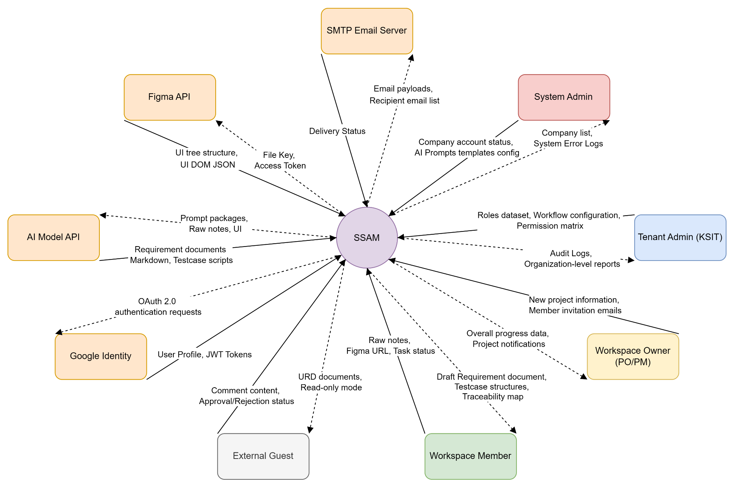

Figure I - 1: Context diagram

2. Main Business Flow

2.1 Onboarding and Authentication for personal and corporation (BF-01)
Trigger: An unauthenticated Guest clicks the "Go to SSAM" button on the Landing Page.
End condition: User identity is verified via Login (using local credentials or Google SSO), or a new Personal / Corporate (Tenant) account is created and activated via email verification (Register). The system establishes an authenticated session and redirects the user to the main Dashboard.
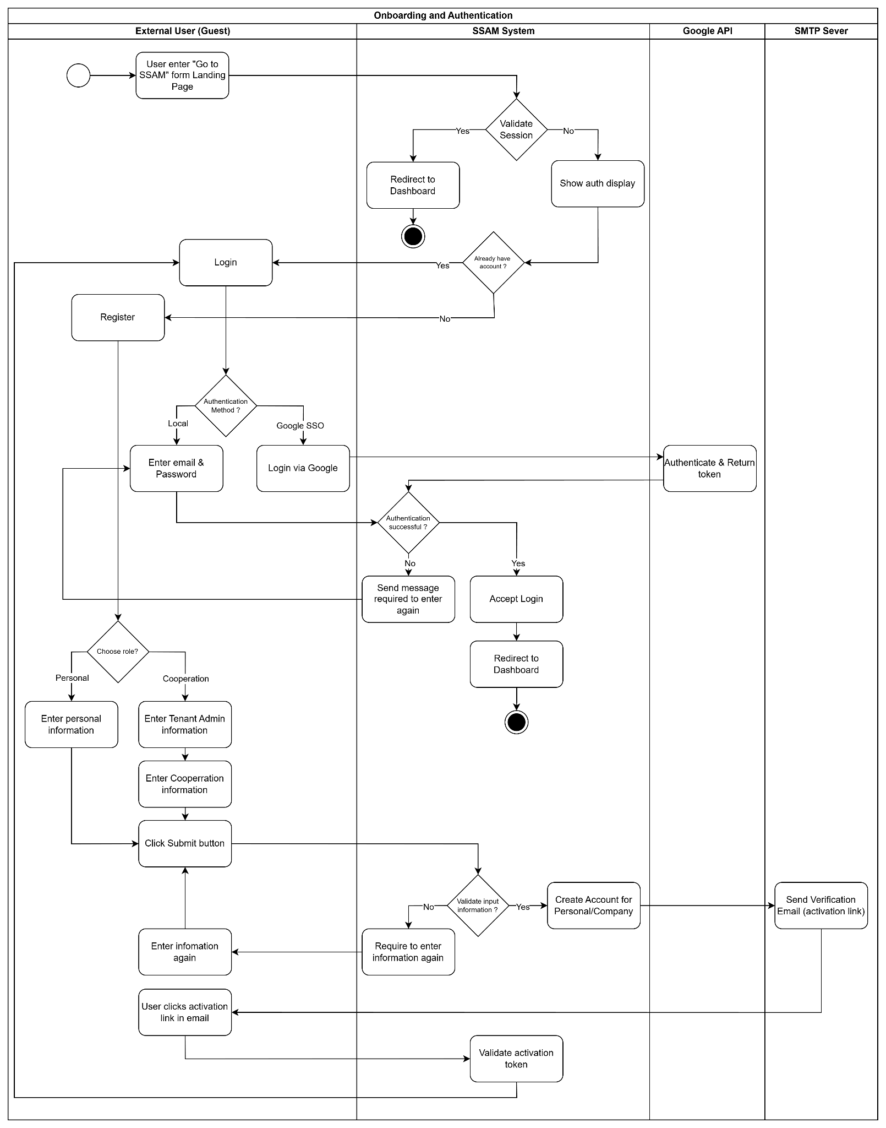
Figure 1.2.1: BF-01 – Onboarding and Authentication

2.2 Workspace & Project Initialization (BF-02)
Trigger: An authorized user (Project Initiator / Workspace Admin granted workspace or project creation capabilities by the Tenant Admin) logs into the system and clicks the "Create Workspace" or "Create Project" button.
End condition: The workspace, project profile, phases, and issue workflow rules (configured via predefined templates or custom phases and statuses) are successfully established. The system redirects the Project Initiator to the initialized Project Dashboard, while dispatching project invitations to selected team members (Assigned Users) to join the project.
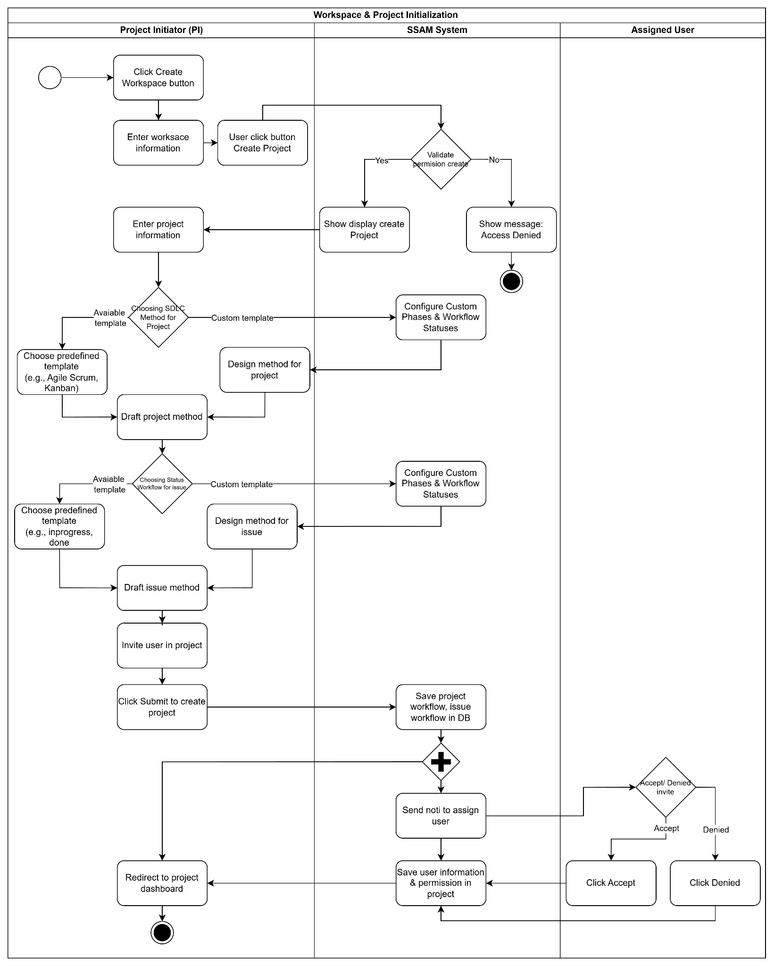
Figure 1.2.2: BF-02 – Workspace & Project Initialization

2.3 Drafting, Discussing, and Approving Specification Documents (BF-03)
Trigger: A Project Member (Business Analyst) creates a new specification document in Draft status, either composing the document manually or providing raw notes for optional AI-assisted generation.
End condition: When using AI, raw notes are converted into a structured template and broken down into identifiable Requirement Items (comprising textual content and process diagrams) for manual review (Accept or Reject). All inline review comments from the Reviewer are resolved, and the Reviewer formally approves the specification document as an official baseline.
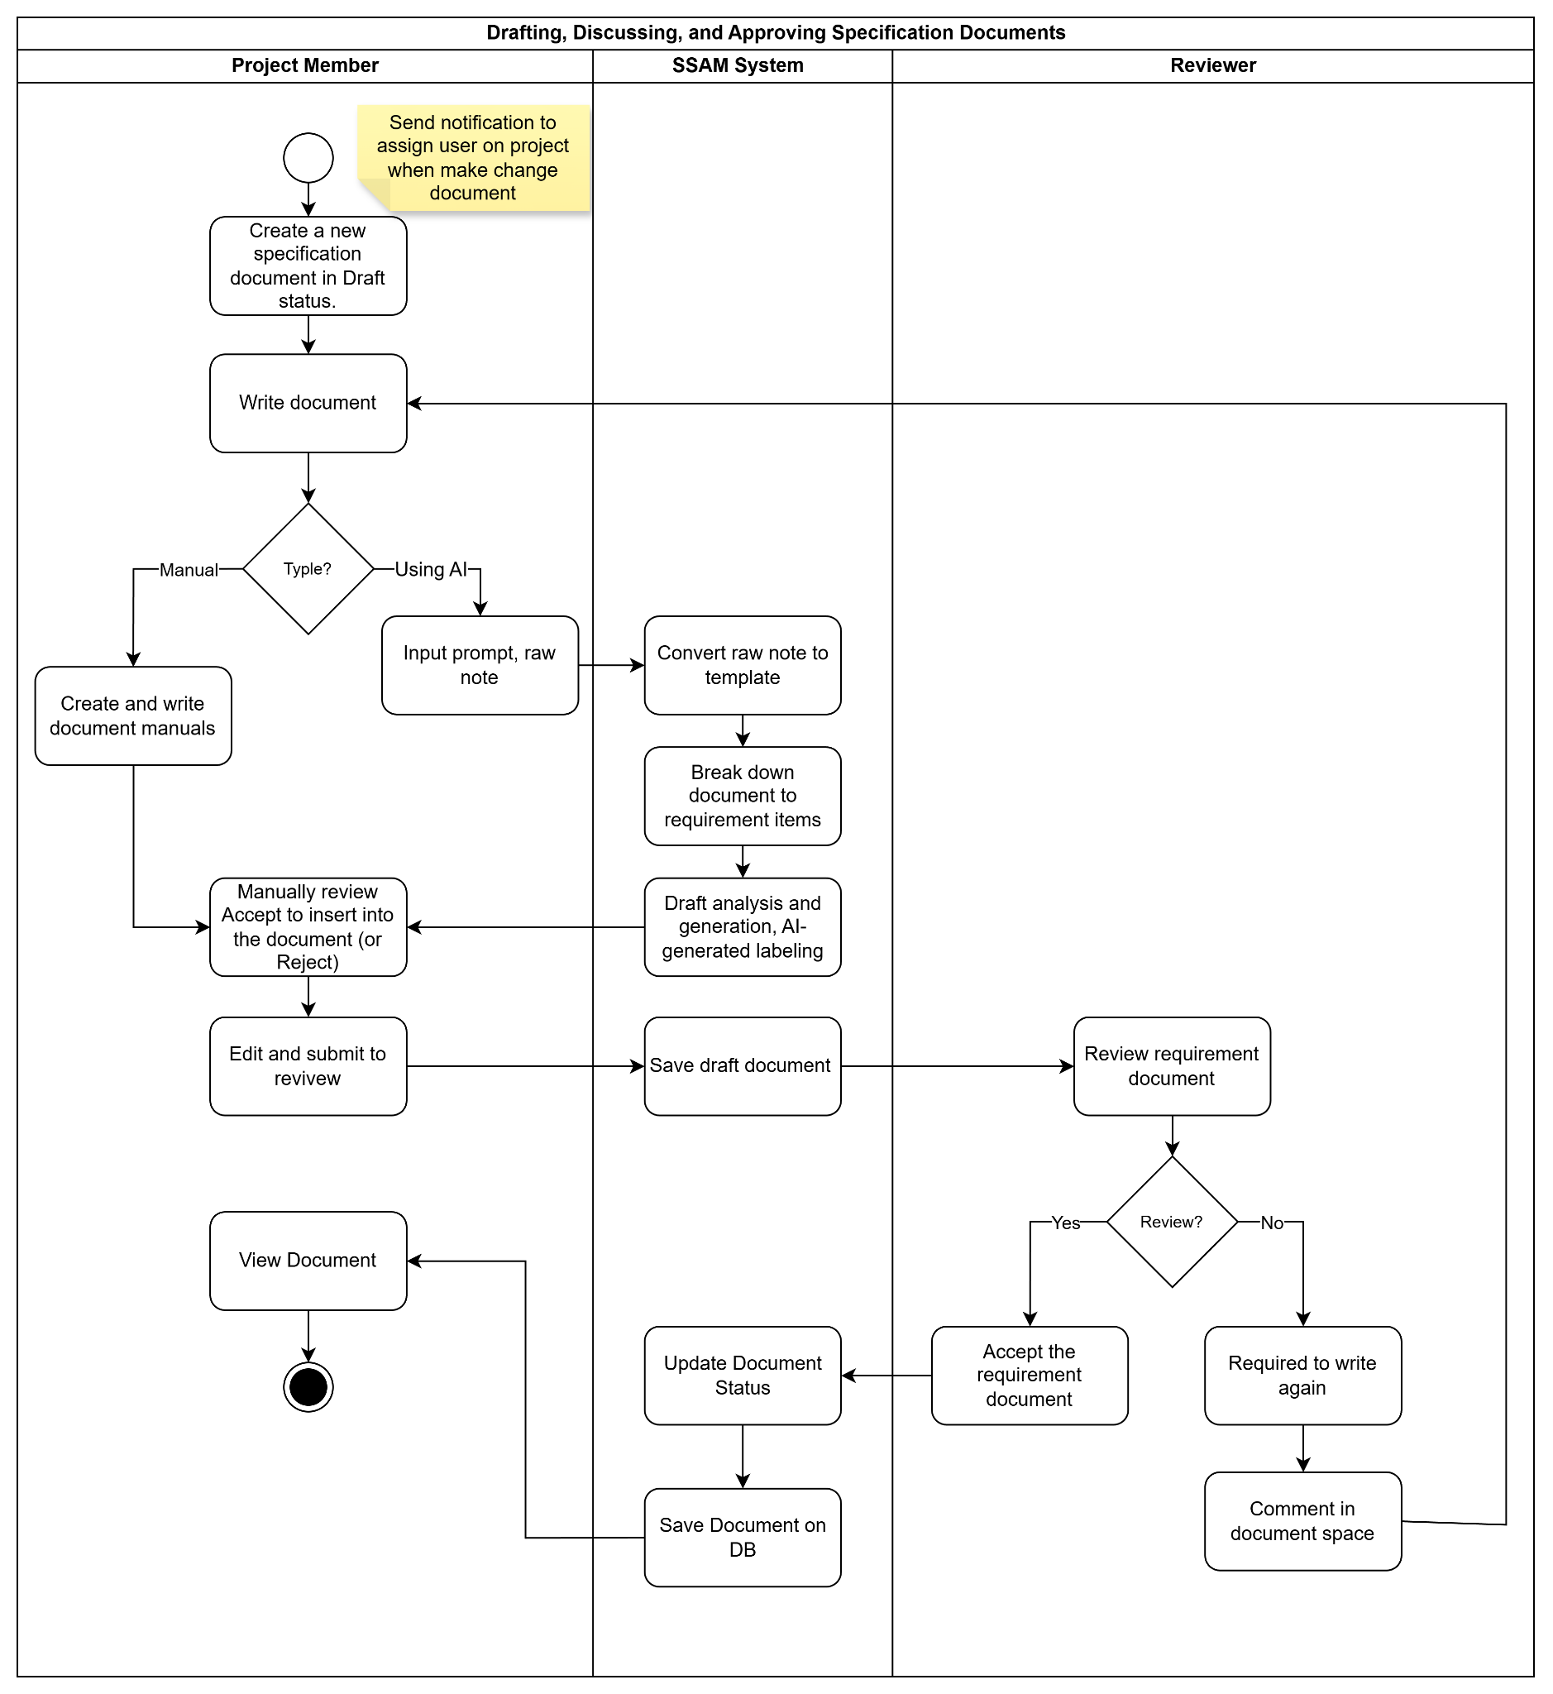
Figure 1.2.3: BF-03 – Drafting, Discussing, and Approving

2.4 Test Scenario Design (BF-04)
Trigger: A Project Member (Tester/QA) selects an APPROVED specification document and clicks "Generate Testcase".
End condition: The system validates whether the required specification inputs (URD/BRD/SRS fields) and interface designs (Figma UI) are complete. If any inputs are missing, the system alerts the Tester, who can either confirm generating draft test cases using the existing data or submit a request to the BA/Designer to supplement the missing fields or Figma UI links before regenerating. The generated test cases are automatically linked to their corresponding Requirement Items and UI designs, reviewed and approved by the Tester, and uploaded to the Requirements Traceability Matrix (RTM).
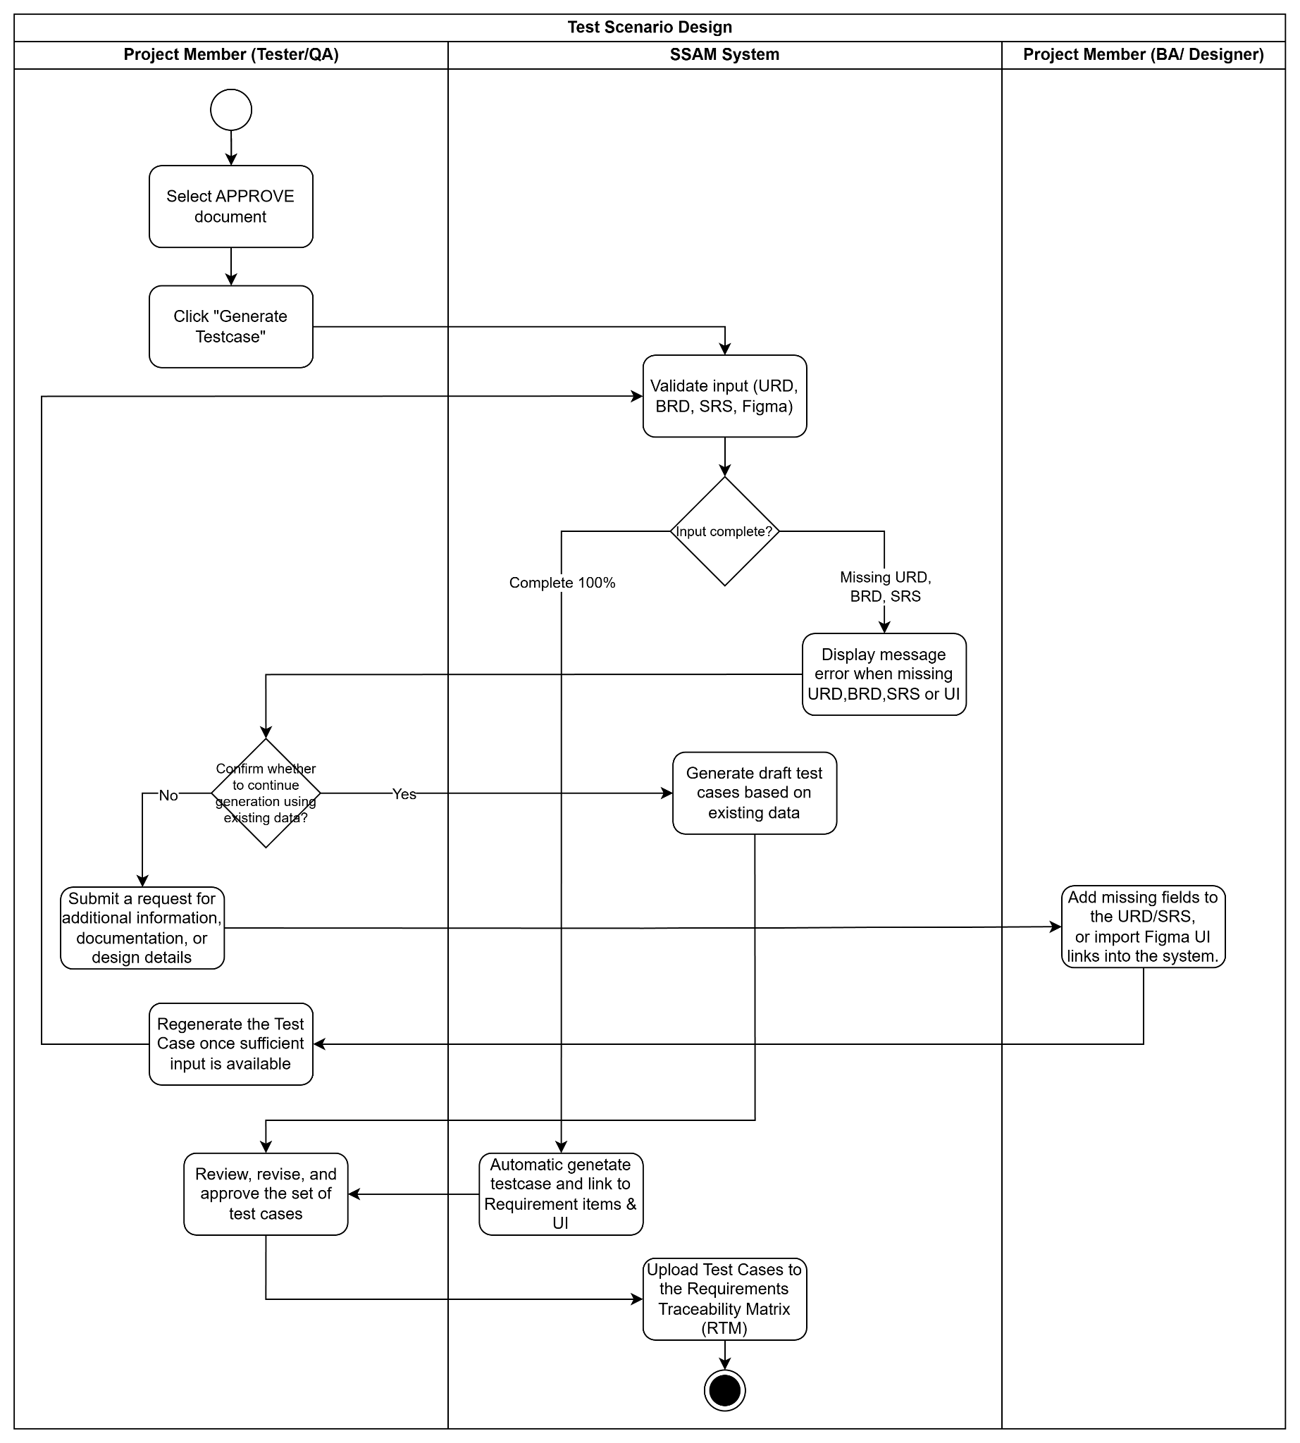
Figure 1.2.4: BF-04 – Test Scenario Design

2.5 Work Management, Assignment and Collaboration (BF-05
Trigger: A Project Member (Task/Issue Creator) creates a new Issue (Task/Bug), provides a detailed description, sets its priority, and assigns it to a team member.
End condition: The system generates a project-specific Issue ID (e.g., SSAM-101) and notifies the Assignee. The Issue is collaborated on via comments, reassigned if necessary via @newassignee, and transitioned across workflow statuses under role-based permission validation (GB-04) until the task is completed and the Issue is closed.
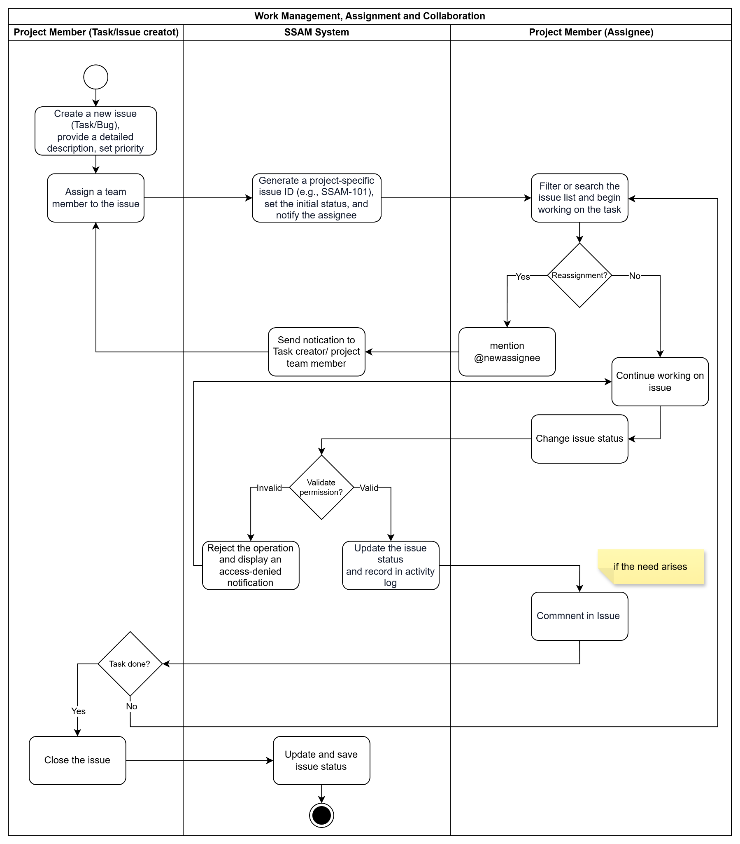
Figure 1.2.5: BF-05 – Work Management, Assignment, and Collaboration

2.6 Project Tracking, Advance Search and Filter (BF-06)
Trigger: A Project Member (Assigned User) accesses the Personal Dashboard to monitor work progress, or initiates a request to search and filter project artifacts (Issues, Documents) using manual advanced filters or the conversational AI Chatbot.
End condition: The user retrieves and opens the desired Issue or Document space. All search and inquiry results—whether obtained through manual filter conditions or analyzed by the AI Chatbot—are strictly validated and restricted by the system based on the user's contextual access permissions.
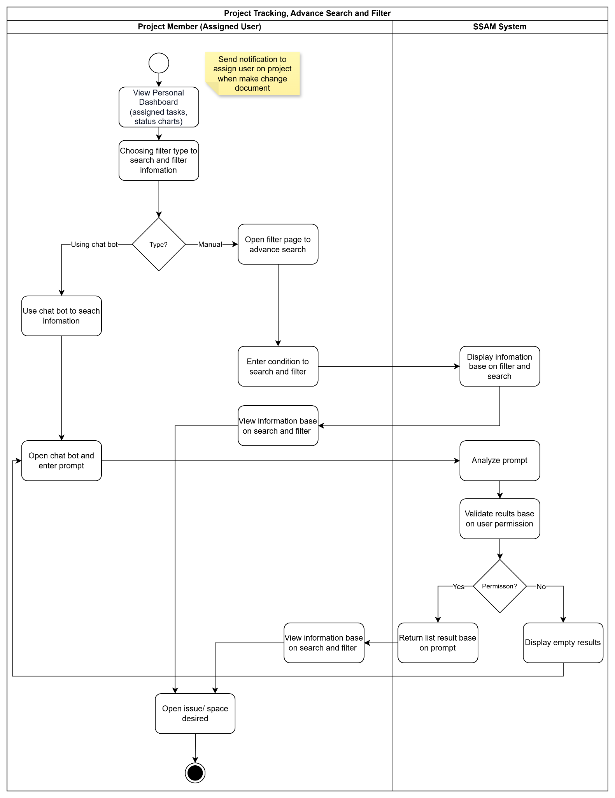
Figure 1.2.6: BF-06 – Project Tracking, Advanced Search, and Filter

2.7 Document Editing, History Retrieval, and Change Impact Handling Workflow (BF-07)
Trigger: A Project Member (BA) opens an existing specification document and edits the Content, Diagram, or linked UI of a Requirement Item.
End condition: The system records the modification in the Requirement History Log, verifies RTM links, and marks related Test Cases and Issues as "Unconfirmed Stale" while the update awaits review. If the Reviewer rejects the change, the draft is reverted and the RTM status returns to "Fresh". Once the Reviewer approves the change, a new Approved document version is issued and linked items are escalated to "Confirmed Stale". The Tester/QA inspects the before-and-af
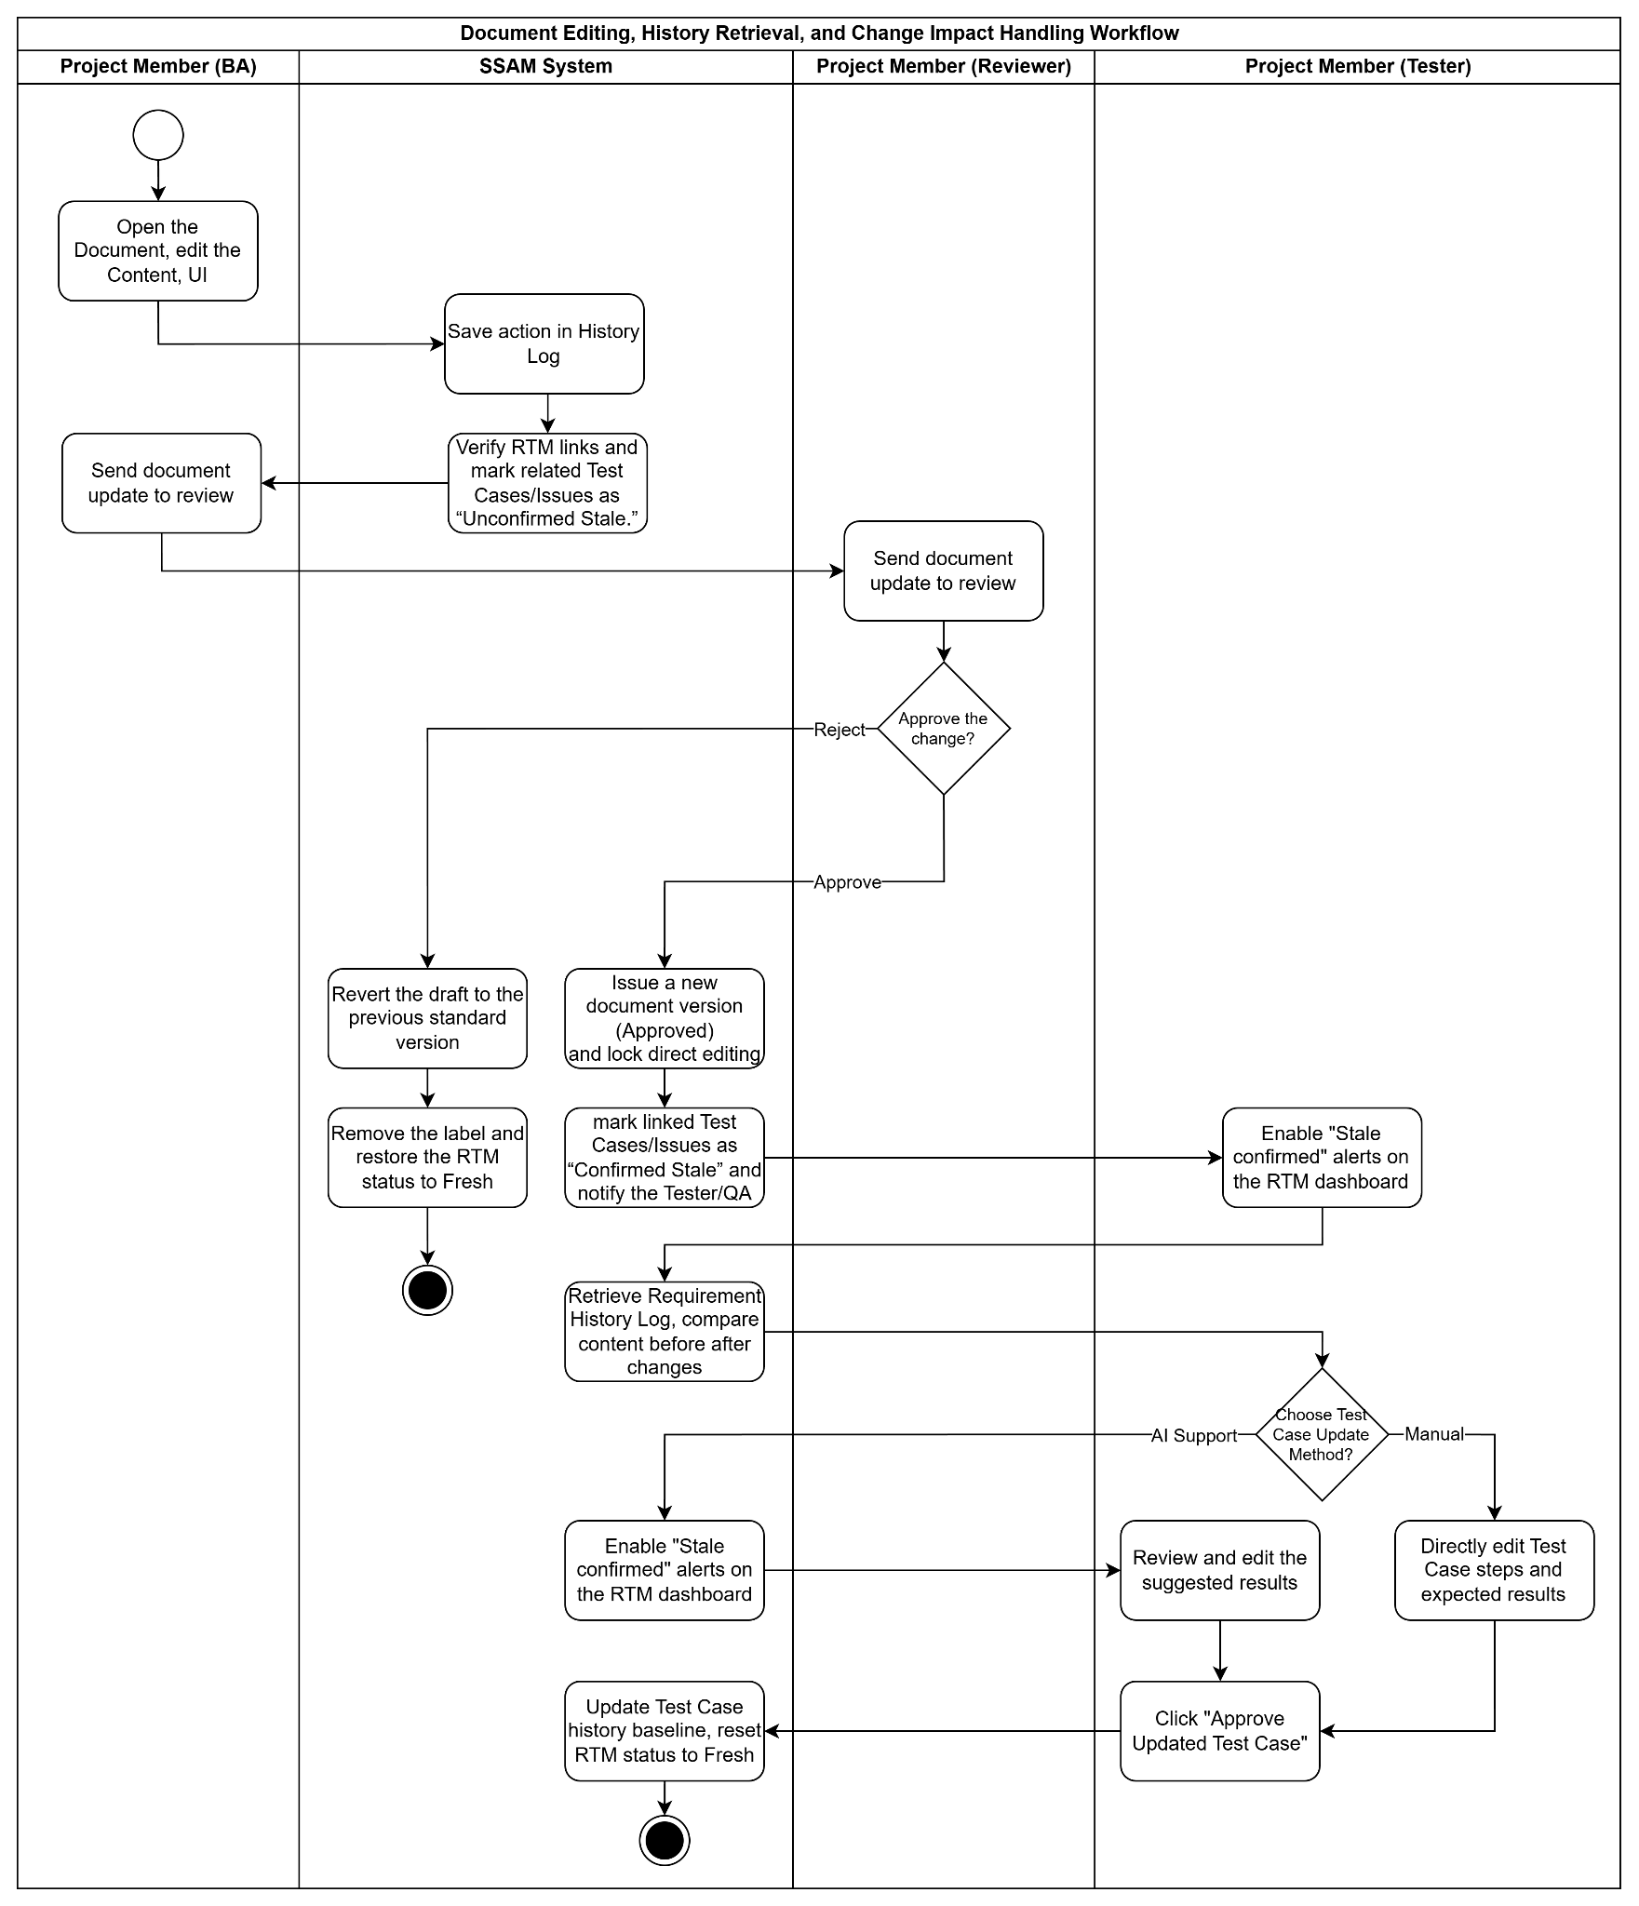
Figure 1.2.7: BF-07 – Document Editing, History Retrieval, and Change Impact Handling in RTM

3. Conceptual Data Model

3.1 Entity Relationship Diagram
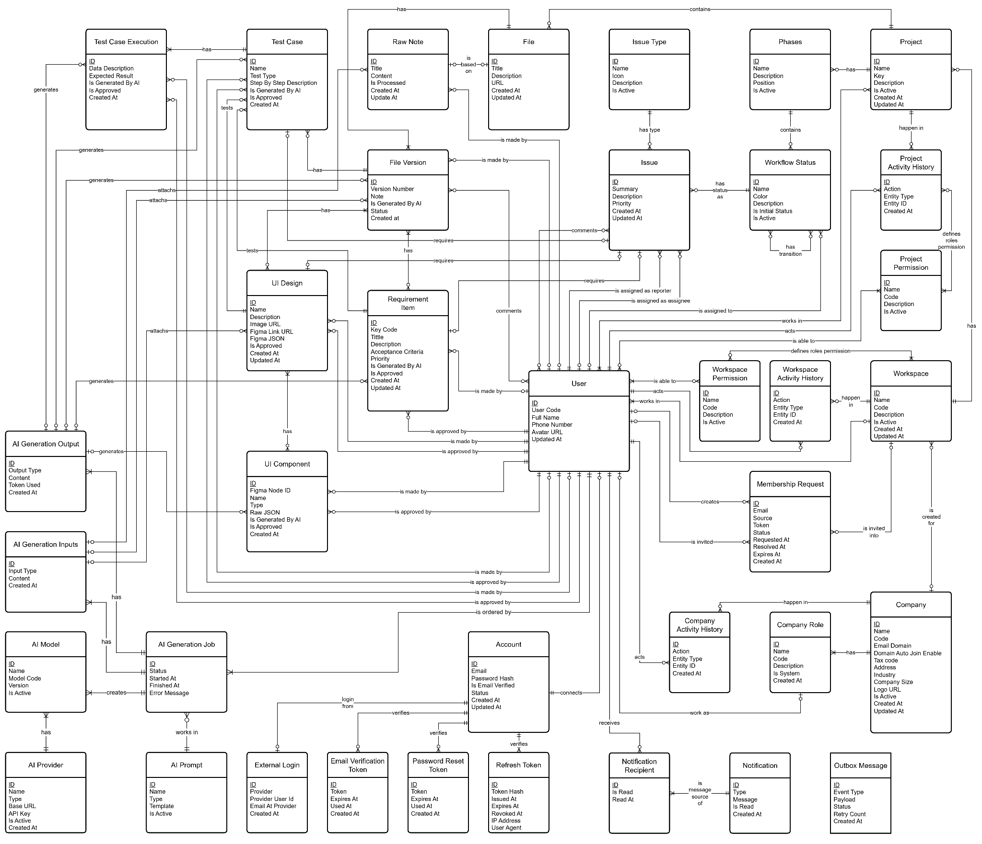
Figure 1.3.1: ERD Diagram
The Entity Relationship Diagram (ERD) below illustrates the conceptual data structure of the SSAM system using the Crow's Foot notation. The diagram focuses on four primary modules: Organizational Structure Management (Company/Workspace/Project), Dynamic Workflow Management (Phases/Workflow Status/Issue), Document & Traceability Management (Requirement Item/ UI Design/Test Case), and AI Integration (AI Model/Prompt/Generation).

3.2 Entity Descriptions
Entity: Account
Field | Value
Purpose | Represent each account in the system, containing login information.
Key business attributes | Email, Password Hash, Is Email Verified, Status.
Business identity | Email (via the linked Account entity) must be unique across the entire system.
Status / lifecycle | Active (normal) · Inactive (deactivated) · Locked (temporary — after repeated failed sign-in attempts)

Entity: User
Field | Value
Purpose | Contains user’s information of each account.
Key business attributes | User Code, Full Name, Phone Number, Avatar URL
Business identity | User Code must be unique across the entire system.

Entity: Company
Field | Value
Purpose | Represents an organization in the system, containing basic company’s information.
Key business attributes | Name, Code, Email Domain, Tax Code, Address, Industry, Company Size, Is Active
Business identity | Email Domain and Tax Code must be globally unique across the entire system.
Status / lifecycle | Active (normal) · Inactive (suspended by System Admin).

Entity: Workspace
Field | Value
Purpose | Represents an isolated workspace for an organization or individual, containing all projects and members belonging to that organization.
Key business attributes | Name, Code, Description, Is Active
Business identity | The Workspace Code must be globally unique across the entire SSAM system.
Status / lifecycle | Active (normal) · Inactive (suspended by Tenant Admin). Never permanently deleted.

Entity: Project
Field | Value
Purpose | The highest-level management framework for a software development lifecycle, containing Phases, Documents, and Issues.
Key business attributes | Name, Key, Description, Is Active
Business identity | The Project Key must be unique within a Workspace (e.g., "SSAM"). This key serves as the prefix for generating Issue IDs.
Status / lifecycle | Active → Inactive (Closed/Archived)

Entities: Issue
Field | Value
Purpose | A specific unit of work (Task/Bug) to be executed, tracked, and managed within a Project.
Key business attributes | Summary, Description, Priority, Story Points
Business identity | The Issue ID is generated by concatenating the Project Key and an auto-incrementing number (e.g., SSAM-101).
Status / lifecycle | Transitions through dynamic statuses (Workflow Status) configured by the Project Owner (e.g., To Do → In Progress → Done).

Entities: File
Field | Value
Purpose | The comprehensive software file, including requirement specification document (URD/SRS) and testing document, which can be generated by AI based on Raw Notes and other file documents.
Key business attributes | Title, Description, URL
Business identity | Each project can have multiple Requirement Documents, distinguished by a unique system ID.
Status / lifecycle | Draft → In Review → Approved → Archived (Managed via the Requirement Version entity)

Entities: Requirement Item
Field | Value
Purpose | A specific functional block or atomic requirement extracted from the Requirement Document to facilitate Traceability.
Key business attributes | Key Code, Title, Description, Acceptance Criteria, Priority
Business identity | The Key Code is unique within the scope of a single Project.
Status / lifecycle | Active → Obsolete

Entities: UI Design
Field | Value
Purpose | Contains mockup of a screen designed in Figma, containing its data and previews.
Key business attributes | Name, Description, Image URL, Figma Link URL, Figma JSON, Is Approved
Business identity | Unique system ID.
Status / lifecycle | Active → Obsolete

Entities: Test Case
Field | Value
Purpose | A testing scenario used to verify if a Requirement Item is successfully implemented. Can be automatically generated by AI.
Key business attributes | Title, Description, Is AI Generated
Business identity | Unique system ID. Must always be linked to at least one Requirement Item and one UI Design (via the "tests" mapping).
Status / lifecycle | Draft → Approved → Obsolete

3.3 Data Business Rules
Rule | Description | Enforced On
Project Key uniqueness | The Project Key must not be duplicated within the same Workspace to ensure Issue ID generation does not conflict. | Project creation and key update
Dynamic issue transition | An Issue's state (Workflow Status) must strictly belong to the list of statuses configured for its corresponding Phase within that project. | Issue status update
Traceability integrity | A Test Case cannot exist in isolation; it must be mapped to at least one Requirement Item to ensure end-to-end traceability. | Test Case creation and update
Audit trail immutability | All data within Workspace Audit Log and Company Audit Log entities are append-only. They cannot be modified or removed under any circumstances. | All system and data actions
Contextual member access | A User can only interact with Issues or Documents if they possess a valid Project Member record mapped with specific Project Permissions within that project. | Data access and interaction at the Project level
AI generation read-only | AI-generated results (AI Generation Output) are stored immutably for reference. Users can create a new Requirement Document version from this output but cannot directly overwrite the generation history. | AI Copilot execution
Logical deletion only | Core entities (User, Project, Workspace) are never physically deleted from the database to maintain data integrity. They are only soft-deleted (Is Active = False). | Workspace, Project, and User deletion
Evaluations are permanent | Once an Interviewer submits rating and feedback, neither can be changed by anyone. | Evaluation submission
CV files are access-controlled | CV files must never be accessible via a guessable or publicly shareable link. Access verified by system on every download. | CV file access

4. User Requirements

4.1 Actors
In the architecture of the SSAM system—designed following a multi-tier Contextual Role-Based Access Control (RBAC) model across Organization, Workspace, and Project scopes—human actors are not rigidly bound to static job titles. Instead, actors are categorized based on their administrative levels and the specific permission capabilities granted to them at the time of interaction. Additionally, the system interacts with non-human external services.
No | Actor | Description
1 | External Guest (Guest) | Represents an unauthenticated visitor accessing the public gateway of the platform. This actor can view product introductions on the Landing Page, register a new Personal or Corporate account, verify account ownership via email, sign in using internal credentials or Google SSO, and recover forgotten passwords.
2 | System Admin | Represents the platform-level super administrator responsible for monitoring overall server resource health, managing the status of subscribing organizations across the platform, and configuring system-level authentication and external service credentials.
3 | Tenant Admin | Represents the organization-level administrator of a subscribing company. This actor manages the company's legal profile, oversees the internal user directory by inviting or deactivating employee accounts, defines organizational roles and permission matrices, initializes departmental Workspaces, grants workspace or project creation capabilities, and retrieves company-wide audit logs.
4 | Project Initiator | Represents authorized users granted workspace governance or project creation and management capabilities, such as Workspace Admins, Project Managers, Product Owners, or Scrum Masters. This actor is responsible for creating Projects, configuring two-tier dynamic workflows including project phases, task statuses, and role-based transition rules, managing project members and permissions, and reviewing and approving specification documents as official baselines.
5 | Project Member (Assigned User) | Represents operational team members invited to participate in a specific project who perform actions strictly governed by their assigned project-level permissions:  Business Analyst (BA) & Designer: Initializes specification documents, converts raw business notes into structured requirement items containing text content and process diagrams, updates requirement details, and imports or synchronizes Figma UI design links.  Reviewer: Inspects specification drafts and requirement modifications, leaves inline feedback comments, and approves or rejects document changes when granted review permissions.  Tester / QA: Validates input completeness, generates or manually designs test cases, approves and publishes test cases to the Requirements Traceability Matrix, and inspects the Requirement History Log to resolve unconfirmed or confirmed stale warnings.  Developer (Task/Issue Creator & Assignee): Creates, assigns, collaborates on via mentions and comments, and transitions tasks and bugs across Kanban workflow stages until completion.
6 | AI Provider | An External System actor, such as Anthropic Claude or OpenAI GPT services. The SSAM system sends normalized business notes, requirement contexts, or user inquiries to this actor, which returns structured draft requirement items, diagram scripts, draft or updated test cases, and source-cited conversational answers.
7 | Design System | An External System actor represented by the Figma platform. This actor exposes APIs that provide user interface screen structures, frames, and component data to the SSAM system, enabling cross-verification between specification requirements and interface designs for test case generation.
8 | Notification & Identity Gateway | External System actors comprising the SMTP Email Server and Google Identity services. These services authenticate Google single sign-on requests and dispatch account activation emails, password recovery links, project invitations, and real-time system notifications to users' personal inboxes.

4.2 Use Cases (UC)
ID | Use Case Name | Functional Module | Brief Description
UC-01 | View Landing Page | Home and Access | Access the product landing page and proceed to the system’s getting-started screen.
UC-02 | Navigate to the System | Home and Access | Check the current login status and direct the user to the appropriate workspace screen.
UC-03 | Register a Personal Account | User Authentication | Create a personal account and confirm its activation via email.
UC-04 | Register a Business Account | User Authentication | Register an organization in the system and grant administrator privileges to the registrant.
UC-05 | Log In with an Internal Account | User Authentication | Verify the username and password to access the main dashboard.
UC-06 | Log In with Google | User Authentication | Quickly sign in to the system using a linked Google account.
UC-07 | Log Out | User Authentication | Safely end the user’s current session.
UC-08 | Reset Password | User Authentication | Receive an email link to set a new password if the current password is forgotten.
UC-09 | Create an Employee Account Manually | Organization Administration | Create an individual employee account and send an invitation to join the system.
UC-10 | Bulk Import Employees | Organization Administration | Upload an employee list from a spreadsheet to send invitations in bulk.
UC-11 | Create a New Role | Organization Administration | Define job titles and roles to categorize employees within the company.
UC-12 | View Role List | Organization Administration | View all job roles configured for the organization.
UC-13 | Update Role Information | Organization Administration | Edit the names and descriptions of existing roles.
UC-14 | Change Account or Role Status | Organization Administration | Enable or disable the status of a role or employee account.
UC-15 | Assign Members to the Organization | Organization Administration | Add new employees to the company’s official member list.
UC-16 | View Personal Profile | Organization Administration | View a user’s contact information and personal profile details.
UC-17 | View Business Profile | Organization Administration | View the company’s general and legal information.
UC-18 | Update Business Profile | Organization Administration | Edit the company’s legal information, address, and branding images.
UC-19 | Deactivate an Employee Account | Organization Administration | Block access for departing employees and notify relevant parties that their assigned tasks need to be reassigned.
UC-20 | Update Personal Profile | Organization Administration | Edit personal information and change the login password.
UC-21 | Create a Workspace | Workspace Management | Create a separate workspace for a department or team.
UC-22 | View Workspace Information | Workspace Management | View general information about a specific workspace.
UC-23 | Update Workspace | Workspace Management | Edit the workspace name, description, and general settings.
UC-24 | Change Workspace Status | Workspace Management | Archive a workspace and switch all its data to read-only mode.
UC-25 | View Workspace Members | Workspace Management | View the list of all members participating in the workspace.
UC-26 | Add Members to a Workspace | Workspace Management | Invite and add new members to collaborate in the workspace.
UC-27 | Remove a Member from a Workspace | Workspace Management | Revoke a member’s workspace access while retaining their work history.
UC-28 | View Workspace Permissions | Workspace Management | View the list of permissions configured for the workspace.
UC-29 | Create Workspace Permissions | Workspace Management | Set up a new group of access permissions within the workspace.
UC-30 | Update Workspace Permissions | Workspace Management | Edit the details of permissions configured for the workspace.
UC-31 | Change Workspace Permission Status | Workspace Management | Enable or disable a permission group within the workspace.
UC-32 | Assign Workspace Permissions to Roles | Workspace Management | Apply a workspace permission group to specific roles.
UC-33 | Create a New Project | Project Management | Create a new project and assign it a unique identifier.
UC-34 | View Project List | Project Management | View the list and overall progress of managed projects.
UC-35 | Update Project Information | Project Management | Edit general project information and configure the use of AI features for the project.
UC-36 | Change Project Status | Project Management | Pause, archive, or reopen a project.
UC-37 | Create Project Permissions | Project Management | Set up an access-permission configuration specifically for a project.
UC-38 | Update Project Permissions | Project Management | Adjust the details of permissions for actions within the project.
UC-39 | Change Project Permission Status | Project Management | Enable or disable permission settings at the project level.
UC-40 | Assign Project Permissions to Roles | Project Management | Assign project-level action permissions to each participating role.
UC-41 | View Project Members | Project Management | View the list of employees directly involved in the project.
UC-42 | Add Members to a Project | Project Management | Invite employees to the project and assign an appropriate role to each member.
UC-43 | Remove a Member from a Project | Project Management | Revoke a member’s access to the project when they are no longer involved.
UC-44 | Create a Project Phase | Dynamic Workflow Management | Create phases to manage each stage of the project’s development.
UC-45 | Update a Project Phase | Dynamic Workflow Management | Edit a project phase’s name, order, and description.
UC-46 | Change Phase Status | Dynamic Workflow Management | Enable or disable the use of a project phase.
UC-47 | Assign a Workflow to a Phase | Dynamic Workflow Management | Apply a work-status workflow template to a specific phase.
UC-48 | Create Workflow Statuses | Dynamic Workflow Management | Create work-processing status steps within a project phase.
UC-49 | Update Statuses and Transitions | Dynamic Workflow Management | Edit workflow statuses and define rules for transitioning between work statuses.
UC-50 | Change Workflow Status | Dynamic Workflow Management | Enable or disable a configured workflow.
UC-51 | Create a Specification Document Set | Document Management | Create a new requirements specification document set in draft status within a project.
UC-52 | View a Specification Document Set | Document Management | View the document outline, requirement-section content, and diagrams.
UC-53 | Edit Requirement Sections and Diagrams | Document Management | Draft requirement sections with headings, text content, and diagram images.
UC-54 | Delete a Specification Document | Document Management | Delete a document and display a warning if it is linked to any test cases.
UC-55 | View a Document in Safe Mode | Document Management | View a document in read-only mode and prevent editing once it has been approved.
UC-56 | Manage Versions and Change History | Document Management | Save document versions and view content before and after each edit.
UC-57 | Export a Document File | Document Management | Download the specification document set, including diagram images and version information, to a computer.
UC-58 | Comment on a Requirement Section | Document Management | Add review comments and discuss individual requirement sections.
UC-59 | View Document Comments | Document Management | Track the full history of comments and replies on a document set.
UC-60 | Approve a Specification Document Set | Document Management | Approve and finalize the baseline document version for development and testing.
UC-61 | Create a New Task | Task Management | Create a task or bug report and assign it to a responsible team member.
UC-62 | View Task Details | Task Management | View the task description, priority, and current status.
UC-63 | Update Task Information | Task Management | Edit the task description and priority, and retain a history of changes.
UC-64 | Delete a Task | Task Management | Delete a task and display a warning if it is linked to other data.
UC-65 | Change Task Status | Task Management | Update task progress through workflow statuses according to assigned permissions.
UC-66 | Reassign a Task | Task Management | Transfer responsibility for a task to another member and automatically send a notification.
UC-67 | Comment on a Task | Task Management | Discuss the task and mention other members directly within it.
UC-68 | Link a Task to a Requirement | Task Management | Directly link a task to the corresponding requirement in the specification document set.
UC-69 | View the Task Board | Task Management | Visually track all project tasks across status columns.
UC-70 | Advanced Task Search | Task Management | Search and filter tasks using multiple combined criteria.
UC-71 | View Filtered Task List | Task Management | View tasks that match the applied filter criteria.
UC-72 | Standardize Input Business Notes | AI-Assisted Specification | Enter initial meeting notes and convert them into a standardized structure for analysis.
UC-73 | Generate Draft Requirement Sections with AI | AI-Assisted Specification | Use AI to turn notes into draft requirement sections with content and illustrative diagrams.
UC-74 | Review AI-Generated Content | AI-Assisted Specification | Review and edit AI-generated drafts, accept them into the document, or reject them.
UC-75 | Sync Figma UI Designs | AI-Assisted Specification | Provide a Figma design link to retrieve screen information and associate it with the relevant requirement.
UC-76 | Validate Inputs and Generate Test Cases | AI-Assisted Testing | Check the completeness of the document and UI, flag missing information, and automatically generate test cases.
UC-77 | Update Test Cases with AI | AI-Assisted Testing | Use AI to suggest revised test steps based on changes recorded in the requirement history.
UC-78 | Approve AI-Generated Test Cases | AI-Assisted Testing | Review, edit, and approve the set of test cases suggested by AI.
UC-79 | Create Test Cases Manually | AI-Assisted Testing | Write new test cases manually and link each one to a requirement in the document.
UC-80 | Update Test Cases | AI-Assisted Testing | Directly edit test steps and expected results.
UC-81 | Change Test Case Status | AI-Assisted Testing | Set a test case’s status to approved or discontinued.
UC-82 | Comment on a Test Case | AI-Assisted Testing | Discuss and add internal notes directly to an individual test case.
UC-83 | Flag Outdated Items When Requirements Change | Traceability | Automatically mark an item as awaiting confirmation while a requirement is being edited as a draft, then mark it as confirmed once the requirement is approved.
UC-84 | Manage the Traceability Matrix | Traceability | Add approved test cases to the traceability matrix, manage links, and update synchronization statuses.
UC-85 | Search Across the System | Search and Filtering | Quickly search for tasks, documents, and comments in projects the user is authorized to access.
UC-86 | Filter the Task List | Search and Filtering | Quickly retrieve tasks by status, assignee, or priority.
UC-87 | Filter the Document List | Search and Filtering | Quickly retrieve document sets by approval status and version.
UC-88 | Receive In-App Notifications | Notifications | Receive task reminders and document-change alerts within the system interface.
UC-89 | Configure Notification Preferences | Notifications | Enable or disable in-app or email notifications for specific events.
UC-90 | View Personal Dashboard | Dashboard and Reporting | View an overview of assigned task progress and status charts immediately after logging in.
UC-91 | View Project Activity History | Dashboard and Reporting | Track the history of actions performed in the project, including creation, editing, and status changes.
UC-92 | View Workspace Overview | Dashboard and Reporting | View summary reports on the number of projects and overall task progress within the workspace.
UC-93 | View and Export Audit Logs | Audit and Administration | Search and download company-wide activity reports for security auditing.
UC-94 | Administer the System Platform | Audit and Administration | Monitor server status, manage the organization list, and configure external service integrations.
UC-95 | Ask the AI Virtual Assistant | AI Virtual Assistant | Ask questions in natural language to quickly retrieve project information within the user’s access permissions.

4.3 Use Case Diagrams

4.3.1 UCs for Authentication & Onboarding
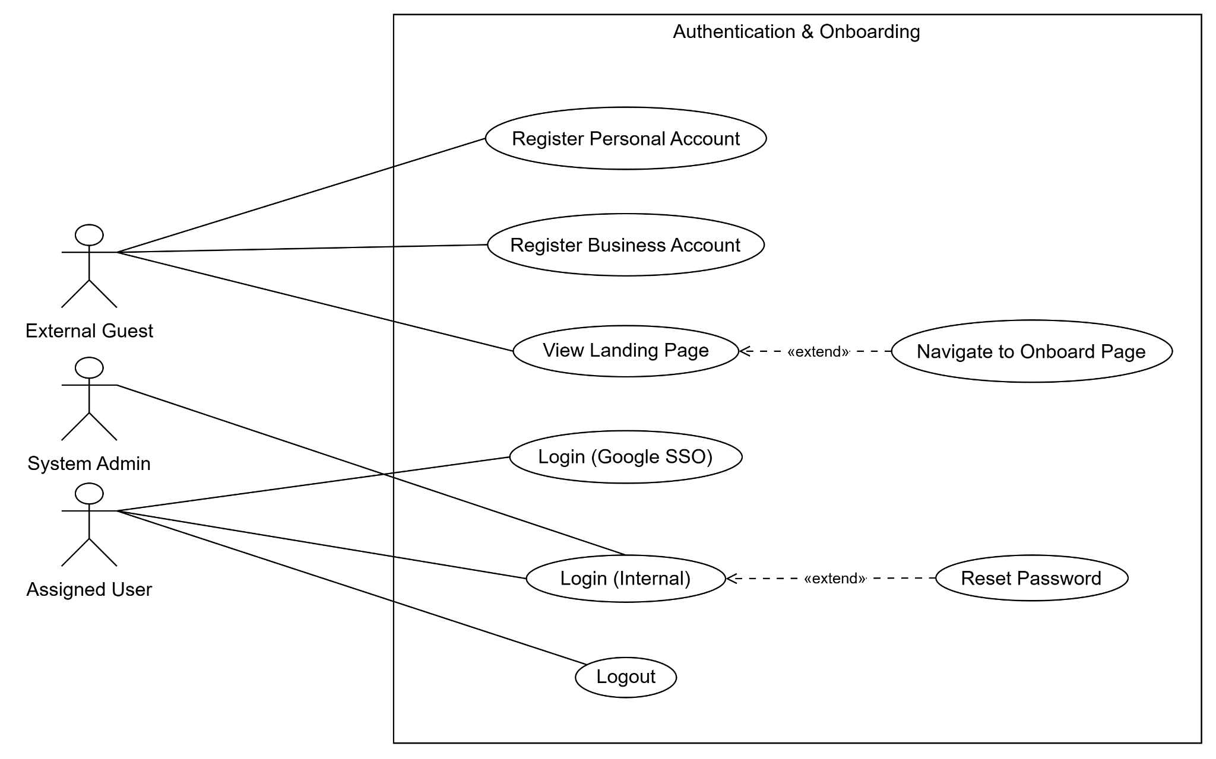Figure 1.4.3.1: Usecase diagram for authentication

4.3.2 UCs for Organization & Workspace
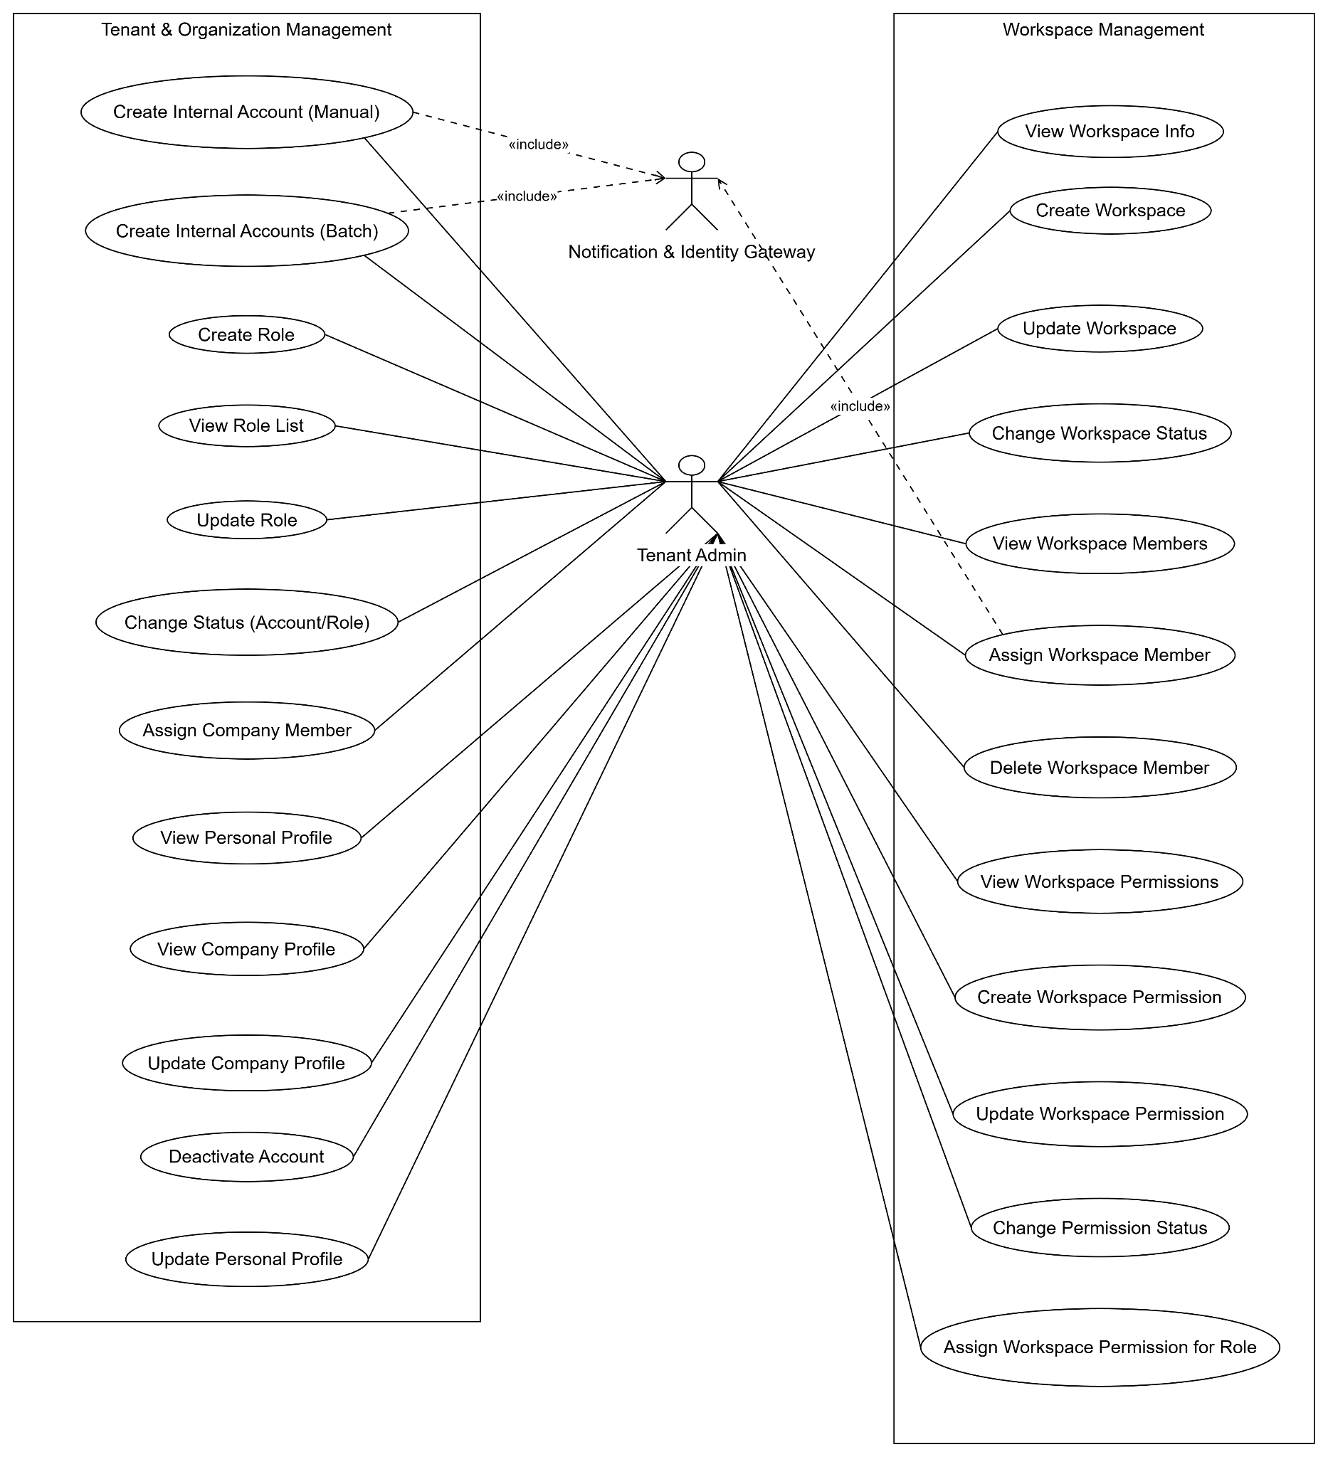Figure 1.4.3.2: Usecase for Org & Workspace

4.3.3 UCs for Project & Dynamic Workflow
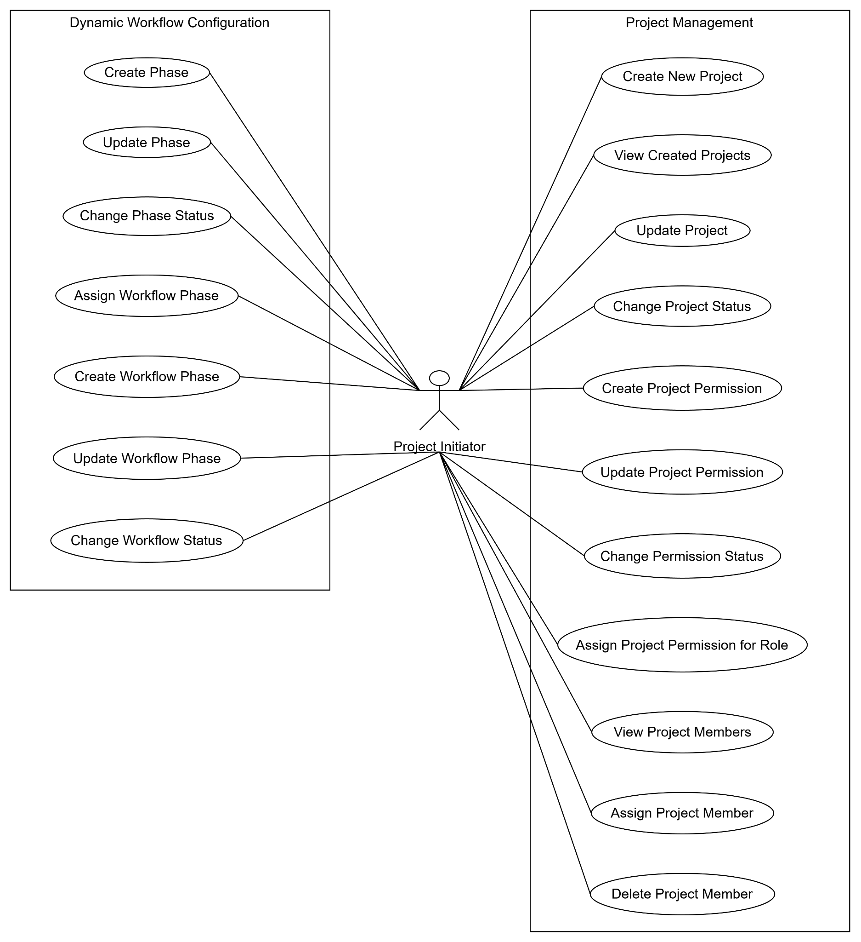Figure 1.4.3.3: Usecase for Project

4.3.4 UCs for Document & Issue Tracking
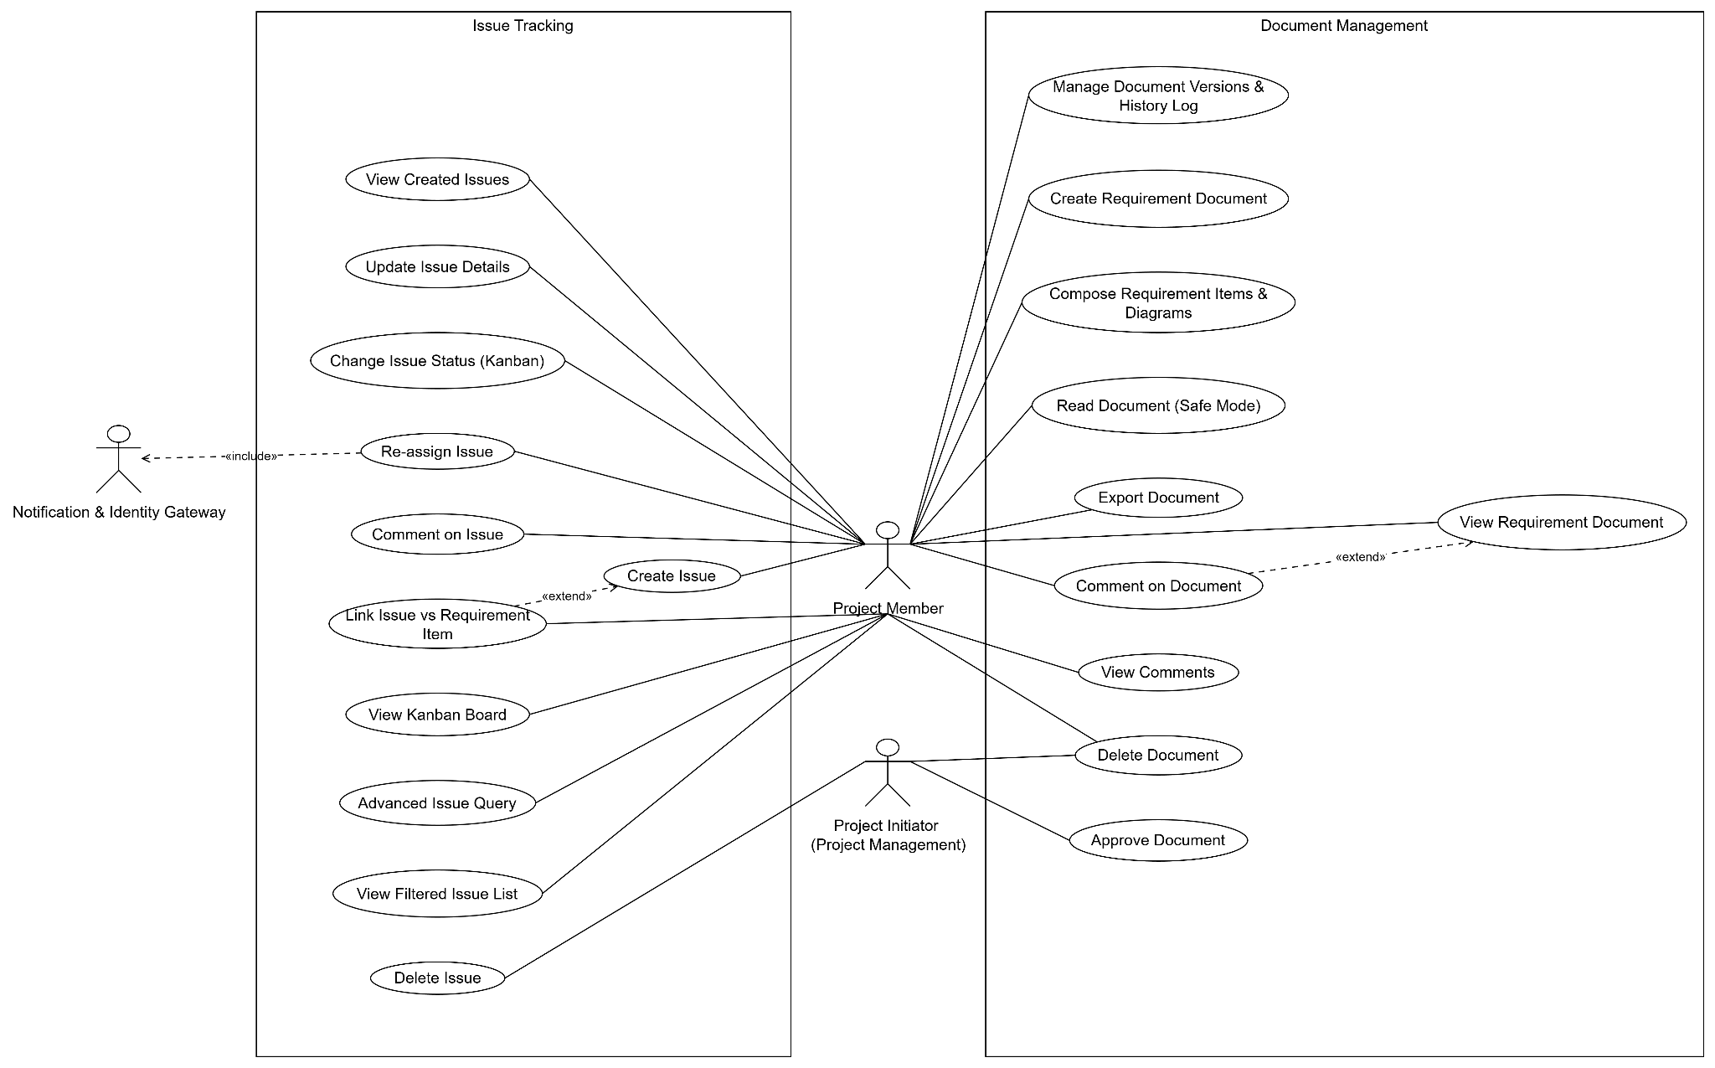
Figure 1.4.3.4: Usecase for Document & Issue tracking

4.3.5 UCs for AI Ecosystem & Traceability
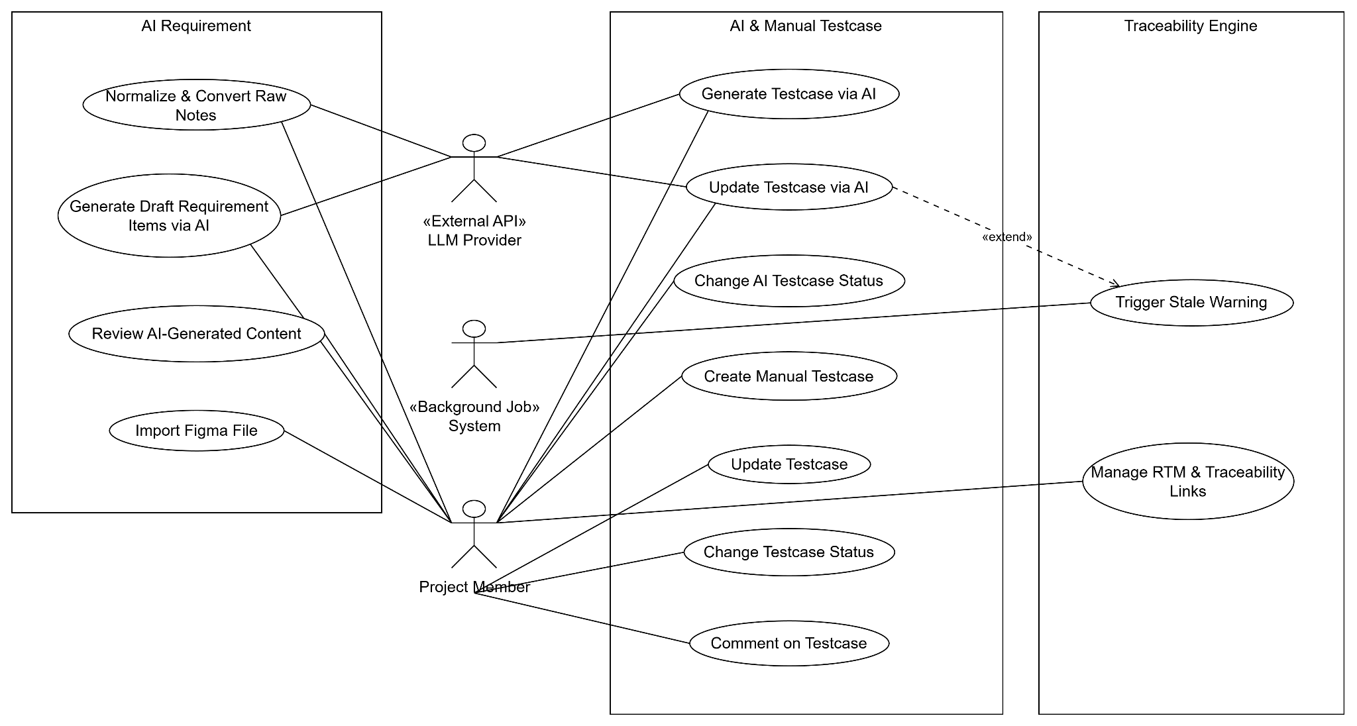Figure 1.4.3.5: Usecase for AI & Traceability

4.3.6 UCs for System Utility
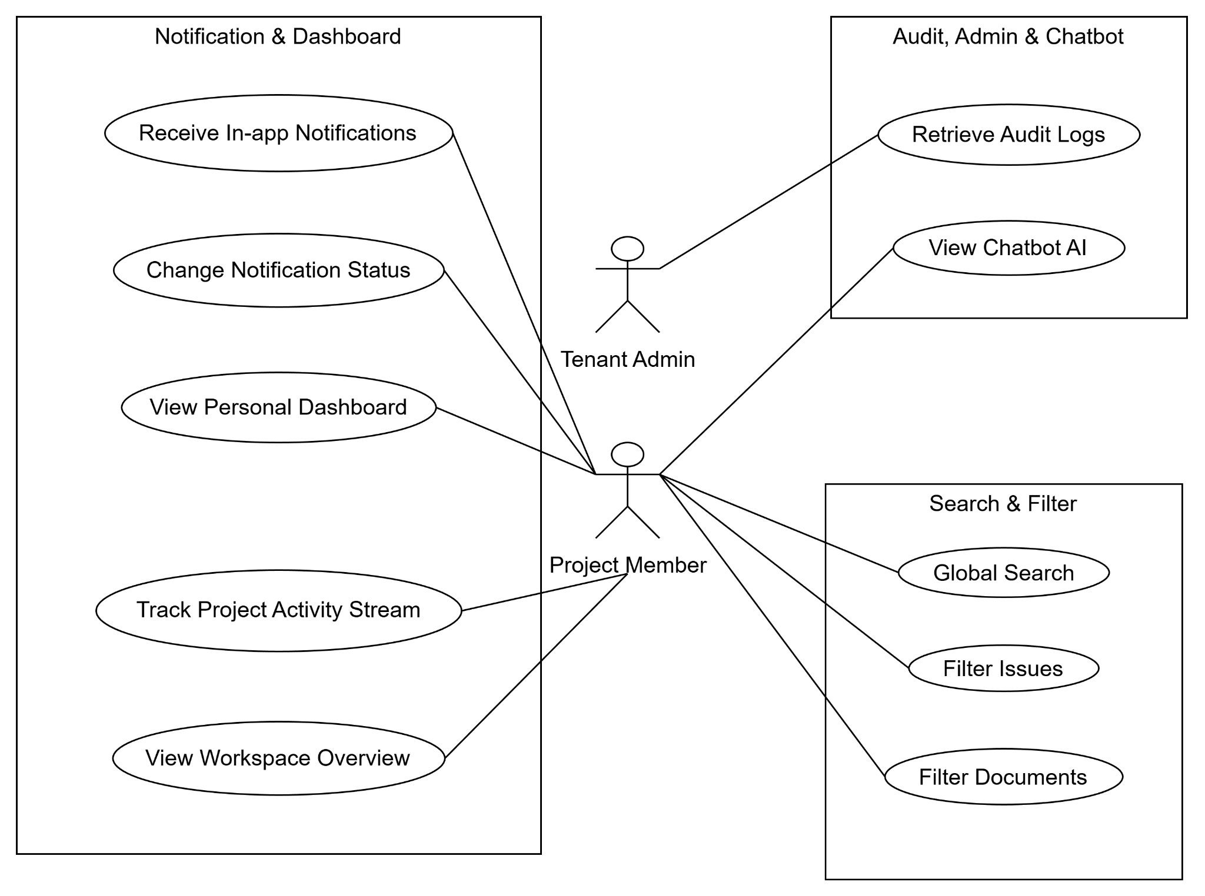
Figure 1.4.3.6: Usecase for System

4.4 Permission Matrix
Legend: Full = unrestricted, Restricted = conditions apply (see footnotes), No = denied
Entity | Action | Tenant Admin | Workspace Admin | Project Manager | BA / Designer | Developer | Tester / QA | Guest
User account | Self-register / Reset password | No | No | No | No | No | No | Full
User account | Create / Invite (Manual & Batch) | Full | No | No | No | No | No | No
User account | Update personal profile | Restricted ¹ | Restricted ¹ | Restricted ¹ | Restricted ¹ | Restricted ¹ | Restricted ¹ | No
User account | Deactivate / Unlock account | Full | No | No | No | No | No | No
Organization & Role | View company profile & directory | Full | Restricted ² | Restricted ² | Restricted ² | Restricted ² | Restricted ² | No
Organization & Role | Update company legal settings | Full | No | No | No | No | No | No
Organization & Role | Manage global roles & permissions | Full | No | No | No | No | No | No
Workspace | Create workspace | Full | No | No | No | No | No | No
Workspace | View workspace overview & members | Full | Restricted ³ | Restricted ⁴ | Restricted ⁴ | Restricted ⁴ | Restricted ⁴ | No
Workspace | Edit workspace settings | Full | Restricted ³ | No | No | No | No | No
Workspace | Manage workspace members & roles | Full | Restricted ³ | No | No | No | No | No
Workspace | Archive workspace (Read-only) | Full | Restricted ³ | No | No | No | No | No
Project | Create project in workspace | No | Restricted ³ | Restricted ³ | No | No | No | No
Project | View project overview & activity | No | Restricted ³ | Restricted ⁵ | Restricted ⁶ | Restricted ⁶ | Restricted ⁶ | No
Project | Edit settings & Toggle AI module | No | No | Restricted ⁵ | No | No | No | No
Project | Manage project members & roles | No | No | Restricted ⁵ | No | No | No | No
Project | Archive project | No | Restricted ³ | Restricted ⁵ | No | No | No | No
Dynamic workflow | View phases & workflow statuses | No | Restricted ³ | Restricted ⁵ | Restricted ⁶ | Restricted ⁶ | Restricted ⁶ | No
Dynamic workflow | Create / Edit phases & statuses | No | No | Restricted ⁵ | No | No | No | No
Dynamic workflow | Configure status transition rules | No | No | Restricted ⁵ | No | No | No | No
Specification document | View document & history log | No | Restricted ³ | Restricted ⁵ | Restricted ⁶ | Restricted ⁶ | Restricted ⁶ | No
Specification document | Create / Compose items & diagrams | No | No | No | Restricted ⁷ | No | No | No
Specification document | Approve / Reject baseline | No | No | Restricted ⁵ | No | No | No | No
Specification document | Create new revision / Export file | No | No | Restricted ⁵ | Restricted ⁶ | No | No | No
Specification document | Delete document | No | No | Restricted ⁸ | No | No | No | No
UI design (Figma) | View synced UI designs | No | Restricted ³ | Restricted ⁵ | Restricted ⁶ | Restricted ⁶ | Restricted ⁶ | No
UI design (Figma) | Import / Update / Archive Figma link | No | No | No | Restricted ⁶ | No | No | No
Issue (Task / Bug) | View issues & Kanban board | No | Restricted ³ | Restricted ⁵ | Restricted ⁶ | Restricted ⁶ | Restricted ⁶ | No
Issue (Task / Bug) | Create / Edit / Link requirement | No | No | Restricted ⁵ | Restricted ⁶ | Restricted ⁶ | Restricted ⁶ | No
Issue (Task / Bug) | Assign / Re-assign issue | No | No | Restricted ⁵ | Restricted ⁶ | Restricted ⁶ | Restricted ⁶ | No
Issue (Task / Bug) | Change status (Kanban transition) | No | No | Restricted ⁹ | Restricted ⁹ | Restricted ⁹ | Restricted ⁹ | No
Issue (Task / Bug) | Delete issue | No | No | Restricted ⁸ | No | No | No | No
Test case & RTM | View test cases & RTM | No | Restricted ³ | Restricted ⁵ | Restricted ⁶ | Restricted ⁶ | Restricted ⁶ | No
Test case & RTM | Create / Edit / Approve test cases | No | No | Restricted ⁵ | No | No | Restricted ¹⁰ | No
Test case & RTM | Manage RTM links & Resolve Stale | No | No | Restricted ⁵ | No | No | Restricted ⁶ | No
Comment | View / Post / Resolve comments | No | Restricted ³ | Restricted ⁵ | Restricted ⁶ | Restricted ⁶ | Restricted ⁶ | No
AI assistant | Generate draft requirement items | No | No | No | Restricted ¹¹ | No | No | No
AI assistant | Generate / Update draft test cases | No | No | No | No | No | Restricted ¹¹ | No
AI assistant | Query project AI Chatbot | No | Restricted ¹¹ | Restricted ¹¹ | Restricted ¹¹ | Restricted ¹¹ | Restricted ¹¹ | No
Audit & Platform | View / Export company audit logs | Full | No | No | No | No | No | No
Audit & Platform | Manage platform & system API keys | No ¹² | No ¹² | No ¹² | No ¹² | No ¹² | No ¹² | No

1. Restricted ¹ (Personal Account Access): Users can only update their own personal information and change their own passwords.
2. Restricted ² (Organization Scope): Users can only view the company profile and internal user directory of their own organization.
3. Restricted ³ (Workspace Management): Workspace Admins and authorized Project Managers can only configure settings, manage members, archive workspaces, or create projects within the workspaces they administer.
4. Restricted ⁴ (Workspace Membership): Members can only view the overview and member list of workspaces they have been invited to join.
5. Restricted ⁵ (Project Management): Project Managers can only configure project settings, manage workflows and members, and approve specification baselines for projects they manage.
6. Restricted ⁶ (Project Membership): Project members, including Business Analysts, Designers, Developers, and Testers/QA, can only view, create, or update project materials within their assigned projects.
7. Restricted ⁷ (Draft Status Lock): Business Analysts and Designers can only create or edit requirements and diagrams while a document is in Draft status. Once approved, the document becomes read-only and cannot be edited directly.
8. Restricted ⁸ (Traceability Protection): Deleting a specification document or issue is restricted. A prominent warning must be displayed if it has active links to test cases.
9. Restricted ⁹ (Workflow Transition Rules): Members can only move issues between Kanban statuses when their project roles permit the specific transition.
10. Restricted ¹⁰ (Mandatory Requirement Link): A test case can only be saved if it is linked to at least one existing requirement.
11. Restricted ¹¹ (AI Access and Human Review): AI drafting and chatbot features are only available when enabled for the project. Their use must remain within the member's authorized project scope, and all AI-generated content must be reviewed by a person before approval.
12. Restricted ¹² (System Administrator Access): Only the System Administrator can monitor platform health, suspend organizations, and configure external services at the system level.

5. System Functionalities

5.1 Screen Inventory

a. Screen Flow

Auth & Onboarding Flow
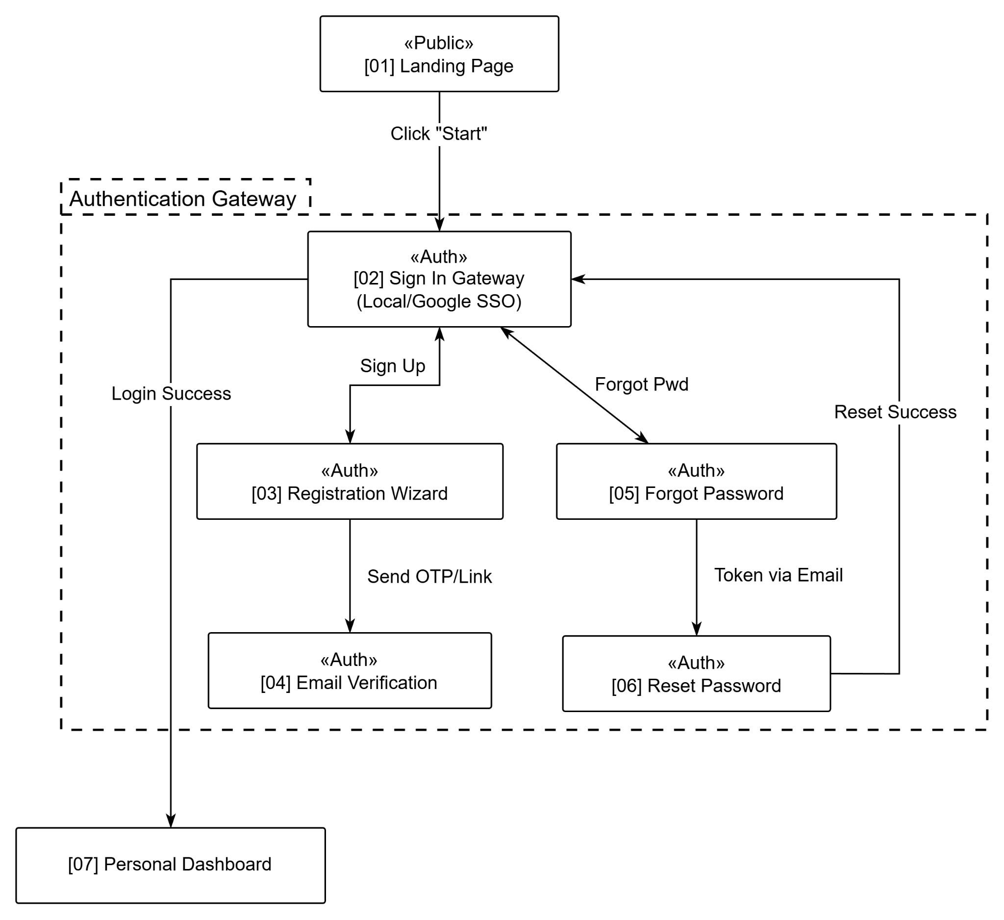
Figure 1.5.1: Screen flow auth, onboarding

Global, Tenant & Workspace Flow
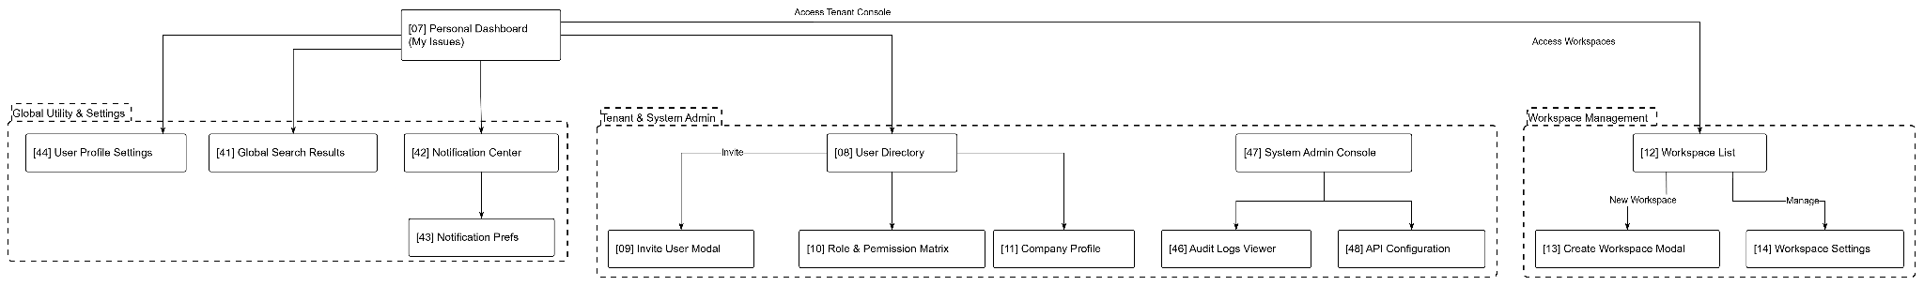
Figure 1.5.2: Screen flow global and workspace flow

Project & Dynamic Workflow Flow
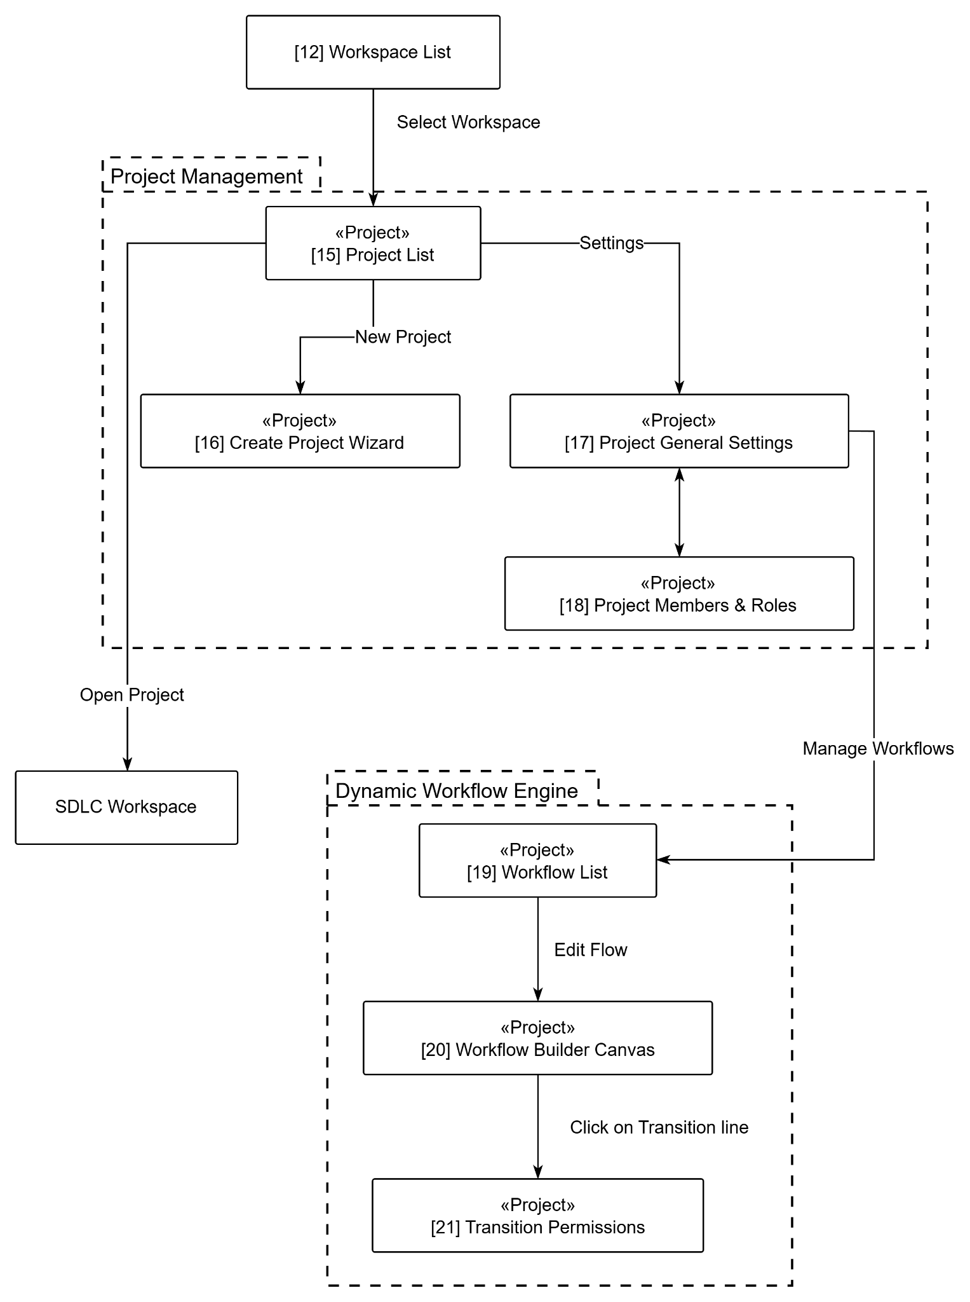
Figure 1.5.3: Screen flow project & dynamic workflow

SDLC Execution Flow
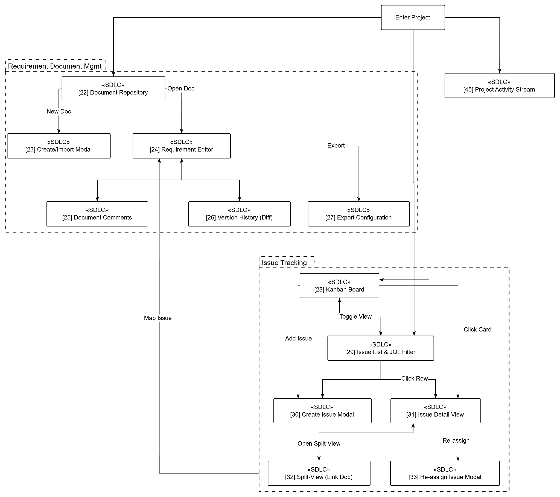
Figure 1.5.4: Screen flow execution flow

AI & Traceability Flow
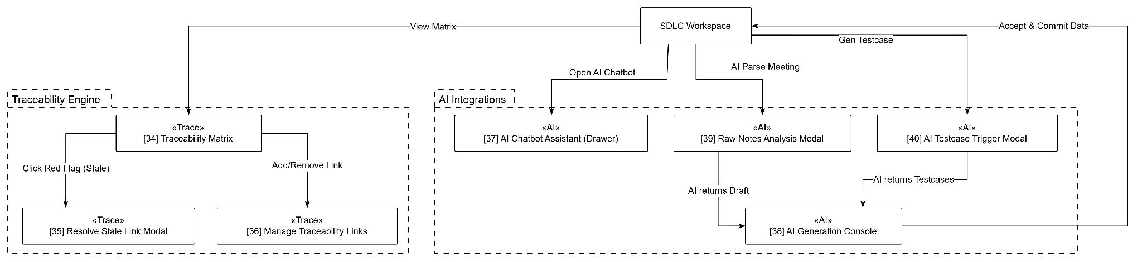
Figure 1.5.5: Screen flow for AI & Trace

b. Screen List
No | Screen Name | Feature | Description
Authentication & Public Gateway
1 | Landing Page | Authentication | Introduces SSAM product features, service packages, and a Call-to-Action (CTA) button redirecting users to the registration flow.
2 | Sign In Gateway | Authentication | Centralized authentication portal allowing any user to log in via an internal account (Email/Password) or Google SSO.
3 | Registration Wizard | Authentication | Two-step guided setup allowing a new Guest to create an account and configure initial data.
4 | Email Verification | Authentication | Prompts users to enter an OTP or click a secure link to verify the ownership of their email address.
5 | Forgot Password | Authentication | Input form to request the system to send a secure password recovery link via email.
6 | Reset Password | Authentication | Interface for users to set up a new password (accessible exclusively via a valid token sent to their email).
Tenant & Workspace Management
7 | Personal Dashboard | Tenant management | Primary post-login screen. Integrates a "My Issues" widget that automatically filters and displays Tasks/Bugs assigned to the current user.
8 | User Directory | Tenant management | Interface for managing the Tenant's internal personnel list, allowing Admins to view activity statuses or deactivate accounts.
9 | Invite User Modal | Tenant management | Dialog box to input multiple email addresses and assign initial Role Tags to send joining invitations.
10 | Role & Permission Matrix | Tenant management | Grid matrix mapping Role Tags against Entity Actions to configure physical access permissions.
11 | Company Profile | Tenant management | Configuration form for the company's legal information, tax identification, brand logo, and contact details.
12 | Workspace List | Workspace management | List of existing workspaces displaying storage capacity and the number of active members.
13 | Create Workspace Modal | Workspace management | Dialog box to input the Name and Identifier Code (e.g., SSAM) to initialize a new, data-isolated Workspace.
14 | Workspace Settings | Workspace management | Configuration screen for Workspace metadata, Archive actions, and Workspace-level permission allocation.
Project & Workflow Configuration
15 | Project List | Project management | List of projects within a specific Workspace, displaying overall progress bars and project statuses.
16 | Create Project Wizard | Project management | Three-step project setup: Input General Info -> Select Workflow Template -> Invite Members.
17 | Project General Settings | Project management | Project metadata configuration featuring toggle switches to enable or disable Artificial Intelligence (AI) modules.
18 | Project Members & Roles | Project management | Interface to manage project personnel and assign Contextual Roles valid strictly within the project scope.
19 | Workflow List | Dynamic Workflow | List of custom workflows currently existing or applied within the active project.
20 | Workflow Builder Canvas | Dynamic Workflow | 2D interactive drawing board allowing drag-and-drop of Phases and connections of status Transitions.
21 | Transition Permissions | Dynamic Workflow | Dialog box to define which Role Tags are authorized to drag-and-drop issue cards through a specific Transition pathway.
Requirement Document Management
22 | Document Repository | Document management | Document management interface featuring a left-side folder Tree-view and a detailed document list on the right.
23 | Create/Import Doc Modal | Document management | Dialog box to create a blank document, use a template, or upload DOCX/PDF files for AI parsing.
24 | Requirement Editor | Document management | Core block-based text editor. Supports an Approve button and inline commenting features.
25 | Document Comments | Document management | Right-side sliding drawer displaying all conversational threads attached to specific Requirement Blocks.
26 | Version History (Diff) | Document management | Split-screen interface comparing document versions: Deleted text (Red highlight) vs. Added text (Green highlight).
27 | Export Configuration | Document management | Dialog box to select export format (PDF/DOCX), insert watermarks, and configure accompanying metadata.
Issue Tracking
28 | Kanban Board | Issue Tracking | Visual card board categorized by Status columns, supporting Drag & Drop operations based on Workflow rules.
29 | Issue List & Filter | Issue Tracking | Tabular issue list integrating a multi-condition search bar to filter by Assignee and Status.
30 | Create Issue Modal | Issue Tracking | Dialog box to initialize a new Task/Bug: Input Title, Description, Assignee, Priority, and file attachments.
31 | Issue Detail View | Issue Tracking | Full-screen overlay displaying Issue details, status change history, and the discussion area.
32 | Split-View (Link Doc) | Issue Tracking | Split-screen interface: Issue details on the left and Requirement Document on the right for easy cross-referencing and mapping.
33 | Re-assign Issue Modal | Issue Tracking | Dialog box to transfer an issue to another member, including an input field for handover notes.
Traceability Engine
34 | Traceability Matrix | Traceability | Two-dimensional matrix correlating Requirement Blocks and Testcases. Displays red warning flags for "Stale" links.
35 | Resolve Stale Link Modal | Traceability | Dialog triggered by clicking a stale Testcase: Displays Requirement modifications so QAs can update the Testcase accordingly.
36 | Manage Traceability Links | Traceability | Interface to search, manually Add, or Remove traceability links between Blocks and Testcases.
 | AI Integrations
37 | Chatbot Assistant Drawer | AI Integrations | Right-side sliding drawer providing an AI conversational interface with clickable Source Citations in the responses.
38 | AI Generation Console | AI Integrations | Draft review interface listing AI-generated Blocks/Testcases with confidence scores for Users to Accept or Reject.
39 | Raw Notes Analysis Modal | AI Integrations | Dialog box to upload meeting minutes (Raw Notes) for the AI system to automatically extract and semantically analyze.
40 | AI Testcase Trigger Modal | AI Integrations | Dialog box to select specific Requirement Blocks as the Context, prompting the AI to automatically generate Testcases.
Utility & System Administration
41 | Global Search Results | Utility & Admin | Interface displaying system-wide search results, categorized by tabs: Issues, Documents, and Comments.
42 | Notification Center | Utility & Admin | Dropdown dialog from the Bell icon displaying real-time system events and notifications.
43 | Notification Prefs | Utility & Admin | Preference settings to toggle notification delivery methods (In-app / Email) for specific system event types.
44 | User Profile Settings | Utility & Admin | Interface to update Avatar, Display Name, securely change Passwords, and view personal login history.
45 | Project Activity Stream | Utility & Admin | Chronological timeline recording all actions (Create/Update/Delete/Transition) performed on any object within the project.
46 | Audit Logs Viewer | Utility & Admin | Append-only data table interface tracking all system configuration and permission changes for security auditing.
47 | System Admin Console | Utility & Admin | Dedicated dashboard for Super Admins to manage the Tenant list and monitor server resource utilization.
48 | API Configuration | Utility & Admin | Dialog box for Super Admins to input peripheral authentication credentials (e.g., Google SSO Client ID, LLM Provider API Key, SMTP).

5.2 External API Inventory
No | API Name | Calling Path | Description
1 | Google Workspace SSO API | SSAM → Google Identity | Enables seamless single sign-on (SSO) authentication, allowing users to register or log in using their corporate Google accounts.
2 | LLM Provider API | SSAM → External AI Provider | Facilitates natural language processing for the Chatbot RAG, requirement semantic analysis, and automated testcase generation.
3 | Email Delivery Gateway | SSAM → SMTP Service | Dispatches transactional offline emails including workspace invitations, password reset tokens, and batched system alerts.

5.3 Background Job Inventory
[Fill details of each background job into the table with the columns and sample data as below]
# | Job Name | Group | Description
1 | Unlock expired locked accounts | Scheduled | Every 15 minutes
2 | Clean up old audit log entries | Scheduled | Daily at 2:00 AM

II. Use Case Specifications

1. Initial Experience (Landing & Onboarding)

1.1 Navigation and Access Routing
Primary Actors | External Guest (Guest), Authenticated User (All Roles) | Secondary Actors | None
Description | As a visitor or returning user, I want to access the SSAM Landing Page and have the system automatically verify my authentication status when I click to enter the platform so that I am routed directly to my dashboard or the authentication gateway.
Preconditions | None
Normal Flow | 1. The user accesses the product Landing Page to view SSAM product features, architecture highlights, and workflow introductions.  2. The user clicks the "Go to SSAM" button.  3. The system checks the user's current authentication session.  4. If the user is not logged in (no valid session), the system automatically redirects them to the Sign In / Registration Gateway.  5. If the user is already logged in and their session is still valid, the system skips the authentication step and redirects them directly to the Personal Dashboard.
Alternative Flows | 3a. Expired or revoked session token: If a stored session token has expired or been invalidated, the system clears the local session state and redirects the user to the Sign In Gateway.
Postconditions | 1. The user is redirected to the Personal Dashboard (if authenticated) or the Sign In Gateway (if unauthenticated).  2. No system business data is modified.

2. Authentication

2.1 Register New Account
Primary Actors | External Guest (Guest) | Secondary Actors | Notification & Identity Gateway (Email Delivery Service)
Description | As an unauthenticated Guest, I want to register a new Personal account or Corporate Organization account (Tenant) via the Registration Wizard and verify my email ownership so that I can establish my identity and start using the SSAM system.
Preconditions | 1. The user is not currently logged in.  2. The provided email address does not already exist in the system.
Normal Flow | 1. User accesses the Landing Page or Sign In Gateway and clicks the "Register" or "Sign Up" button.  2. System displays the Registration Wizard Step 1: Select Account Type (Personal or Corporate / Organization).  3. User selects the account type and clicks "Next".  4. System displays Step 2: Enter Registration Details according to the selected type:  - For Personal Account: Full Name, Email Address, Password, and Confirm Password.  - For Corporate Account: Tenant Admin Information (Full Name, Work Email, Password) and Organization Profile (Company Legal Name, Tax Code / Identifier, Corporate Email Domain).  5. User fills in all required information and clicks "Register".  6. System validates the data format and password strength, then temporarily saves the account (and initializes the Tenant record with Tenant Admin privileges if Corporate) in the database with a "Pending Verification" status.  7. System automatically calls the Email Delivery Service API to send a verification email containing an activation link / OTP code to the user's email address.  8. System redirects the user to the "Email Verification" screen.  9. User clicks the activation link in the email (or retrieves the OTP, inputs it into the system, and clicks "Verify").  10. System verifies the token/OTP validity, transitions the account status to "Active", establishes an authenticated session (issues a JWT Token), and redirects the user to the Personal Dashboard screen.
Alternative Flows | 6a. Email already exists: If the input email already exists in the database, the system displays an error message (MSG-AUTH01) "This email is already in use" and provides navigation buttons directing the user to the "Sign In" or "Forgot Password" pages.  6b. Missing fields or weak password: If required fields are empty or the password does not meet complexity criteria, the system highlights the invalid fields and prompts the user to enter again.  9a. Invalid or expired OTP / activation link: If the user enters an incorrect OTP or the verification token has expired, the system displays an error message (MSG-AUTH02) "Invalid or expired verification code" and provides a "Resend OTP / Verification Email" button.
Postconditions | 1. The Personal user account or Corporate Tenant account (with Tenant Admin privileges) is created and activated (Active status).  2. The user is granted a valid login session.

2.2 Authenticate User (Login)
Primary Actors | External Guest (Guest) | Secondary Actors | Notification & Identity Gateway (Google Workspace SSO API)
Description | As a registered user, I want to authenticate using my internal email and password or via my linked Google Workspace account so that I can securely access the SSAM dashboard and my assigned workspaces/projects.
Preconditions | 1. The user is not currently logged into the system.  2. The user has a registered account in the database.
Normal Flow | 1. User accesses the Landing Page and clicks the "Login" button.  2. System displays the "Sign In Gateway" screen.  3. User inputs their registered Email and Password.  4. User clicks the "Login" button.  5. System validates the entered credentials against the database records.  6. System issues a secure JWT token for the user's authenticated session.  7. System records the successful login event in the User Profile history and Audit Logs.  8. System redirects the user to the "Personal Dashboard" screen.
Alternative Flows | 4a. Login via Google SSO: User clicks the "Login with Google SSO" button instead of entering an email and password. System redirects the user to the external Google authentication gateway. User authenticates using their Google account, and Google returns a successful authentication token to the system. System verifies the token, maps it to the existing SSAM account, and resumes from Step 6 of the Normal Flow (if no mapped account exists, the system redirects the user to the Registration Wizard).  5a. Invalid Credentials: If the user inputs an incorrect email or password, the system denies access and displays an error message (MSG-AUTH03) "Invalid email or password."  5b. Unverified Account: If the user enters correct credentials but their account is still in the "Pending Verification" status, the system displays an error message (MSG-AUTH04) "Please verify your email address to log in." and provides a "Resend Verification Email" button.  5c. Account Locked (Security Policy): If the user fails to log in 5 consecutive times, the system temporarily locks the account for 30 minutes to prevent brute-force attacks and displays a warning message (MSG-AUTH05) "Your account has been locked due to multiple failed login attempts. Please try again in 30 minutes or reset your password."  5d. Account Deactivated: If the user's account has been explicitly disabled by a Tenant Admin, the system denies access and displays an error message (MSG-AUTH06) "Your account has been deactivated. Please contact your organization administrator."
Postconditions | 1. The user is successfully authenticated and granted a valid login session.  2. The system grants access to role-specific areas, workspaces, and projects based on the user's permissions.

2.3 Password Recovery and Session Logout
Primary Actors | External Guest (for Password Recovery), Authenticated User (for Session Logout) | Secondary Actors | Notification & Identity Gateway (Email Delivery Service)
Description | As a user, I want to recover a forgotten password via a secure email reset link or safely log out to terminate my current active session.
Preconditions | 1. For Password Recovery, the user is unauthenticated and possesses a registered email address.  2. For Session Logout, the user is currently logged into an active session.
Normal Flow | 1. Request Password Reset: On the Sign In Gateway, the user clicks "Forgot Password?". System opens the "Forgot Password" screen.  2. User inputs their registered Email Address and clicks "Send Recovery Link".  3. System verifies the account and dispatches a time-limited password recovery link via the Email Delivery Service.  4. User clicks the recovery link in their email. System validates the reset token and displays the "Reset Password" screen.  5. User inputs a New Password and Confirm Password, then clicks "Reset Password".  6. System validates password strength, updates the password credential in the database, invalidates the recovery token, and redirects the user to the Sign In Gateway.  7. Session Logout: When an authenticated user clicks "Logout" in the top header on any screen, the system terminates the active session, clears session tokens, and redirects the user to the Sign In Gateway.
Alternative Flows | 4a. Invalid or expired recovery link: If the reset token has expired or was already used, the system displays an error alert and prompts the user to request a new recovery link.  5a. Weak password or confirmation mismatch: If the new password fails security rules or confirmation does not match, the system highlights the error and blocks submission.
Postconditions | 1. For Password Recovery, the account password is updated and old sessions are invalidated.  2. For Session Logout, the user's active session is terminated.

3. Tenant Management

3.1 Account Provisioning and Organizational Role Management
Primary Actors | Tenant Admin | Secondary Actors | Notification & Identity Gateway (Email Delivery Service)
Description | As a Tenant Admin, I want to define and manage organizational job roles and provision internal employee accounts manually or in bulk via Excel import so that company personnel can join the organization's SSAM environment.
Preconditions | 1. The user is logged in with Tenant Admin privileges.  2. The user accesses the Organization Administration area ("Role & Permission Matrix" or "User Directory").
Normal Flow | 1. View Organizational Roles: Tenant Admin opens "Role & Permission Matrix". System displays all defined roles in the organization (Role Name, Description, Assigned Users Count, Active Status).  2. Create or Update Role: Tenant Admin clicks "Create Role" (or selects an existing role to "Update"), inputs/edits the Role Name, Description, and organizational permissions, and clicks "Save". System validates uniqueness and saves the role configuration.  3. Change Role or Account Status: Tenant Admin toggles the Active / Inactive switch on a role or user account to enable or disable its active status.  4. Provision Internal Employee Accounts: Tenant Admin navigates to "User Directory" and clicks "Invite Member". System opens the "Invite & Batch Import User Modal".  5. Tenant Admin either inputs individual employee Email addresses and selects initial Roles, OR uploads a standardized Excel file containing a batch list of employees, and clicks "Send Invitations".  6. System validates the submitted records, creates internal user accounts linked to the Tenant, and automatically sends invitation emails to each employee via the Email Delivery Service.
Alternative Flows | 2a. Duplicate role name: If the entered Role Name already exists within the organization, the system displays a validation error and prevents saving.  6a. Existing or invalid accounts in Batch Excel file: When processing an uploaded Excel file, if the system detects an email address that already exists within the organization or is malformed, it skips the corresponding row and provides the Tenant Admin with a detailed summary of successful and skipped invitations.
Postconditions | 1. Organizational roles and permission structures are saved.  2. Internal employee accounts are created and invitation emails are dispatched.

3.2 Personal and Company Profile Management
Primary Actors | Authenticated User (All Roles for Personal Profile), Tenant Admin (for Company Profile) | Secondary Actors | None
Description | As an authenticated user, I want to view and update my personal profile and security password; and as a Tenant Admin, I want to view and update the enterprise's legal and brand profile.
Preconditions | 1. The user is logged into an active account within the organization.
Normal Flow | 1. View & Update Personal Profile: User opens "User Profile Settings". System displays the user's Avatar, Full Name, Email, Role, and Password Change form.  2. User updates their contact/display information or inputs their Current Password and New Password, then clicks "Save Changes". System validates the inputs and saves the updated personal profile.  3. View & Update Company Profile: Tenant Admin accesses the "Company Profile" screen. System displays the enterprise's Legal Name, Tax Identifier, Brand Logo, Corporate Email Domain, and Contact Details.  4. Tenant Admin updates the company details and clicks "Save". System validates required fields, updates the Tenant profile in the database, and records the change in the Audit Log.
Alternative Flows | 2a. Incorrect current password: If the user enters an incorrect current password when changing passwords, the system rejects the change and displays an error message.  4a. Missing required legal fields: If required company fields (Legal Name or Tax Identifier) are empty, the system highlights the missing fields and prevents saving.
Postconditions | 1. Personal or corporate profile information is accurately updated and persisted in the database.

3.3 Employee Assignment and Account Deactivation
Primary Actors | Tenant Admin | Secondary Actors | None
Description | As a Tenant Admin, I want to assign onboarded personnel to the active organization directory and deactivate accounts of departing employees while automatically identifying their assigned Issues for handover.
Preconditions | 1. The user is logged in as a Tenant Admin and is viewing the "User Directory" screen.
Normal Flow | 1. Assign Company Member: Tenant Admin reviews newly onboarded personnel in the "User Directory" and assigns them to active organizational roles.  2. Deactivate Departing Employee Account: When an employee leaves the organization, the Tenant Admin locates the employee's row and clicks "Deactivate Account".  3. System scans all workspaces and projects for open Issues (Tasks/Bugs) still assigned to that employee and displays a confirmation dialog listing those outstanding Issues.  4. Tenant Admin clicks "Confirm Deactivation".  5. System disables the employee's login access (Inactive status), terminates their active sessions, revokes their active assignments, and notifies the Tenant Admin and relevant Project Managers to reassign the outstanding Issues promptly.
Alternative Flows | 2a. Prevent self-deactivation: The system disables the "Deactivate" action on the Tenant Admin's own account to prevent organizational lockout.  4a. Cancel deactivation: If the Tenant Admin clicks "Cancel", the confirmation dialog closes and the account remains Active.
Postconditions | 1. The departing employee's account is locked (Inactive) while historical audit records are preserved.  2. Open Issues previously assigned to that employee are flagged for handover and reassignment.

4. Workspace Management

4.1 Workspace Provisioning and Lifecycle Governance
Primary Actors | Tenant Admin (for Create, View, Update, Archive), Workspace Admin (for View, Update, Archive), Project Member (for View) | Secondary Actors | None
Description | As a Tenant Admin or Workspace Admin, I want to create isolated departmental workspaces, view workspace information, update workspace settings, and archive workspaces into read-only mode so that departmental environments are properly organized and governed.
Preconditions | 1. The user is logged in.  2. Creating a workspace requires Tenant Admin privileges; updating or archiving requires Tenant Admin or Workspace Admin privileges for that workspace.
Normal Flow | 1. View Workspace List & Info: User navigates to "Workspace List". System displays the list of workspaces accessible to the user with columns: No, Workspace Code, Name, Description, Active Projects Count, Members Count, Status (Active or Archived), and Created At.  2. Create Workspace: Tenant Admin clicks "+ Create Workspace". System opens the "Create Workspace Modal" containing required fields: Workspace Name *, Identifier Code * (e.g., CORE, FIN), and Description, along with "Create" and "Cancel" buttons.  3. Tenant Admin fills in the required fields and clicks "Create". System validates code uniqueness, saves the new workspace in Active status, and refreshes the "Workspace List".  4. Update Workspace: Tenant Admin or Workspace Admin navigates to "Workspace Settings" ("General" tab), edits the Workspace Name or Description, and clicks "Update". System saves the changes and updates the Last Updated Date.  5. Change Workspace Status / Archive: Tenant Admin or Workspace Admin clicks "Archive Workspace" (when Status is Active) and confirms. System transitions the workspace status to "Archived" and switches all projects, documents, issues, and test cases inside the workspace to Read-Only Mode.
Alternative Flows | 1a. No available workspace: If there is no workspace created by or assigned to the user, the system displays an empty-state message indicating that no workspace is available.  3a. Cancel or missing required fields: If the user clicks "Cancel", the modal closes. If required fields are missing or the Identifier Code already exists, the system highlights the fields and prompts the user to enter again.  5a. Reactivate archived workspace: If the workspace is currently "Archived", clicking the "Reactivate Workspace" button restores the workspace status to "Active".
Postconditions | 1. New workspaces are created, or existing workspace metadata and active/archived read-only states are updated in the database.

4.2 Workspace Membership Management
Primary Actors | Tenant Admin, Workspace Admin (for View, Invite, Remove); Project Member (for View) | Secondary Actors | Notification & Identity Gateway (Email Delivery Service)
Description | As a Tenant Admin or Workspace Admin, I want to view participating workspace members, invite/assign new members into the workspace, and remove members while preserving their historical activities.
Preconditions | 1. The user is logged in and has access to the workspace.  2. Inviting or removing members requires Tenant Admin or Workspace Admin privileges for the current workspace.
Normal Flow | 1. View Workspace Members: User navigates to the "Members" tab in Workspace Settings. System displays the member list with columns: No, Member Name, Email, Workspace Role, Status, and Joined At.  2. Invite / Assign Workspace Member: Admin clicks the "+ Invite Member" button. System displays a dialog containing an Email / User Search field, a Workspace Role selector (Workspace Admin, Project Initiator, Workspace Member), an "Invite" button, and a "Cancel" button.  3. Admin enters or selects the target user's email, chooses their Workspace Role, and clicks "Invite". System grants workspace membership (or creates a membership invitation) and sends an invitation notification via the Email Delivery Service.  4. Remove Workspace Member: Admin locates the member to remove and clicks "Remove" in the action column. System displays a confirmation dialog with "Confirm" and "Cancel" buttons.  5. Admin clicks "Confirm". System revokes the member's access to the workspace and all projects inside that workspace while preserving their historical activity logs, then refreshes the member list.
Alternative Flows | 3a. Cancel or empty email field: If the user clicks "Cancel", the dialog closes. If no email is entered, the "Invite" button remains disabled.  3b. External email not yet in system: If no existing user owns the entered email, the system dispatches an onboarding invitation email through the Email Delivery Service.  5a. Member already removed: If the targeted member was already removed, the system refreshes the member list.
Postconditions | 1. Workspace membership additions or removals are saved in the database while historical work logs remain preserved.

4.3 Workspace Role and Permission Configuration
Primary Actors | Tenant Admin, Workspace Admin | Secondary Actors | None
Description | As a Tenant Admin or Workspace Admin, I want to view workspace roles and permissions, create and update workspace permission sets, toggle permission active status, and assign permission sets to workspace roles.
Preconditions | 1. The user is logged in as the Tenant Admin or Workspace Admin of the current workspace.  2. The user is at the "Workspace Settings" screen ("Roles & Permissions" tab).
Normal Flow | 1. View Workspace Roles & Permissions: User navigates to the "Roles & Permissions" tab. System displays the list of workspace roles (No, Role Name, Description, Number of Members, Is Active toggle) and the list of workspace permissions (No, Permission Name, Description, Number of Roles, Is Active toggle).  2. Create or Update Workspace Permission Set: User clicks "Create Role / Permission" (or selects an existing item to edit), inputs/edits the Name and Description, and clicks "Save".  3. Assign Workspace Permission for Role: User selects a role, checks or unchecks specific workspace access privileges (ws.view_overview, ws.edit_settings, ws.archive, ws.manage_members, ws.create_project), and clicks "Save".  4. Change Workspace Permission Status: User switches the Is Active toggle button to enable or disable the effect of a role or permission set.  5. System validates and saves the updated role and permission configurations to the database.
Alternative Flows | 4a. Core Workspace Admin lock: The system prevents disabling the primary Workspace Admin role to ensure continuous workspace governance.
Postconditions | 1. Workspace roles, permission sets, active statuses, and role-permission assignments are updated in the database.

5. Project Management & Dynamic Workflow

5.1 Project Initialization and Lifecycle Management
Primary Actors | Workspace Admin, Project Manager (Project Initiator) (for Create, View, Update, Change Status); Project Member (for View) | Secondary Actors | Notification & Identity Gateway (Email Delivery Service)
Description | As a Workspace Admin or Project Manager, I want to initialize new projects via the Create Project Wizard with predefined or custom SDLC methodologies, view managed projects, update project metadata and AI module toggles, and change project operational statuses.
Preconditions | 1. The user is logged in and is a member of the workspace.  2. Creating a project requires Workspace Admin or Project Initiator privileges (ws.create_project); updating or archiving a project requires Project Manager or Workspace Admin privileges.
Normal Flow | 1. View Created Projects: User navigates to the "Project List" screen of the workspace. System displays the list of projects accessible to the user with columns: No, Project Key, Name, SDLC Method, Progress Bar, Status, and Created At.  2. Create New Project: Authorized user clicks "+ Create Project". System navigates to the "Create Project Wizard":  - Step 1 – Project Info & SDLC Method: User inputs Project Name *, Project Key Prefix * (e.g., TEST, CORE), Description, and the Enable AI Module (BA/QA) toggle. Under "Choose SDLC Method for Project", the system displays 7 predefined SDLC models (Agile Scrum, Waterfall, Iterative & Incremental, V-Model, Kanban, Spiral Model, RAD) and Custom SDLC Template, along with the "Phase Pipeline Definition" table (Phase Order, Phase Name, Description / Scope, Statuses in Phase).  - Edit Preset into Custom SDLC Template: When the user selects a predefined SDLC model, its phases and statuses populate the preview table. If the user clicks the "Edit" button on that preset model, the system retains all phases and statuses of the selected model and automatically switches the active tab to "Custom SDLC Template" so the user can freely add, edit, reorder, or remove phases and statuses.  - Step 2 – Invite Members: User selects workspace members to invite into the project, assigns their contextual Project Role (Project Manager, BA / Designer, Developer, Tester / QA), and clicks "Create Project".  3. System validates all inputs, commits the project, SDLC phases, and workflow statuses to the database, redirects the creator to the Project Overview Dashboard, and sends project invitation notifications to the selected members.  4. Update Project: Project Manager navigates to "Project Settings" ("General" tab), edits the Project Name, Description, or AI Module (BA/QA & Chatbot) toggle switch, and clicks "Update". System saves the changes and updates the Last Updated Date.  5. Change Project Status: Project Manager clicks "Archive Project" (or "Suspend" / "Reopen"). System updates the project status; when archived, all project artifacts transition to Read-Only Mode.
Alternative Flows | 1a. No available project: If no project exists in the workspace, the system displays an empty-state message indicating no available project.  2a. Cancel or validation failure: If the user clicks "Cancel", the wizard returns to "Project List". If required fields (Name, Key) are missing, the Project Key is duplicated, or a phase has no status, the system highlights the missing/invalid fields and prompts the user to correct them.  3a. Invited member accepts or declines invitation: Invited members receive the notification and click "Accept" (activating their project membership and permissions) or "Decline".
Postconditions | 1. A new project and its SDLC phase/status structure are created, or existing project settings and lifecycle statuses are updated in the database.

5.2 Project Membership Assignment and Access Control
Primary Actors | Project Manager (Project Initiator), Workspace Admin (for View, Assign, Remove); Project Member (for View) | Secondary Actors | Notification & Identity Gateway (Email Delivery Service)
Description | As a Project Manager, I want to view project members, assign workspace members into the project with specific roles, and remove members from the project while preserving their historical activities.
Preconditions | 1. The user is logged in and has access to the project.  2. Assigning or removing members requires Project Manager or Workspace Admin privileges for the current project.
Normal Flow | 1. View Project Members: User navigates to the "Members" tab of the project. System displays the table of project members with columns: No, Member Name, Email, Project Role, Status, and Joined At.  2. Assign New Member into Project: Project Manager clicks the "+ Add Member" button. System displays a dialog listing workspace members who are not yet in this project, a Project Role selector (Project Manager, BA / Designer, Developer, Tester / QA), an "Assign" button, and a "Cancel" button.  3. Project Manager selects one or more workspace members, assigns their Project Role, and clicks "Assign". System adds the selected members to the project member list and dispatches project assignment notifications.  4. Remove Member from Project: Project Manager locates the member to remove and clicks "Remove" in the action column. System displays a confirmation dialog with "Confirm" and "Cancel" buttons.  5. Project Manager clicks "Confirm". System revokes the member's access to the project while preserving their historical activities and comments, and refreshes the member list.
Alternative Flows | 3a. Cancel or no member selected: If the user clicks "Cancel", the dialog closes. If the user does not select any member, the "Assign" button remains disabled.  3b. Selected member removed from workspace: If any selected member was removed from the parent workspace, the system displays an error message, reloads the candidate list, and prompts the user to try again.  5a. Member already removed: If the targeted member was already removed, the system refreshes the page.
Postconditions | 1. Project member assignments or removals are saved in the database while historical project logs remain intact.

5.3 Project Role and Permission Matrix Configuration
Primary Actors | Project Manager (Project Initiator), Workspace Admin | Secondary Actors | None
Description | As a Project Manager, I want to create project permission sets, update detailed project permissions, toggle permission validity status, and assign project access rights to participating roles.
Preconditions | 1. The user is logged in as the Project Manager (or Workspace Admin) of the current project.  2. The user is at the "Project Settings" screen ("Roles & Permissions" tab).
Normal Flow | 1. User navigates to the "Roles & Permissions" tab in Project Settings. System displays the list of project roles (No, Role Name, Description, Number of Members, Is Active toggle) and the project permission matrix (proj., phase., doc., issue., qa., collab., ai.*).  2. Create or Update Project Permission: User creates a project role/permission set or adjusts detailed permissions within the project scope.  3. Assign Project Permission for Role: User selects a project role, checks or unchecks specific project permissions, and clicks "Save".  4. Change Project Permission Status: User switches the Is Active toggle button to enable or disable the validity of project-level role or permission settings.  5. System validates and saves the updated project permission matrix to the database.
Alternative Flows | 4a. Core Project Manager lock: The system prevents disabling core management permissions on the Project Manager role to avoid project lockout.
Postconditions | 1. Project roles, permission statuses, and role-permission mappings are saved and enforced across the project.

5.4 Dynamic SDLC Phase and Workflow Transition Configuration
Primary Actors | Project Manager (Project Initiator) (for Create, Update, Configure Transitions); Project Member (for View) | Secondary Actors | None
Description | As a Project Manager, I want to view, create, update, and toggle SDLC Phases, assign workflow schemas to phases, create and update Workflow Statuses within each phase, and configure role-based Status Transition Rules so that task progression on the Kanban board is strictly controlled.
Preconditions | 1. The user is logged in as the Project Manager of the current project (any Project Member can view).  2. The user is at the project "Workflow" configuration screen.
Normal Flow | 1. View Phases and Workflow Statuses: User navigates to the "Workflow" tab. System displays the ordered list of project Phases (Phase Order, Name, Description / Scope, Is Active) and the list of Workflow Statuses (Name, Category: To Do / In Progress / Done, Color, Is Active) inside each phase, along with the visual BPMN workflow preview.  2. Add or Update Phase: Project Manager clicks "+ Add new Phase" (or selects a phase and clicks "Update"), fills/edits Phase Name *, Description / Scope, Phase Order / Position, or switches the Is Active toggle, and clicks "Create" / "Update". System saves the phase to the database and refreshes the phase list.  3. Assign Workflow Schema & Add/Update Workflow Status: Inside a phase, Project Manager applies a workflow schema or clicks "+ Add new Status" / "Update Status", inputs/edits Status Name *, Status Category (To Do, In Progress, Done), Color picker, Description, or switches the Is Active toggle, and clicks "Create" / "Update". System saves the workflow status in that phase.  4. Manage Workflow Status Transitions & Role Permissions: Project Manager selects a phase and clicks "Manage Transitions". System displays the transition configuration dialog showing the single Initial Status selector, allowed "From Status -> To Status" transition paths, the multi-select "Allowed Roles" (Project Manager, BA / Designer, Developer, Tester / QA) permitted to move Issues along each transition path, and a "Require Comment" toggle.  5. Project Manager edits the transition rules and clicks "Save". System validates and saves the transition matrix into the database and displays a success message.
Alternative Flows | 1a. No available phase or status: If no phase or workflow status exists, the system displays an empty-state prompt.  2a/3a/5a. Cancel or no changes made: User can click "Cancel" to close any dialog without saving. If required fields are empty or no changes were made, the "Create" / "Update" / "Save" button remains disabled.
Postconditions | 1. Project phases, workflow statuses, and role-based status transition rules are updated in the database.

6. Document Management

6.1 Specification Authoring, Versioning, and Export
Primary Actors | Project Member (BA / Designer), Project Manager | Secondary Actors | None
Description | As a Business Analyst or Project Manager, I want to create specification documents in a Confluence-style hierarchical page tree, view and compose free-form content while segmenting business requirements by Headings into identifiable Requirement Items comprising textual Content and process Diagrams, track before-and-after revisions in the Requirement History Log, export files, and delete unused drafts.
Preconditions | 1. The user is logged in and holds specification authoring permissions (BA / Designer or Project Manager) in the current project.  2. The user accesses the project's Confluence-style Specification Workspace.
Normal Flow | 1. Create Document or New Revision: User clicks "+ Create Document" to initialize a new specification document in Draft status within the hierarchical page tree (or clicks "+ Create New Revision" on an Approved baseline document to initialize an editable draft version vN+1).  2. View & Compose Requirement Items and Diagrams: User views the page tree and composes specification content freely (text paragraphs, tables, bullet lists, callouts) organized by Headings (H1, H2, H3). When a Heading is marked as a traceable requirement, the system assigns an immutable identifier (e.g., REQ-01, REQ-02) and automatically groups all textual Content, process Diagrams (Mermaid/PlantUML scripts rendered as visual flowcharts), and linked Figma UI embeds under that Heading into a structured Requirement Item in the database.  3. Save & Record Requirement History Log: User saves the document. For any modified Requirement Item, the system compares the updated section against its previous snapshot, records the before-and-after changes in the Requirement History Log, and submits the document to In Review status when ready for approval.  4. Export Document: User clicks "Export", selects the target format (PDF or DOCX) and inclusion options (embedded diagrams, metadata, version history), and downloads the generated file to their computer.  5. Delete Document: User selects "Delete Document" and confirms removal.
Alternative Flows | 3a. Non-substantive whitespace edit: If saving the document does not alter the actual text content, diagram, or UI link of a Requirement Item, the system does not generate a duplicate Requirement History Log entry.  5a. Delete document containing active traceability links: If the document contains Requirement Items linked to existing Test Cases or Issues, the system displays a prominent warning message (MSG04) detailing the affected traceability links and requires explicit confirmation (or blocks deletion of approved baselines).
Postconditions | 1. Specification documents, segmented Requirement Items (Content & Diagrams), and Requirement History Log records are saved in the database.

6.2 Specification Review, Baseline Approval, and Safe Mode Reading
Primary Actors | Project Manager (Reviewer) (for Approve / Reject), Project Member (All Roles for Safe Mode Reading) | Secondary Actors | Notification & Identity Gateway (Email Delivery Service)
Description | As a Reviewer (Project Manager), I want to inspect specification documents submitted for review and either formally approve them as an official baseline or reject them for revision; and as a project member, I want to read approved baseline documents in Read-Only Safe Mode.
Preconditions | 1. The user is logged in and is a member of the project.  2. A specification document exists in In Review status (for approval) or Approved status (for Safe Mode reading).
Normal Flow | 1. Reviewer (Project Manager) opens a specification document in In Review status and inspects the Requirement Items (Content, Diagrams, Figma UI links) and Requirement History Log diffs.  2. Reviewer verifies that all inline review comments are resolved and clicks "Approve Baseline".  3. System transitions the document status to APPROVED, records the approval metadata, and locks all direct editing tools.  4. If the approved document is a revision of a previous baseline, the system automatically escalates linked Test Cases and Issues on the RTM from "Unconfirmed Stale" to "Confirmed Stale" and notifies the responsible Tester/QA and Developers.  5. Read Document in Safe Mode: When any project member opens an APPROVED document, the system renders it in Read-Only Safe Mode with a baseline lock banner, preventing direct edits unless an authorized author creates a new draft revision (vN+1).
Alternative Flows | 2a. Reviewer rejects changes / requires revision: If the Reviewer rejects the document update ("Reject"), the system returns a new draft to the author for rewriting (or, for an update to an existing baseline, reverts the draft to the previous standard version, removes the "Unconfirmed Stale" label, and restores the RTM status of linked Test Cases and Issues back to "Fresh").  2b. Unauthorized user: Users without Reviewer / Project Manager approval authority (doc.approve) will not see or have access to the "Approve Baseline" button.
Postconditions | 1. Approved specification documents are locked in Read-Only Safe Mode as official baselines, or reverted if rejected, and RTM status flags are updated accordingly.

6.3 Inline Requirement Discussion and Comment Resolution
Primary Actors | Project Member (BA / Designer / Developer / Tester), Project Manager (Reviewer) | Secondary Actors | Notification & Identity Gateway (Email Delivery Service)
Description | As a project member or reviewer, I want to leave inline comments directly on specific Requirement Items, view the discussion history, resolve comments during review, and have the system automatically flag comments as Stale if the underlying requirement text changes.
Preconditions | 1. The user is logged in, is a member of the project, and opens a specification document.
Normal Flow | 1. User selects a specific Requirement Item (or text segment) within the document, types a comment (optionally mentioning colleagues with @mention), and clicks "Post".  2. System saves and displays the comment attached to that Requirement Item and notifies mentioned members.  3. User opens the "View Comments" drawer, and the system displays the complete discussion history and replies across the document.  4. After addressing feedback, the BA or Reviewer clicks "Resolve" on the comment thread to mark it resolved prior to baseline approval.
Alternative Flows | 4a. Requirement text modified after commenting: If the Requirement Item containing an open comment is modified by another user, the system automatically flags that comment as "Stale" to indicate that the discussion context has changed.
Postconditions | 1. Inline comments, replies, stale flags, and resolution statuses are stored in the context of their respective Requirement Items.

7. Issue Tracking

7.1 Issue Lifecycle, Assignment, and Kanban Progression
Primary Actors | Project Member (Developer / BA / Tester), Project Manager | Secondary Actors | Notification & Identity Gateway (Email Delivery Service)
Description | As a project member or manager, I want to create Issues (Tasks and Bugs) with comprehensive Jira-style governance attributes, view and update issue details in a full-screen workspace, hand over/reassign work, transition issue statuses across Kanban columns under role-based rules, and delete issues with link validation.
Preconditions | 1. The user is logged in and is a member of the project.  2. The project has established SDLC Phases and Workflow Statuses.
Normal Flow | 1. Create Issue: User clicks "+ Create Issue" on the project's Jira-style workspace. System opens the 2-column Create Issue Modal.  2. User fills in the issue details: Issue Type * (Task or Bug), SDLC Phase *, Initial Status *, Summary *, Description, Managing Department / Team Label *, Component *, Data Classification * (Public, Internal, Confidential / PII, Restricted), Labels, Priority, Story Points, Original Estimate, Due Date, responsibility roles (Assignee, Issue Owner, Reporter, Watchers), and Linked Requirement Item (REQ-xx) (plus Severity, Environment, and Steps to Reproduce if Bug), then clicks "Create Issue".  3. System generates a project-specific Issue ID (e.g., CORE-101), saves the Issue to the database, and notifies the Assignee, Owner, and Watchers.  4. View & Update Issue Details: User clicks an Issue card to open the Full-Screen Issue Detail View, edits descriptions, classification, or estimation fields, and saves changes. System records all updates in the Issue Activity Log.  5. Re-assign Issue: User clicks "Re-assign", selects a new team member (@newassignee), inputs handover notes, and confirms. System updates the Assignee, records the handover in the Activity Log, and automatically sends an email/in-app notification to the new assignee and Watchers.  6. Change Issue Status on Kanban: User drags and drops the Issue card from one status column to another on the Kanban board (or updates the status dropdown in the full-screen detail view). System validates the user's role against the phase's Transition Matrix, updates the Issue status, logs the transition, and closes the Issue when the task is done.  7. Delete Issue: Authorized user chooses to delete the Issue and confirms removal.
Alternative Flows | 6a. Unauthorized status transition: If the user drags a card or selects a status transition not permitted for their role, the system rejects the operation, pushes the card back to its previous position, and displays an access-denied notification (MSG05).  6b. Transition requires mandatory comment: If the transition rule requires a comment, the system prompts the user to enter a transition note before completing the status change.  7a. Delete Issue containing traceability links: If the Issue contains active links to a Requirement Item or Test Case, the system displays a prominent impact warning (MSG04) and requires explicit confirmation before deletion.
Postconditions | 1. The Issue lifecycle, ownership, status transitions, and activity logs are strictly and transparently maintained in the database.

7.2 Kanban Tracking, Advanced Query, Collaboration, and Requirement Linking
Primary Actors | Project Member (Developer / BA / Tester), Project Manager | Secondary Actors | Notification & Identity Gateway (Email Delivery Service)
Description | As a project member, I want to monitor overall project progress on the visual Kanban board, execute advanced multi-condition issue queries, collaborate via @mention comments, and link Issues directly to Confluence Requirement Items via Split-View.
Preconditions | 1. The user is logged in as a member of the project, and Issue and Specification Document data exist in the system.
Normal Flow | 1. View Kanban Board: User opens the Kanban board and switches between SDLC Phases (All Phases, Phase 1, Phase 2...) to monitor task progress, Story Points, and any Unconfirmed / Confirmed Stale flags on linked Requirement Items.  2. Advanced Issue Query & Filtered List: User enters multi-condition filter criteria (e.g., High-priority Tasks/Bugs assigned to me, filtered by Phase, Status, Owner, Department Label, Component, Data Classification, or Stale Status). System validates the query and displays the filtered result list.  3. Comment & Mention on Issue: User writes a comment inside the Issue and uses @mentions to tag colleagues. System saves the comment and notifies mentioned colleagues and Watchers.  4. Link Issue <-> Requirement Item: User opens the "Jira <-> Confluence Split-View" comparison interface (or the Requirement Traceability panel inside the full-screen Issue view), selects a Requirement Item (REQ-xx) from the specification document, and connects it directly to the Issue card.
Alternative Flows | 2a. Contradictory or empty query results: If no Issues match the query conditions, the system displays MSG01 ("No search results") and provides a "Clear filters" option.  4a. Inspect upstream Requirement Item changes: If the linked Requirement Item (REQ-xx) is modified in a draft or approved in a new baseline, the Issue displays an "Unconfirmed Stale" or "Confirmed Stale" warning badge; the user can expand the embedded REQ-xx content and diff view directly inside the Issue screen to review the changes and confirm synchronization.
Postconditions | 1. Project progress is tracked, discussions are recorded, and bidirectional traceability links between Issues and Requirement Items are established.

8. AI Features

8.1 Raw Notes Normalization and AI-Assisted Requirement Drafting
Primary Actors | Project Member (BA / Designer), Project Manager | Secondary Actors | AI Provider (LLM Provider API)
Description | As a Business Analyst, I want to input raw meeting notes and convert them into a standardized specification template, use AI to break down the document and generate draft Requirement Items (textual Content and process Diagrams) with AI labels and confidence scores, and manually review (Accept or Reject) each draft before inserting it into the specification document.
Preconditions | 1. The user is logged in with specification authoring permissions in the project.  2. The AI module is enabled for the project, and the system has a stable connection to the AI Provider.
Normal Flow | 1. Input & Normalize Raw Notes: Inside the Confluence Specification Workspace, the analyst opens the AI generation modal, inputs prompts and raw meeting notes, and triggers normalization.  2. System converts the raw notes into a standardized specification template (Target Scope, Participating Actors, Main Business Flows, Business Rules & Constraints) for the analyst to review.  3. Break Down & Generate Draft Requirement Items: Analyst commands the system to generate requirements. System sends the normalized context to the AI Provider, which breaks down the document into candidate Requirement Items (REQ-xx) containing structured Content, Mermaid/PlantUML Diagram scripts, confidence scores, and mandatory "AI-Generated" labels.  4. Manually Review AI-Generated Content: The analyst reviews each draft Requirement Item and rendered diagram preview, edits the content if necessary, and selects "Accept" to insert the Requirement Item into the specification document.
Alternative Flows | 4a. Reject AI-generated draft: If the analyst finds an AI-generated draft item inaccurate or deviated from the intent, they select "Reject", and the system immediately discards that draft item without inserting it into the document.  3a. AI service unavailable or context limit exceeded: If the raw notes exceed the token limit or the AI service times out, the system notifies the user to narrow the input scope or retry.
Postconditions | 1. Accepted Requirement Items (Content and Diagrams) are inserted into the specification document draft under human supervision.

8.2 Figma UI Design Synchronization and Requirement Mapping
Primary Actors | Project Member (BA / Designer), Project Manager | Secondary Actors | Design System (Figma API)
Description | As a BA or Designer, I want to import Figma UI design links, extract screen structures and display components, and link them to corresponding Requirement Items (REQ-xx) so that interface designs serve as complete source material for automated Test Case generation.
Preconditions | 1. The user is logged in as a BA / Designer or Project Manager in the project.  2. The system has been granted access to the Figma file via a valid URL and access token.
Normal Flow | 1. User enters the URL of the Figma interface design screen/frame in the "Figma UI Sync" screen (or directly on a Requirement Item in the Confluence editor).  2. System connects to the Figma REST API, scans, and extracts screen frames, preview thumbnails, and display components (such as text, buttons, and input fields).  3. System records this interface structure and links the Figma UI screen to the corresponding Requirement Item(s) (REQ-xx) to provide visual context when validating inputs and generating test cases.
Alternative Flows | 2a. Invalid Figma URL or permission error: If the URL is invalid or the token does not have permission to view the design file, the system reports an access error and prompts the user to verify credentials.
Postconditions | 1. The Figma UI structure is synchronized and linked to its corresponding Requirement Items in the database.

9. AI Testcase

9.1 Input Completeness Validation and AI-Assisted Testcase Generation & Maintenance
Primary Actors | Project Member (Tester / QA) | Secondary Actors | AI Provider (LLM Provider API), Project Member (BA / Designer – for input supplementation)
Description | As a Tester/QA, I want to select an APPROVED specification document to generate Test Cases via AI after the system validates input completeness (URD, BRD, SRS, and Figma UI), auto-link generated test cases to Requirement Items & UI, review and approve them to upload to the RTM, and use AI to refresh test case steps from Requirement History Log diffs when upstream requirements change.
Preconditions | 1. The user is logged in with Tester / QA (or Project Manager) permissions in the project.  2. At least one specification document in the project has APPROVED status containing segmented Requirement Items (REQ-xx).
Normal Flow | 1. Select Approved Document & Trigger Generation: Tester/QA selects an APPROVED specification document and clicks "Generate Testcase".  2. Validate Input Completeness: System automatically validates the input completeness across all selected Requirement Items (checking URD, BRD, SRS specification fields and linked Figma UI designs).  3. Automatic Generation & Linking (Complete 100%): When inputs are 100% complete, the system sends the Requirement Items and Figma UI structure to the AI Provider, automatically generates detailed Test Cases (Preconditions, Test Steps, Test Data, Expected Results), and automatically links each Test Case to its corresponding Requirement Item (REQ-xx) and UI design.  4. Review, Revise, and Approve Set of Test Cases: Tester/QA reviews the generated Test Cases, revises steps if necessary, and clicks "Approve" to finalize the set of test cases.  5. Upload to RTM: System uploads the approved Test Cases to the Requirements Traceability Matrix (RTM) in "Fresh" status.  6. Update Testcase via AI upon Requirement Change: When an original Requirement Item is modified and approved (flagging linked Test Cases as "Confirmed Stale"), the Tester/QA opens the Stale resolution dialog, inspects the before-and-after diff from the Requirement History Log, and selects "AI Support". The AI rewrites the affected test steps based on the diff, and the Tester clicks "Approve Updated Test Case" to restore the RTM status to "Fresh".
Alternative Flows | 2a. Missing URD, BRD, SRS, or Figma UI: If the input validation in Step 2 detects missing URD/BRD/SRS fields or missing Figma UI links, the system displays a warning message detailing the missing inputs and asks the Tester/QA to confirm whether to continue generation using existing data:  - 2a-1. Confirm continuing generation using existing data (Yes): If the Tester/QA confirms ("Yes"), the system generates draft test cases based on the existing data, automatically links them to the Requirement Items & available UI, and proceeds to Step 4 for review and approval.  - 2a-2. Request additional information from BA/Designer (No): If the Tester/QA declines ("No"), the Tester submits a request for additional information, documentation, or design details. The system notifies the BA / Designer, who adds the missing fields to the URD/SRS or imports the Figma UI links into the system. Once sufficient input is available, the Tester/QA clicks "Regenerate the Test Case" (resuming from Step 2).  3a. Input exceeds single-run AI token limit: If the number of selected Requirement Items exceeds the AI processing limit for a single run, the system warns the user and processes the selected batch sequentially.
Postconditions | 1. Generated Test Cases are linked to their Requirement Items and Figma UI designs, approved by the Tester/QA, and uploaded to the Requirements Traceability Matrix (RTM).

9.2 Manual Testcase Operations
Primary Actors | Project Member (Tester / QA) | Secondary Actors | None
Description | As a Tester/QA, I want to manually create, edit, finalize approval status, and comment on Test Cases, with the system enforcing a mandatory link to at least one Requirement Item.
Preconditions | 1. The user is logged in with Tester / QA permissions in the project.  2. At least one Requirement Item (REQ-xx) exists in the project's specification documents.
Normal Flow | 1. Create Manual Testcase: The specialist clicks "+ Create Manual Test Case", enters the Title, Preconditions, and Test Steps (Step #, Action, Test Data, Expected Result), links the Test Case to at least one Requirement Item (REQ-xx) from the specification document, and clicks "Save".  2. Update Testcase: The specialist opens an existing Test Case and directly edits the test steps and expected results (including manual updates when resolving a Stale alert).  3. Change Testcase Status: The specialist changes the status of the Test Case (e.g., approves/freezes the test case and uploads it to the RTM, or deprecates it).  4. Comment on Testcase: During quality review, the specialist comments and leaves internal notes directly on the Test Case.
Alternative Flows | 1a. Missing mandatory Requirement Item link: If the specialist skips linking the Test Case with an original Requirement Item, the system disables the Save button and displays error message (MSG03) to prevent creating untraceable test cases.
Postconditions | 1. Manual Test Cases are saved, linked to their source Requirement Items, and updated on the RTM.

10. Traceability

10.1 Two-Stage Stale Warning and Change Impact Engine
Primary Actors | Project Member (BA / Designer), Project Manager (Reviewer) | Secondary Actors | Notification & Identity Gateway (Email Delivery Service)
Description | When a BA or Designer edits the Content, Diagram, or UI of a Requirement Item, the system records the modification in the Requirement History Log and automatically manages the two-stage stale warning lifecycle ("Unconfirmed Stale" during draft edits and "Confirmed Stale" upon approval, or revert to "Fresh" upon rejection) across all linked Test Cases and Issues on the RTM.
Preconditions | 1. Traceability links between Requirement Items (REQ-xx) and Test Cases / Issues have been established on the RTM.
Normal Flow | 1. Edit Requirement Item & Trigger Stage 1 Warning: A Project Member (BA / Designer) opens a specification document, edits the Content, Diagram, or linked UI of a Requirement Item (REQ-xx), and saves the draft update.  2. System saves the action and before-and-after content snapshots in the Requirement History Log, verifies RTM links, and automatically marks related Test Cases and Issues as "Unconfirmed Stale".  3. BA / Designer sends the document update to the Reviewer (Project Manager) for review.  4. Approve Change & Escalate to Stage 2 Warning: Reviewer inspects the document update and approves the change ("Approve").  5. System issues a new Approved document version, locks direct editing, automatically marks linked Test Cases and Issues as "Confirmed Stale", enables "Confirmed Stale" alerts on the RTM dashboard, and notifies the Tester/QA and Developers.
Alternative Flows | 4a. Reviewer rejects the document change: If the Reviewer rejects the change ("Reject"), the system reverts the draft to the previous standard approved version, removes the "Unconfirmed Stale" label, and restores the RTM status of all linked Test Cases and Issues to "Fresh".  2a. Non-substantive typo/whitespace edit: If saving the document does not change the actual content, diagram, or UI link, the system does not trigger a false-positive Stale warning.
Postconditions | 1. All substantive modifications are recorded in the Requirement History Log.  2. Linked Test Cases and Issues on the RTM are accurately flagged as "Unconfirmed Stale", escalated to "Confirmed Stale", or restored to "Fresh".

10.2 Requirements Traceability Matrix (RTM) and Stale Resolution Management
Primary Actors | Project Member (Tester / QA / BA), Project Manager | Secondary Actors | AI Provider (LLM Provider API – optional when refreshing steps via AI)
Description | As a Tester/QA or Project Manager, I want to observe end-to-end relationships on the Requirements Traceability Matrix (RTM), establish or remove manual links, retrieve Requirement History Log diffs for Stale items, and update/approve Test Cases to reset their RTM status to Fresh.
Preconditions | 1. The user is logged in as a member of the project, and Requirement Item, Issue, and Test Case data exist in the system.
Normal Flow | 1. View RTM Dashboard: User opens the Requirements Traceability Matrix (RTM). System displays coverage metrics (Total REQ Items, Fresh, Unconfirmed Stale, Confirmed Stale, Coverage Gaps) and the matrix correlating Requirement Items (REQ-xx), Figma UI Designs, Issues, and Test Cases.  2. Manage Manual Traceability Links: To create a new connection, the user links a Requirement Item to a Test Case or Issue; to remove an incorrect connection, the user unlinks an existing intersection. System validates and records the link immediately.  3. Inspect Requirement History Log & Resolve Stale Alert: Tester/QA clicks on a "Confirmed Stale" alert on the RTM dashboard.  4. System retrieves the Requirement History Log and displays a side-by-side comparison of the Requirement Item's content/diagram before and after the changes.  5. Tester/QA chooses the Test Case update method ("AI Support" to review and edit AI-suggested step updates, or "Manual" to directly edit Test Case steps and expected results).  6. Tester/QA clicks "Approve Updated Test Case".  7. System updates the Test Case history baseline reference and resets its RTM status to "Fresh".
Alternative Flows | 2a. Prevent unlinking the sole Requirement Item of a Test Case: If unlinking would leave a Test Case with no linked Requirement Item, the system blocks the action and displays a validation warning.
Postconditions | 1. Manual link refinements and updated Test Case baselines are saved, and the RTM status is restored to "Fresh".

11. Search and Filter

11.1 Global Search
Primary Actors | Project Member (Assigned User), Project Manager (Project Initiator) | Secondary Actors | None
Description | As a User, I want to enter a keyword in the global search bar so that I can quickly find Issues, Documents, and Comments across all the projects I participate in, without having to browse each project one by one.
Preconditions | 1. The user is logged in.  2. The user has a valid Project Member record in at least one project (Contextual member access). Search results are always restricted to the projects the user is a member of.  3. The global search bar in the page header is available on the current screen.
Normal Flow | 1. User clicks the global search bar in the page header, types a keyword (e.g., an Issue ID such as “SSAM-101”, an Issue summary, a document title, or a phrase from a Requirement Item or comment), and presses Enter or clicks the search icon.  2. System validates the keyword (not empty, at least 2 characters, within the maximum length).  3. System searches the keyword against Issues (Issue ID, Summary, Description), Documents (Title and the content of Requirement Items), and Comments (comments on Issues and on Documents). Only data belonging to projects where the user is a member is searched.  4. System navigates the user to the “Global Search Results” screen and displays the results grouped into three tabs: Issues, Documents, and Comments, each showing its result count. The first tab that has results is selected by default.  5. For each result, the system shows the item type, Issue ID or title, a text snippet with the matched keyword highlighted, the project it belongs to, and the last updated date. Results are sorted by relevance (exact Issue ID matches first) and paginated.  6. User switches between tabs to review the other result groups.  7. User clicks a result. System navigates to the corresponding screen: “Issue Detail View” for an Issue, “Confluence Specification Workspace” (positioned at the matching Requirement Item; read-only safe mode if the document is Approved) for a Document, or the related Issue/Document with the comment thread opened for a Comment.
Alternative Flows | 2a. Empty or too-short keyword: If the keyword is empty or has fewer than 2 characters, the system does not run the search and displays an error message (MSG-SRCH01) “Please enter at least 2 characters to search.”  2b. Keyword too long: If the keyword exceeds the maximum length, the system displays an error message (MSG08) “Exceed max length of {max_length}.” and does not run the search.  4a. No search result: If no item matches the keyword in any tab, the system displays the message (MSG01) “No search results.” on the Global Search Results screen. If only some tabs have no match, those tabs show MSG01 in line while the other tabs keep their results.  4b. Search service unavailable: If the search cannot be completed due to a system error, the system displays an error message (MSG-SRCH04) “Unable to complete the search. Please try again later.” The user can retry.  5a. Many results: If a tab contains more results than fit on one page, the system shows the first page and provides pagination controls to load more.  7a. Item no longer accessible: If the selected item has been deleted, or the user’s access to its project has been revoked since the results were loaded, the system displays an error message (MSG-SRCH03) “You no longer have access to this item, or it has been removed.” and keeps the user on the Global Search Results screen.  Any step, session expired: If the user’s session has expired, the system redirects the user to the Sign In Gateway.
Postconditions | 1. The Global Search Results screen displays only the Issues, Documents, and Comments the user is permitted to access.  2. No system data is created, modified, or deleted by this use case.

11.2 Filter Issues
Primary Actors | Project Member (Assigned User), Project Manager (Project Initiator) | Secondary Actors | None
Description | As a User, I want to filter the Issue list by criteria such as status, assignee, owner, priority, component, department label, and data classification so that I can quickly extract the tasks and bugs I need to work on or follow up.
Preconditions | 1. The user is logged in.  2. The user has a valid Project Member record in the current project (Contextual member access).  3. The user is at the “Issue List & Filter” screen of the project.
Normal Flow | 1. User navigates to the “Issue List & Filter” screen of a project. System displays the Issue list (No, Issue ID, Type, Summary, Phase, Status, Assignee, Owner, Department Label, Component, Data Classification, Priority, Updated Date) containing all Issues of the project, together with the filter bar: Status (the workflow statuses configured for the project), Assignee, Owner, Priority, Department Label, Component, Data Classification, Label, Phase, Stale Status, and Created Date (from - to).  2. User selects one or more values for one or more filter criteria (e.g., Status = “In Progress” and Assignee = “Me”).  3. User clicks the “Apply” button.  4. System validates the selected criteria.  5. System retrieves the Issues of the current project that satisfy all selected criteria (values chosen within the same criterion are alternatives, i.e., OR; different criteria are combined with AND).  6. System refreshes the Issue list with the matching Issues and displays the number of results and the list of active filters (removable tags).  7. User clicks an Issue in the list. System navigates to the “Issue Detail View” of that Issue.  8. User clicks “Clear filters”. System removes all active filters and displays the full Issue list again.
Alternative Flows | 2a. Quick filter “My Issues”: If the user selects the “My Issues” quick filter, the system automatically sets Assignee to the current user and resumes from Step 5.  4a. Invalid date range: If the “Created Date - To” value is earlier than the “Created Date - From” value, the system highlights the date fields and displays an error message (MSG-FLT01) “The end date must not be earlier than the start date.” The filter is not applied until the user corrects it.  6a. No matching Issue: If no Issue satisfies the selected criteria, the system displays the message (MSG01) “No search results.” in the list area and keeps the “Clear filters” button available.  6b. Filter cannot be loaded: If the list cannot be retrieved due to a system error, the system keeps the previous list and displays an error message (MSG-FLT02) “Unable to load the filtered list. Please try again.”  7a. Return from Issue Detail View: When the user goes back from the Issue Detail View, the system restores the Issue list with the previously applied filters during the same session.  7b. Issue no longer accessible: If the selected Issue has been deleted or the user’s access has been revoked, the system displays an error message (MSG-SRCH03) “You no longer have access to this item, or it has been removed.” and refreshes the list.  8a. Remove a single filter: If the user removes one active filter tag, the system re-applies the remaining filters and refreshes the list.
Postconditions | 1. The Issue list displays only the Issues of the current project that match the applied filter criteria.  2. No Issue data is created, modified, or deleted by this use case.

11.3 Filter Documents
Primary Actors | Project Member (Assigned User), Project Manager (Project Initiator) | Secondary Actors | None
Description | As a User, I want to filter the Requirement Documents by approval status and version so that I can quickly find the documents in the state I am working with (e.g., Draft documents to edit or Approved baselines to reference).
Preconditions | 1. The user is logged in.  2. The user has a valid Project Member record in the current project (Contextual member access).  3. The user is at the “Document Repository” / Confluence Specification Workspace of the project.
Normal Flow | 1. User navigates to the “Document Repository” screen. System displays the folder/page tree on the left and the document list on the right (Title, Type, Status, Version, Author, Last Updated), together with the filter bar: Status (Draft, In Review, Approved, Archived), Version (specific version number or “Latest version only”), Document Type, and Author.  2. (Optional) User selects a folder/branch in the tree to limit the scope of the document list.  3. User selects one or more values for one or more filter criteria (e.g., Status = “Approved” and Version = “Latest version only”).  4. User clicks the “Apply” button.  5. System retrieves the documents of the current project (within the selected folder, if any) that satisfy all selected criteria (values within the same criterion are alternatives, i.e., OR; different criteria are combined with AND).  6. System refreshes the document list with the matching documents and displays the number of results and the list of active filters (removable tags).  7. User clicks a document in the list. System opens it in the “Confluence Specification Workspace” if the document is not yet approved, or in read-only safe mode if the document is Approved.  8. User clicks “Clear filters”. System removes all active filters and displays the full document list again.
Alternative Flows | 3a. Version filter with “Latest version only”: If the user selects “Latest version only”, the system shows only the most recent version of each document and disables the specific-version selector.  6a. No matching document: If no document satisfies the selected criteria, the system displays the message (MSG01) “No search results.” in the list area and keeps the “Clear filters” button available.  6b. Filter cannot be loaded: If the list cannot be retrieved due to a system error, the system keeps the previous list and displays an error message (MSG-FLT02) “Unable to load the filtered list. Please try again.”  7a. Approved document: If the selected document has the Approved status, the system opens it in read-only safe mode and all editing tools are locked.  7b. Document no longer accessible: If the selected document has been deleted or the user’s access has been revoked, the system displays an error message (MSG-SRCH03) “You no longer have access to this item, or it has been removed.” and refreshes the list.  8a. Remove a single filter: If the user removes one active filter tag, the system re-applies the remaining filters and refreshes the list.
Postconditions | 1. The document list displays only the Requirement Documents of the current project that match the applied filter criteria.  2. No document data is created, modified, or deleted by this use case.

12. Notification

12.1 Receive In-app Notifications
Primary Actors | Project Member (Assigned User), Project Manager (Project Initiator) | Secondary Actors | None
Description | As a User, I want to receive real-time alerts on the SSAM interface when something relevant to me happens (e.g., an Issue is assigned to me, an Issue I watch is updated, I am mentioned in a comment, or a Requirement Item change triggers an Unconfirmed/Confirmed Stale alert) so that I can respond promptly without checking each project manually.
Preconditions | 1. The user is logged in.  2. The user has a valid Project Member record in the project where the event occurs (Contextual member access).  3. In-app delivery is enabled for that event type in the user’s notification preferences.
Normal Flow | 1. A notifiable event occurs in a project the user belongs to (e.g., an Issue is assigned or re-assigned to the user, an Issue where the user is an Owner or Watcher transitions status, the user is mentioned with @ in a comment, a document the user authored is commented on or approved, a linked Testcase or Issue is flagged as Unconfirmed Stale or Confirmed Stale, or the user is added to a project).  2. System creates an in-app notification for each affected user whose preference for this event type has In-app enabled. The user who triggered the event does not receive a notification for their own action.  3. System pushes the notification in real time and increases the unread-count badge on the Bell icon in the page header.  4. User clicks the Bell icon. System opens the “Notification Center” dropdown listing notifications from newest to oldest, each showing the event icon, a short message, the related project, the time received, and a read/unread indicator.  5. User clicks a notification. System marks it as read and navigates to the related item (e.g., “Issue Detail View” for an Issue, “Confluence Specification Workspace” or the comment thread for a Document, “Traceability Matrix (RTM)” for a Stale Testcase).  6. (Optional) User clicks “Mark all as read”. System marks all notifications as read and clears the unread badge.
Alternative Flows | 2a. Preference disabled: If the user has disabled In-app notifications for this event type, the system does not create an in-app notification for that user.  3a. Real-time connection lost: If the real-time connection is interrupted, the badge is not updated immediately. The system retrieves the latest notifications and refreshes the badge when the user opens the Notification Center or reloads the page.  4a. No notifications: If the user has no notifications, the Notification Center displays the message (MSG-NTF01) “You have no notifications.”  4b. Many notifications: If the list exceeds one page, the system shows the most recent notifications first and loads older ones when the user scrolls to the bottom or clicks “Load more”.  5a. Item no longer accessible: If the related item has been deleted or the user’s access has been revoked, the system marks the notification as read, displays an error message (MSG-NTF02) “This item is no longer available.”, and keeps the user on the current screen.  Any step, session expired: If the user’s session has expired, the system redirects the user to the Sign In Gateway.
Postconditions | 1. Relevant users have received in-app notifications and the unread badge reflects the current count.  2. Notifications the user has opened or marked are recorded as read.  3. The underlying Issues, Documents, and Testcases are not modified by reading a notification.

12.2 Change Notification Status
Primary Actors | Project Member (Assigned User), Project Manager (Project Initiator) | Secondary Actors | None
Description | As a User, I want to turn notifications on or off for specific event types and delivery channels (In-app / Email) so that I only receive alerts that matter to me and am not overwhelmed by noise.
Preconditions | 1. The user is logged in.  2. The user is at the “Notification Prefs” screen (reached from the user menu or Notification Center).
Normal Flow | 1. User opens the “Notification Prefs” screen. System displays the list of event types, each with an In-app toggle and an Email toggle showing the current setting. Event types include: Issue assigned or re-assigned to me, Watched Issue status changed, Mentioned in a comment, Comment on my document, Document approved, Stale Testcase warning, and Added to a project.  2. User switches one or more toggles on or off.  3. User clicks “Save”.  4. System validates the selection and saves the preferences to the database.  5. System displays a success message (MSG-NTF03) “Notification preferences updated successfully.” and keeps the updated toggles on screen.  6. From this point on, the system applies the new preferences when generating in-app notifications and sending emails through the Notification Gateway.
Alternative Flows | 2a. Mandatory notifications: Security and account notifications (e.g., password reset, workspace invitation) cannot be disabled. Their toggles are displayed as locked and the user cannot change them.  2b. Reset to default: If the user clicks “Reset to default”, the system restores all toggles to the system default values (not saved until the user clicks “Save”).  3a. Leave without saving: If the user navigates away with unsaved changes, the system asks the user to confirm. If the user confirms, the changes are discarded and the previously saved preferences remain.  4a. Save failed: If the preferences cannot be saved due to a system error, the system keeps the toggles as the user set them and displays an error message (MSG-NTF04) “Unable to save notification preferences. Please try again.”  Any step, session expired: If the user’s session has expired, the system redirects the user to the Sign In Gateway.
Postconditions | 1. The user’s notification preferences are updated and stored.  2. The new preferences apply only to notifications generated after saving. Existing notifications are not removed.  3. Preferences of other users are not affected.

13. Dashboard & Report

13.1 View Personal Dashboard
Primary Actors | Project Member (Assigned User), Project Manager (Project Initiator) | Secondary Actors | None
Description | As a User, I want to see a personal dashboard right after I log in so that I can get an overview of my work progress and jump quickly to the tasks assigned to me.
Preconditions | 1. The user is logged in.  2. The user’s account is Active.
Normal Flow | 1. User logs in successfully, or clicks “Dashboard” in the main navigation. System navigates to the “Personal Dashboard” screen.  2. System retrieves the Issues assigned to the user in all projects where the user has a valid Project Member record (Contextual member access).  3. System displays the dashboard widgets:  - My Issues: a list of Tasks/Bugs assigned to the user (Issue ID, Summary, Project, Priority, Status), sorted by priority and most recently updated.  - Progress Overview: the number of the user’s Issues per workflow status (e.g., To Do, In Progress, Done), shown as a summary chart.  - Quick Shortcuts: links to the user’s projects and recently opened Issues and Documents.  4. User clicks an Issue in the “My Issues” widget. System navigates to the “Issue Detail View” of that Issue.  5. User clicks a project name or shortcut. System navigates to the corresponding project screen (e.g., “Kanban Board”).  6. (Optional) User selects a project in the dashboard filter. System refreshes all widgets to show only data of that project.
Alternative Flows | 2a. No assigned Issue: If no Issue is assigned to the user, the “My Issues” widget displays the message (MSG-DSH01) “You have no assigned issues.” and the Progress Overview shows zero counts.  2b. User not in any project: If the user is not a member of any project, the dashboard displays the message (MSG-DSH02) “You have not joined any project yet.” and hides the project shortcuts.  3a. Widget fails to load: If one widget cannot be loaded due to a system error, that widget displays the error message (MSG-DSH03) “Unable to load this section. Please try again.” with a “Retry” button, while the other widgets are still displayed.  4a. Item no longer accessible: If the selected Issue has been deleted or the user’s access to its project has been revoked, the system displays an error message (MSG-SRCH03) “You no longer have access to this item, or it has been removed.” and refreshes the widget.  Any step, session expired: If the user’s session has expired, the system redirects the user to the Sign In Gateway.
Postconditions | 1. The user sees an up-to-date summary of their own assigned work, limited to projects they are a member of.  2. No system data is created, modified, or deleted by this use case.

13.2 Track Project Activity Stream
Primary Actors | Project Member (Assigned User), Project Manager (Project Initiator) | Secondary Actors | None
Description | As a User, I want to review the chronological history of actions performed within a project so that I can understand who changed what and when, and keep up with the project’s progress.
Preconditions | 1. The user is logged in.  2. The user has a valid Project Member record in the current project (Assigned User), or is the Project Manager who created or manages the project (Project Ownership).  3. The user is in the project context.
Normal Flow | 1. User opens the “Activity” section of a project. System navigates to the “Project Activity Stream” screen.  2. System retrieves the recorded actions of the project (Create, Update, Delete, Status Transition) on its objects (Issues, Documents, Testcases, workflow and member configuration) and displays them as a timeline from newest to oldest. Each entry shows the actor’s name and avatar, the action, the affected object (with a link), a short description of the change, and the timestamp.  3. (Optional) User filters the stream by Action type, Object type, Actor, or Date range and clicks “Apply”. System refreshes the timeline with the matching entries.  4. User scrolls to the bottom of the page or clicks “Load more”. System loads older entries.  5. User clicks the link of an object in an entry. System navigates to the corresponding screen (e.g., “Issue Detail View” or “Confluence Specification Workspace”).
Alternative Flows | 2a. No activity yet: If the project has no recorded action, the system displays the message (MSG-ACT01) “No activity has been recorded for this project yet.”  3a. No matching entry: If no entry matches the selected filters, the system displays the message (MSG01) “No search results.” and keeps the “Clear filters” button available.  3b. Invalid date range: If the end date is earlier than the start date, the system displays an error message (MSG-FLT01) “The end date must not be earlier than the start date.” and does not apply the filter.  3c. Load failed: If the stream cannot be loaded due to a system error, the system displays an error message (MSG-ACT02) “Unable to load project activity. Please try again.”  5a. Object deleted: If the affected object has been deleted, the entry is still displayed but its link is disabled and labeled “Deleted”. The history entry remains available.  5b. Access revoked: If the user’s access to the project has been revoked while viewing, the system displays an error message (MSG-SRCH03) “You no longer have access to this item, or it has been removed.” and redirects the user to the Project List.  Any step, session expired: If the user’s session has expired, the system redirects the user to the Sign In Gateway.
Postconditions | 1. The user has reviewed the project’s action history, limited to the project they are permitted to access.  2. The activity stream is read-only. Entries cannot be edited or deleted by any user, and no system data is modified by this use case.

13.3 View Workspace Overview
Primary Actors | Tenant Admin, Workspace Admin, Project Manager (Project Initiator) | Secondary Actors | None
Description | As a Tenant Admin, Workspace Admin, or Project Manager, I want to view an overview report of a workspace, showing the number of projects and the progress of tasks, so that I can monitor the overall status of the workspace and identify projects that need attention.
Preconditions | 1. The user is logged in.  2. The user is the Tenant Admin of the company that owns the workspace, the Workspace Admin, or a Project Manager granted access to the workspace.  3. The workspace exists and is selected from the “Workspace List”.
Normal Flow | 1. User selects a workspace in the “Workspace List” and clicks “Overview”. System navigates to the workspace overview screen.  2. System aggregates the data of the workspace and displays:  - Project Summary: total number of projects and the number per status (Active / Inactive).  - Task Progress: the total number of Issues in the workspace and the number per workflow status (e.g., To Do, In Progress, Done), with an overall completion percentage.  - Project Progress List: each project with its Key, name, status, number of Issues, and a progress bar (completed Issues / total Issues).  3. (Optional) User selects a project status filter (All / Active / Inactive). System refreshes the summary and list accordingly.  4. User clicks a project in the Project Progress List. System navigates to the “Project Overview” or “Kanban Board” of that project.
Alternative Flows | 2a. Workspace has no project: If the workspace has no project, the system displays the message (MSG-DSH04) “This workspace has no project yet.” and shows zero counts.  2b. Project has no Issue: If a project has no Issue, its progress bar is shown as 0% with the label “No issues”.  2c. Archived workspace: If the workspace is Inactive (archived), the system still displays the overview in read-only mode with an “Archived” indicator.  2d. Report fails to load: If the data cannot be aggregated due to a system error, the system displays an error message (MSG-DSH03) “Unable to load this section. Please try again.” with a “Retry” button.  4a. Project not accessible: If the user does not have access to the selected project’s contents, the system displays an error message (MSG-SRCH03) “You no longer have access to this item, or it has been removed.” and keeps the user on the overview screen.  Any step, session expired: If the user’s session has expired, the system redirects the user to the Sign In Gateway.
Postconditions | 1. The user has an up-to-date overview of the workspace’s projects and task progress, limited to data within the workspace and the user’s permission scope.  2. No system data is created, modified, or deleted by this use case.

14. Audit & Admin

14.1 Retrieve Audit Logs
Primary Actors | Tenant Admin | Secondary Actors | None
Description | As a Tenant Admin, I want to view and extract the company-level history of actions performed in the system so that I can audit configuration and permission changes, investigate incidents, and prove compliance.
Preconditions | 1. The user is logged in.  2. The user is the Tenant Admin of the company, and the account is Active.
Normal Flow | 1. User opens “Audit Logs” from the administration menu. System navigates to the “Audit Logs Viewer” screen.  2. System retrieves the audit entries of the user’s own company (Data Isolation) and displays them in a read-only table, newest first. Each entry shows the timestamp, actor, action type (e.g., Create, Update, Delete, Status Change, Permission Change, Login), target object, workspace/project, and IP address.  3. User sets one or more filters: Date range, Actor, Action type, Object type, Workspace, and clicks “Apply”.  4. System validates the criteria, retrieves the matching entries, and refreshes the table with the result count and the list of active filters.  5. User clicks an entry. System displays its details, including the values before and after the change, where applicable.  6. User clicks “Export” and selects the file format (CSV). System generates a file containing all entries that match the current filters and downloads it to the user’s computer.  7. System records the export action itself as a new audit entry.
Alternative Flows | 3a. Invalid date range: If the end date is earlier than the start date, the system displays an error message (MSG-FLT01) “The end date must not be earlier than the start date.” and does not apply the filter.  4a. No matching entry: If no entry matches the criteria, the system displays the message (MSG01) “No search results.” and keeps the “Clear filters” button available.  4b. Load failed: If the logs cannot be retrieved due to a system error, the system displays an error message (MSG-AUD02) “Unable to load audit logs. Please try again.”  4c. Entries beyond retention period: Entries removed by the scheduled cleanup (JOB-02) are not available. The system shows only entries still within the retention period.  6a. Export too large: If the number of matching entries exceeds the export limit, the system does not generate the file and displays an error message (MSG-AUD01) “Too many entries to export. Please narrow the date range or filters.”  6b. Export failed: If the file cannot be generated, the system displays an error message (MSG-AUD03) “Unable to export audit logs. Please try again.”  Any step, no permission: If a user who is not a Tenant Admin tries to open the screen (e.g., by entering its address directly), the system denies access and displays an error message (MSG-ADM05) “You do not have permission to access this page.”  Any step, session expired: If the user’s session has expired, the system redirects the user to the Sign In Gateway.
Postconditions | 1. The user has reviewed, and optionally exported, the audit entries of their own company.  2. Audit entries are append-only: they cannot be edited or deleted by any user through this use case (Audit trail immutability).  3. The export action is recorded in the audit log.

14.2 Manage System Platform
Primary Actors | System Admin | Secondary Actors | Notification & Identity Gateway (Google Workspace SSO API, Email Delivery Service), AI Provider (LLM Provider API)
Description | As a System Admin, I want to monitor the health of the platform and configure the admin-level API integration keys so that SSAM keeps running stably and its external services (Google SSO, AI provider, email) work correctly.
Preconditions | 1. The user is logged in as a System Admin (Super Admin) and the account is Active.  2. The user is at the “System Admin Console” screen.
Normal Flow | 1. User opens the “System Admin Console”. System displays the Tenant list (Company name, Code, Email Domain, Status) and the Platform Health panel showing server resource utilization (CPU, memory, disk) and the status of core services (Backend API, database, background queue) and external integrations.  2. User reviews the platform health indicators and optionally clicks “Refresh”. System retrieves the latest values and updates the panel.  3. User clicks “API Configuration”. System opens the “API Configuration” dialog showing the integrations: Google SSO (Client ID, Client Secret), LLM Provider (provider name, API Key), and SMTP (host, port, username, password, sender address). Existing secret values are masked and never displayed in plain text.  4. User enters or updates the values of one or more integrations.  5. (Optional) User clicks “Test connection” for an integration. System sends a test request to the corresponding external service and displays the result (MSG-ADM01) “Connection successful.”  6. User clicks “Save”.  7. System validates that all required fields are filled and correctly formatted.  8. System stores the credentials securely on the server side (never exposed to the frontend), records the change in the audit log without logging the secret values, and displays a success message (MSG-ADM02) “API configuration saved successfully.”  9. System applies the new configuration to subsequent requests to the external services.
Alternative Flows | 1a. Suspend or reactivate a Tenant: User selects a Tenant and clicks “Suspend” or “Reactivate”. System asks for confirmation. After the user confirms, the system changes the company status (Active / Inactive), records the action in the audit log, and refreshes the Tenant list.  2a. Health data unavailable: If a metric or service status cannot be retrieved, the system marks that item as “Unknown” and displays a warning message (MSG-ADM03) “Unable to retrieve some platform health data.” The other items are still displayed.  4a. Keep existing secret: If the user leaves a masked secret field unchanged, the system keeps the stored value and updates only the fields the user changed.  5a. Connection test failed: If the test fails, the system displays an error message (MSG-ADM04) “Connection failed: {reason}.” The user can correct the values and retest, or save anyway after confirming a warning.  6a. Cancel: If the user clicks “Cancel” or closes the dialog, the system discards the changes and keeps the previous configuration.  7a. Required field missing: If a required field is empty, the system highlights it and displays an error message (MSG02) “The * field is required.” The configuration is not saved.  7b. Invalid format: If a value has an invalid format (e.g., a non-numeric SMTP port), the system highlights the field and displays an error message (MSG-ADM06) “Invalid value for {field_name}.” The configuration is not saved.  8a. Save failed: If the configuration cannot be saved due to a system error, the system keeps the entered values and displays an error message (MSG-ADM07) “Unable to save API configuration. Please try again.”  Any step, no permission: If a user who is not a System Admin tries to open the console, the system denies access and displays an error message (MSG-ADM05) “You do not have permission to access this page.”  Any step, session expired: If the user’s session has expired, the system redirects the user to the Sign In Gateway.
Postconditions | 1. The System Admin has an up-to-date view of platform health and the Tenant list.  2. If saved, the API integration configuration is updated, stored securely on the server side, and used for subsequent calls to Google SSO, the LLM provider, and the email gateway.  3. Every configuration or Tenant status change is recorded in the audit log.

15. Chatbot

15.1 View Chatbot AI
Primary Actors | Project Member (Assigned User), Project Manager (Project Initiator) | Secondary Actors | AI Provider (LLM Provider API)
Description | As a User, I want to open the AI chatbot assistant and ask questions in natural language so that I can get quick answers about my project (e.g., Requirement Items, Issues, Testcases) without having to search through each document manually.
Preconditions | 1. The user is logged in.  2. The user has a valid Project Member record in the current project (Contextual member access).  3. The AI modules (including the Chatbot) are enabled for the project in “Project General Settings”.  4. The system has a stable connection to the AI service.
Normal Flow | 1. User clicks the Chatbot icon on any project screen. System opens the “Chatbot Assistant Drawer” on the right side of the screen, showing a welcome message, a few suggested questions, a message input box, and a “Send” button. If the user has previous conversations in this project, the system also displays the recent history.  2. User types a question in natural language (e.g., “Which requirements are linked to Issue SSAM-101?”) and clicks “Send” or presses Enter.  3. System validates the question (not empty, within the maximum length) and displays it in the conversation as the user’s message.  4. System accepts the request, shows a “typing” indicator, and retrieves the relevant project content (Specification Documents, Requirement Items, Issues, Testcases, and traceability links) that the user is permitted to access in the current project.  5. System sends the question and the retrieved content to the AI Provider.  6. AI Provider returns the generated answer.  7. System displays the answer in the conversation, together with clickable source citations pointing to the project items the answer is based on.  8. User clicks a source citation. System navigates to the cited item (e.g., “Issue Detail View” or the specific Requirement Item in the “Confluence Specification Workspace”; read-only safe mode if the document is Approved).  9. User continues the conversation with follow-up questions (return to Step 2), or closes the drawer by clicking the close button.
Alternative Flows | 1a. Chatbot disabled: If the Chatbot module is disabled for the project, the system does not display the Chatbot icon. If the user reaches the drawer in another way, the system displays the message (MSG-CHT01) “The AI assistant is not enabled for this project.”  1b. Use a suggested question: If the user clicks a suggested question, the system fills it in the input box and resumes from Step 3.  3a. Empty question: If the question is empty, the “Send” button is disabled and nothing is sent.  3b. Question too long: If the question exceeds the maximum length, the system displays an error message (MSG08) “Exceed max length of {max_length}.” and does not send it.  4a. No relevant information: If the system finds no relevant project content, it replies that the information could not be found in the project data (MSG-CHT02) “I couldn’t find relevant information in this project.” and does not display citations.  4b. Rate limit or quota exceeded: If the user or project has exceeded the AI request limit or daily quota, the system does not send the request and displays an error message (MSG-CHT03) “You have reached the AI usage limit. Please try again later.”  6a. AI service unavailable or timed out: If the AI Provider does not respond, returns an error, or the request times out, the system displays an error message (MSG-CHT04) “The AI assistant is currently unavailable. Please try again.” and provides a “Retry” button.  7a. Answer without citations: If the answer is a general response not based on a project item (e.g., a greeting), the system displays it without citations.  8a. Cited item no longer accessible: If the cited item has been deleted or the user’s access has been revoked, the system displays an error message (MSG-SRCH03) “You no longer have access to this item, or it has been removed.” and keeps the drawer open.  9a. Clear conversation: If the user clicks “New chat”, the system starts a new empty conversation. Previous conversations remain in the history.  Any step, session expired: If the user’s session has expired, the system redirects the user to the Sign In Gateway.
Postconditions | 1. The user has received an answer based only on the data of the current project that the user is permitted to access.  2. The conversation (questions and answers) is saved in the user’s chat history for the project.  3. Project data (Documents, Issues, Testcases) is not created, modified, or deleted by this use case.

III. Functional Requirements
This section describes SSAM's functional screens, grouped by the 15 feature areas below (one per business module, matching the team's work-division sheet in "[SSAM] DEMO CD & UCD.xlsx"). Screen mockups are taken from the wireframe canvas "SSAM - Phac thao mockup toan he thong". Background jobs and external APIs are covered in sections 5 and 6 below.

1. Landing & Onboard

1.1 Landing Page

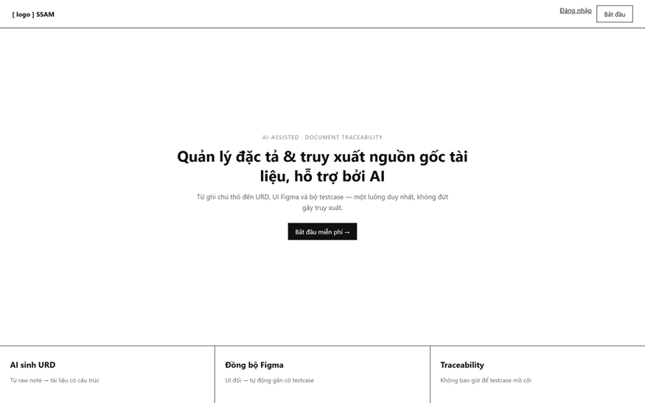
Public entry point shown to unauthenticated visitors (UC-01). Presents the product value proposition and a single "Start" call-to-action that routes to Register (or to Login via the header link).

Field Name | Description
Login | Routes to the Login screen for returning users.
Start | Routes to the Register screen to create a new account.

2. User Authentication

2.1 User Register
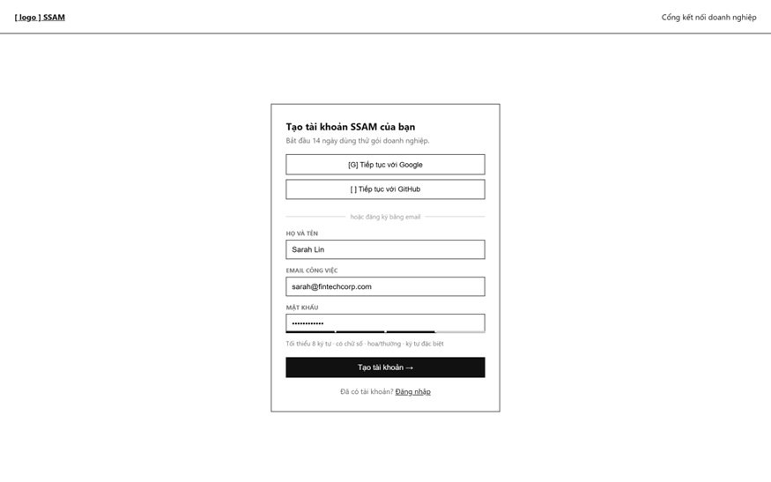
Allows a new user to create a personal or business account via email/password or OAuth (UC-03, UC-04). Google/GitHub buttons perform get-or-create sign-in; the email branch validates password strength live.
Field Name | Description
Google | OAuth sign-up; creates the account with emailVerified = true.
Full name | Required text field.
Email | Required, must be unique and valid format.
Password | Required; live strength meter enforces length and character-class rules.
Create account (button) | Submits the form; triggers email verification flow.

2.2 User Login
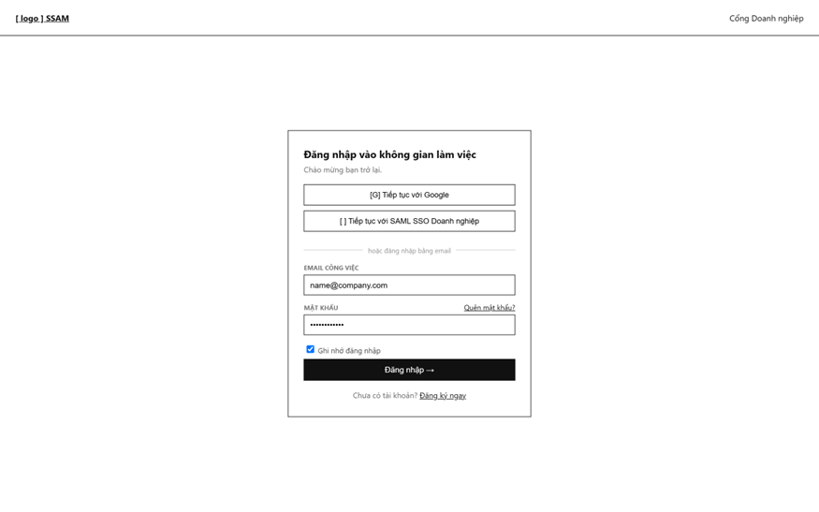
Authenticates a returning user via email/password, Google OAuth, or enterprise SAML SSO (UC-05, UC-06).
Field Name | Description
Google | OAuth sign-up; creates the account with emailVerified = true.
Email | Local credential fields.
Password | Local credential fields.
Remember me (checkbox) | Extends refresh-token lifetime.
Forgot password (link) | Routes to 2.3 Forgot Password.

2.3 Forgot Password
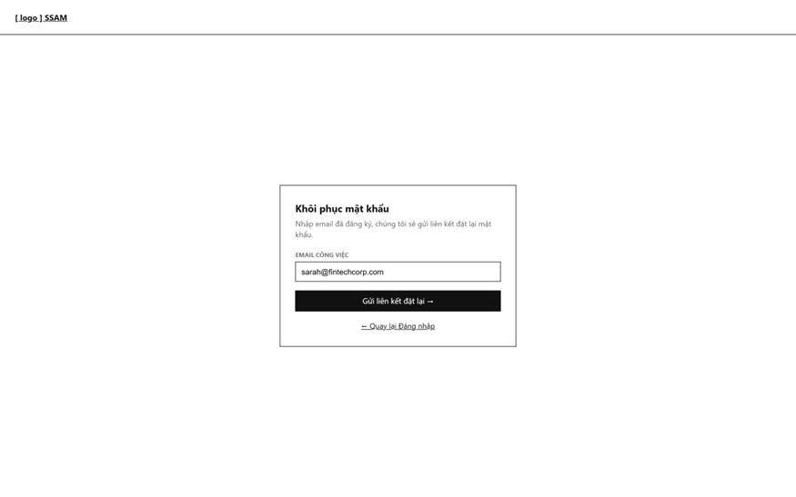
Authenticates a returning user via email/password, Google OAuth, or enterprise SAML SSO (UC-05, UC-06).
Field Name | Description
Email | Required; the system always returns a generic confirmation regardless of whether the email exists (prevents account enumeration).

2.4 Password Reset Email Sent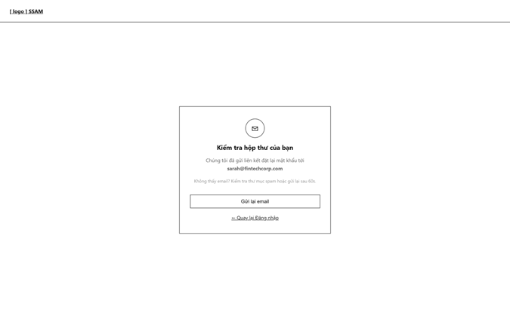
Confirmation state after submitting 2.3; instructs the user to check their inbox and offers a resend action (UC-08).
Field Name | Description
Resend (button) | Re-triggers the reset email, rate-limited server-side.

2.5 Set New Password
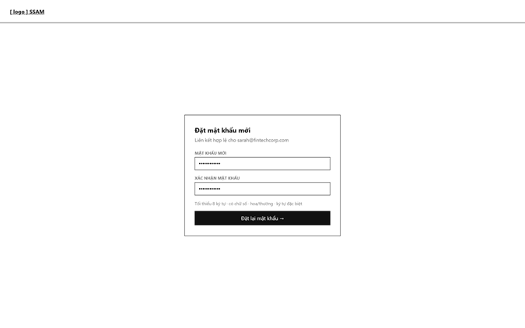
Final step of password recovery, reached via the emailed reset link (UC-08); the token is validated server-side before the form is shown.
Field Name | Description
New password | Required, same strength rules as Register.
Confirm password | Must match the new password field.

2.6 Email Verification Pending
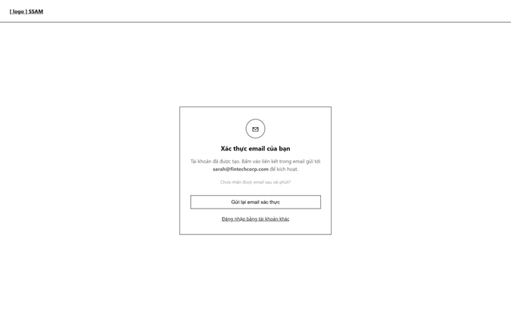
Shown immediately after Register for an email/password account; explains that the account is inactive until the emailed verification link is opened. This screen has no corresponding UC in the original Use Case list and is proposed as a supplemental screen.
Field Name | Description
Resend verification (button) | Re-sends the verification email if the first one expired or was not received.

2.7 Email Verified

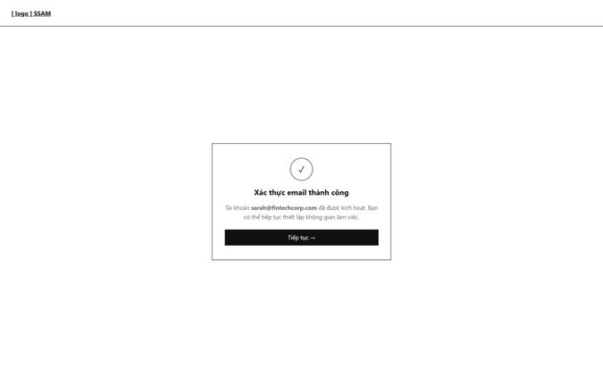
Success confirmation after the verification link is opened; the account becomes active and the user proceeds to onboarding (Choose Account Type). Supplemental screen, same rationale as 2.6.
Field Name | Description
Continue (button) | Routes to 3.1.1 Choose Account Type.

3. Tenant Management

3.1 Business Onboarding

3.1.1 Choose Account Type
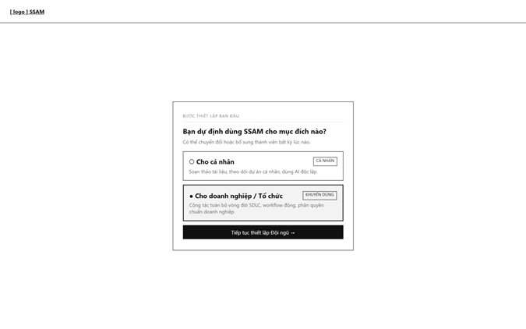
First onboarding step after email verification: the user chooses between a personal workspace or a business (multi-tenant) setup. Not a distinct UC in the original list — currently folded into UC-03/UC-04; proposed as its own step per Auth-DB-UI-Notes.md.
Field Name | Description
Cho cá nhân / For individuals (option) | Skips company setup and goes straight to the personal Dashboard.
Cho doanh nghiệp / For business (option) | Routes to 3.1.2 Company Setup; selected by default in the mockup.

3.1.2 Company Setup
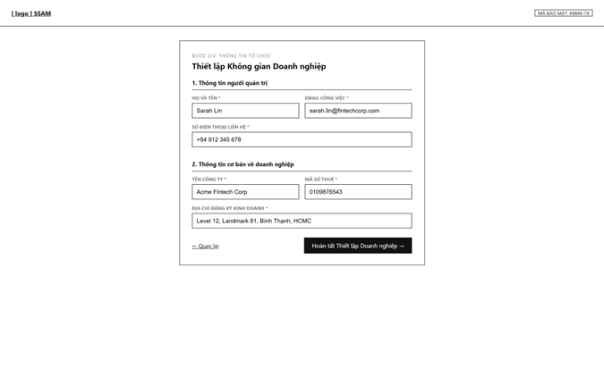
Two-part form to create a new Company (Tenant): administrator contact details and core business information (UC-04). The caller automatically becomes Tenant Admin of the new company.
Field Name | Description
Email | Pre-filled from the registering account where possible.
Contact phone | Required; stored but not OTP-verified in the current scope.
Company name | Required.
Tax code | Required; used for legal verification.
Registered address | Required.

3.1.3 Domain Match Suggestion
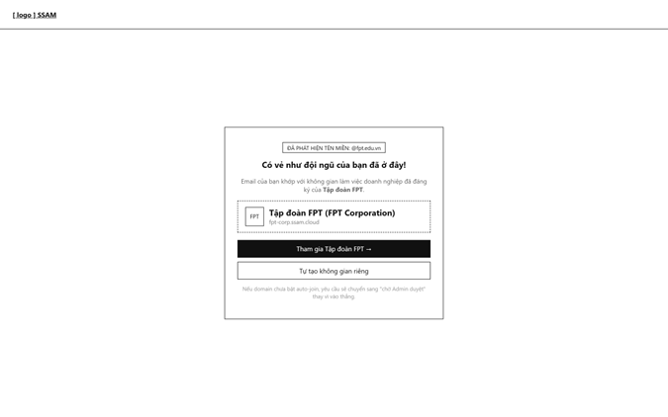
Shown when the registering user's email domain matches an existing Company's configured domain; offers to join that company instead of creating a new one. Supplemental screen (no dedicated UC yet); security-sensitive — default is domainAutoJoinEnabled = false, so the request normally falls through to 3.1.4 pending approval rather than joining immediately.
Field Name | Description
Join company (button) | If auto-join is enabled for the domain, joins immediately; otherwise creates a pending MembershipRequest.
Create my own (button) | Falls back to 3.1.2 Company Setup.

3.1.4 Pending Approval Request
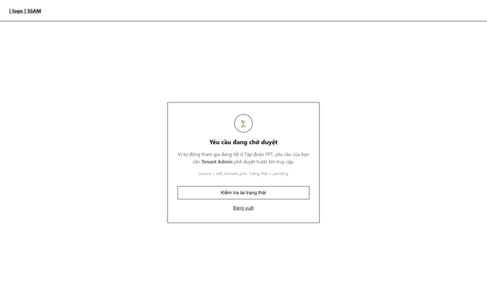
Shown after a self-service domain-match join request (source = self_domain_join) while it awaits Tenant Admin approval. Supplemental screen, same rationale as 3.1.3.
Field Name | Description
Check status (button) | Polls the MembershipRequest status.

3.2 Company Users & Permissions

3.2.1 Company Administration
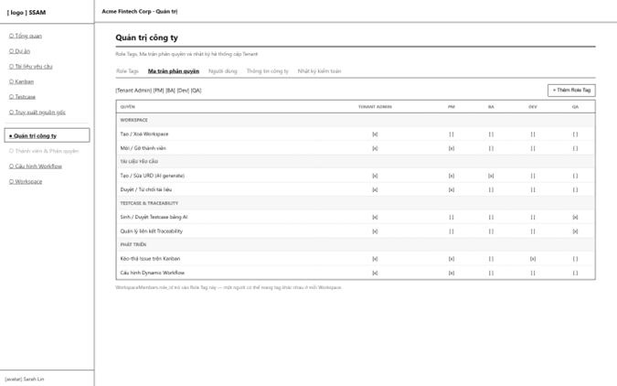
Tenant Admin console with four tabs: Role Tags, Permission Matrix, Company Users, Audit Log. The Permission Matrix tab (shown) lets the admin toggle which Role Tag can perform which action across modules (UC-10, UC-11).
Field Name | Description
Role Tag chips | Lists the company's defined tags (Tenant Admin, PM, BA, Dev, QA, …); "+ Add Role Tag" creates a new one.
Permission matrix cells | One checkbox per (permission × Role Tag); toggling persists immediately.

3.2.2 Company Users
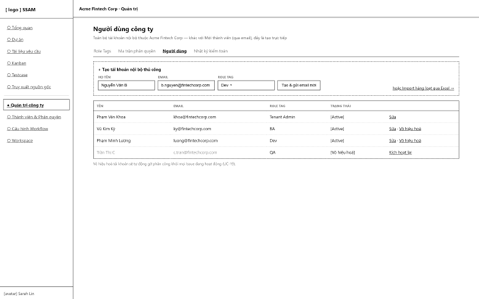
Lists every internal account in the company and allows creating one directly (UC-09) or deactivating an existing one (UC-13). Distinct from "Invite Member" in that accounts are created immediately rather than via an email invitation flow.
Field Name | Description
Name/ Email / Role Tag (inline form) | Creates the account directly and sends an invitation email.
Status column | Active / Deactivated; deactivating a user auto-unassigns their open Issues (UC-13).
Vô hiệu hoá / Kích hoạt lại (row action) | Toggles user status.

3.2.3 Batch User Import

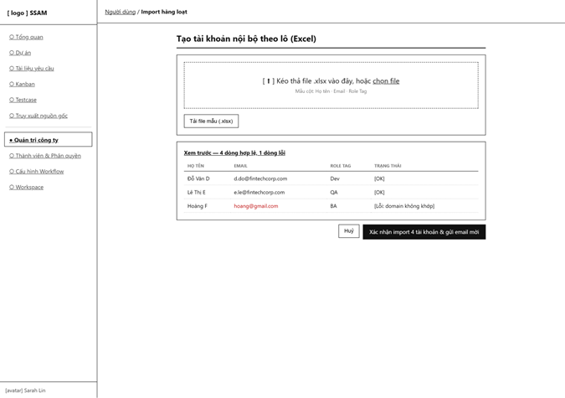
Bulk variant of 3.2.2: uploads an .xlsx file (Full name / Email / Role Tag columns) to create many internal accounts at once (UC-10).
Field Name | Description
File drop zone | Accepts the upload; a template file is downloadable for reference.
Preview table | Shows per-row validation result (e.g. DOMAIN_MISMATCH) before committing.
Confirm import (button) | Creates only the rows marked valid and sends invitation emails in bulk.

3.3 Membership Invitations

3.3.1 Accept Invitation

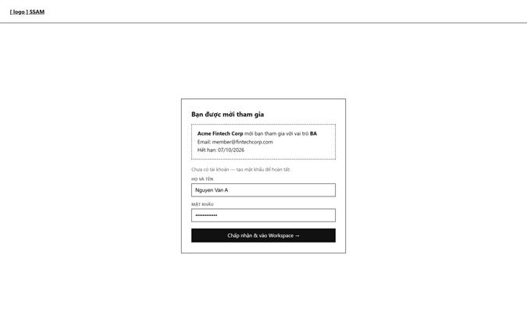
Landing screen for an emailed invitation link; shows who is inviting and to which role, and lets a brand-new user set a password to join in one step (UC-09, UC-18).
Field Name | Description
Invitation summary | Read-only: company, role, expiry.
Họ và tên / Mật khẩu | Only shown when the invited email has no existing account.

3.3.2 Invite Member
Tenant Admin screen to send membership invitations by email and track their status (UC-09, UC-18).
Field Name | Description
Invitee email | Required.
Role Tag | Assigned role for the invitee.
Pending invitations table | Shows status (Pending / Expired) with Revoke / Resend row actions.

4. Workspace Management

4.1 Workspace List

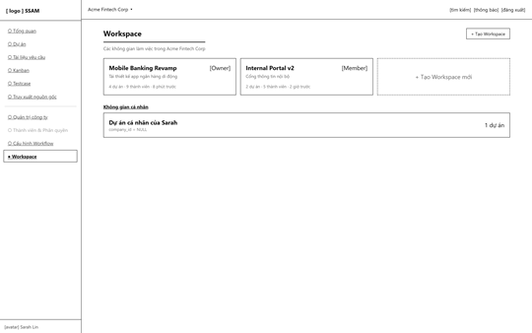
Lists every workspace the current user belongs to within the active company, plus their personal workspace (UC-22).
Field Name | Description
Workspace card | Shows name, description, caller's role, project/member counts; click opens 4.4 Workspace Detail.
+ Tạo Workspace / Create Workspace (button) | Opens 4.2 Create Workspace modal.

4.2 Create Workspace (modal)

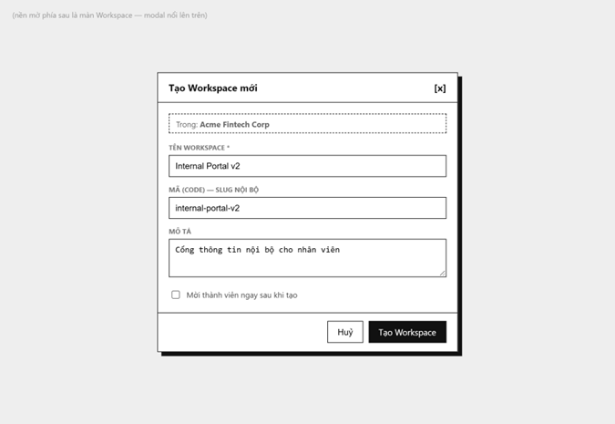
In-app dialog to create a new Workspace inside the currently selected Company (UC-21), as opposed to 4.3 which runs once during onboarding.
Field Name | Description
Name Workspace | Required.
Code | Auto-suggested slug, editable; must be unique within the company.
Description | Optional.
Invite members now (checkbox) | Optionally opens the invite flow right after creation.

4.3 Create Workspace (onboarding)

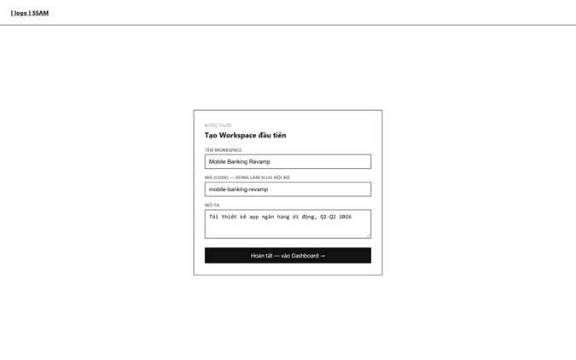Final onboarding step, run once right after Company Setup or after choosing "For individuals" (UC-21); on submit the user lands directly on the Dashboard.
Field Name | Description
Name Workspace / Code / Description | Same fields as 4.2.

4.4 Workspace Detail

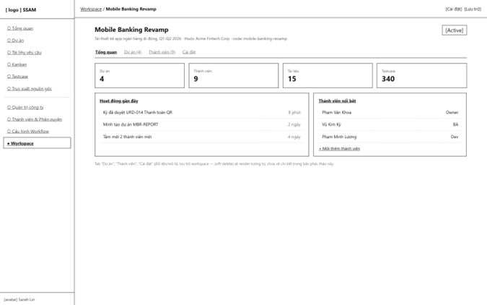
Overview tab of a workspace: summary stats, recent activity and top members, with tabs to Projects, Members and Settings (UC-22, UC-92).
Field Name | Description
Tab bar | Overview (shown) / Projects / Members / Settings.
Stat tiles | Project, member, document and test case counts.
Settings / archive (header buttons) | Shortcut to 4.6 Settings / archive action.

4.5 Workspace Members
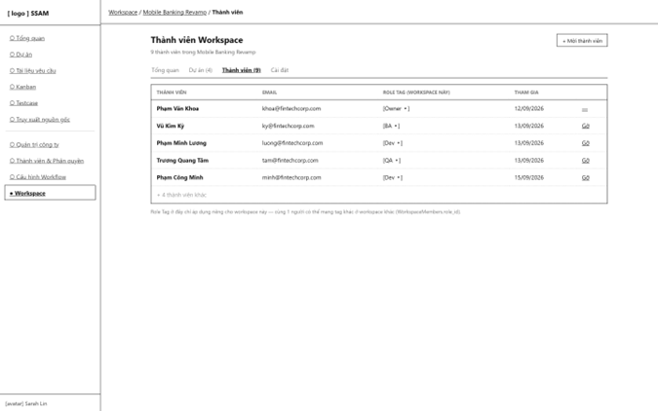
Full member roster of a workspace with the Role Tag each member holds specifically within this workspace (UC-25, UC-26), and member removal (UC-27).
Field Name | Description
Role Tag (workspace này) / per-workspace role dropdown | Changing it only affects this workspace — the same user can hold a different tag elsewhere.
Remove (row action) | Revokes workspace access while preserving the member's historical data (UC-27).

4.6 Workspace Settings

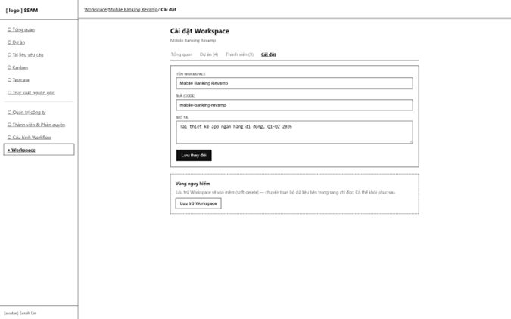
Rename/describe the workspace (UC-23) and archive it (soft-delete, UC-24) from the Danger Zone.
Field Name | Description
Name Workspace / Code / Description | Editable workspace fields.
Save Workspace / Archive (Danger Zone button) | Soft-deletes the workspace — contents become read-only, reversible by support.

5. Project Management

5.1 Project List
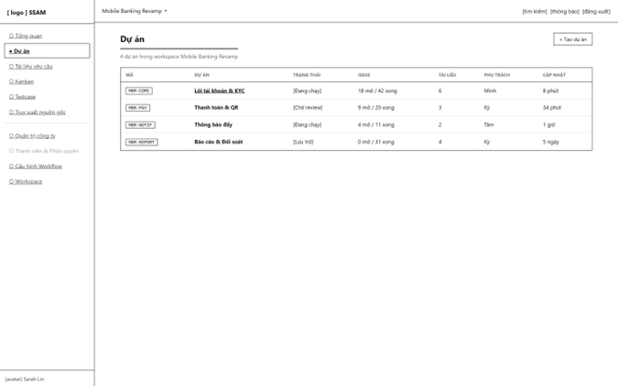
Lists every project in the current workspace with high-level progress indicators (UC-34).
Field Name | Description
Key column | The immutable Issue Key prefix (e.g. MBR-CORE).
Status | Active / Pending review / Archived.
Create project (button) | Opens 5.2 Create Project modal.

5.2 Create Project (modal)

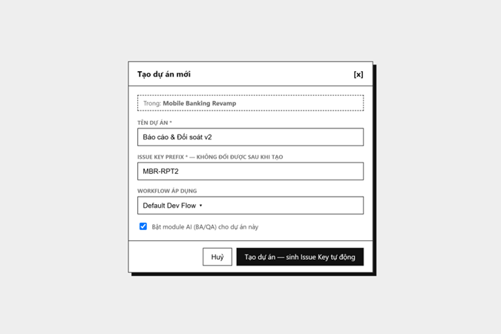Creates a new project and its permanent Issue Key prefix (UC-33).
Field Name | Description
Name | Required.
Issue Key prefix | Required, unique within the workspace, immutable after creation.
Workflow template | Selects the initial Dynamic Workflow scheme.
Enable AI module (checkbox) | Toggles BA/QA AI-assisted features for this project.

5.3 Project Detail

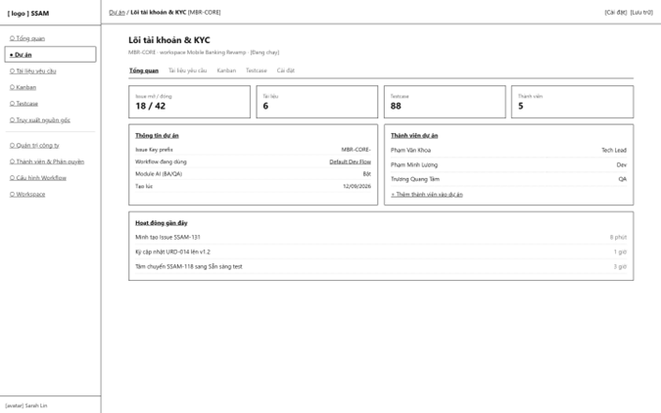Project overview tab: stats, project settings summary (Issue Key prefix, active Workflow, AI module state), members and recent activity, with tabs linking to the project's Documents / Kanban / Testcase screens (UC-34, UC-35, UC-41).
Field Name | Description
Tab bar | Overview (shown) / Requirement Documents / Kanban / Testcase / Settings.
WorkSpace panel | Read-only summary of key project settings.

6. Dynamic Workflow

6.1 Workflow Configuration

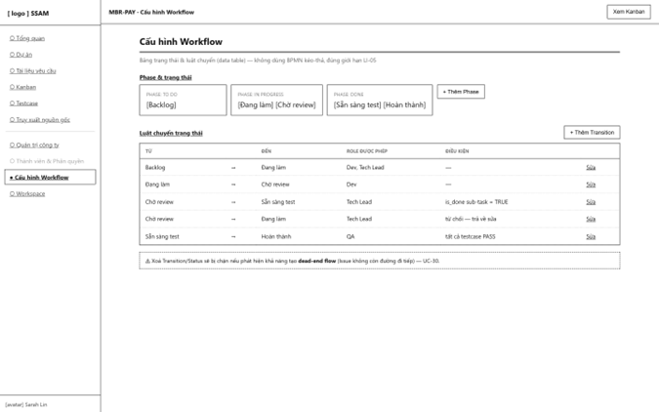
Lightweight, table-based configuration of a project's Kanban phases/statuses and the transition rules between them — intentionally not a graphical BPMN drag-and-drop editor, per scope exclusion LI-05 (UC-44 to UC-50).
Field Name | Description
Phase & Status cards | Group statuses under To Do / In Progress / Done phases; "+ Add Phase" creates a new group.
Transition table | Each row defines one allowed status transition, the Role Tags permitted to perform it, and an optional condition (e.g. "all sub-tasks done").
Remove Transition/Status (row action) | Blocked server-side if removal would create a dead-end flow for any Issue.

7. Document Management

7.1 Requirement Document List
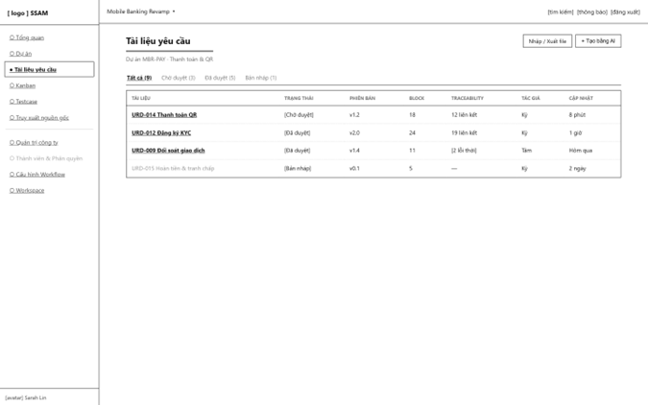
Lists Requirement Documents in a project with status, version, block count and traceability health (UC-51, UC-52).
Field Name | Description
Tabs | Filters the list by document status.
Traceability column | Shows linked-link count or a stale-link warning badge.
Generate with AI (button) | Starts the AI generation flow (see 7.4).

7.2 Document Import / Export

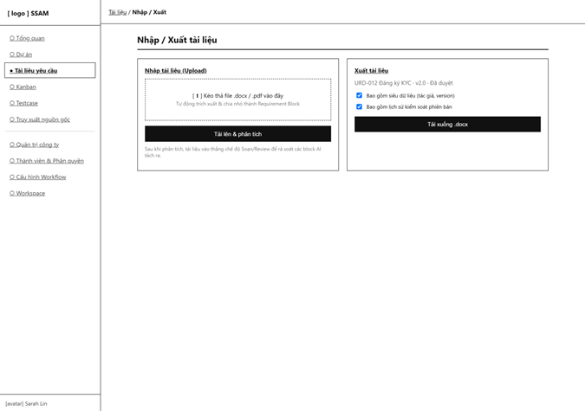
Upload a DOCX/PDF to auto-extract Requirement Blocks (UC-56), or export an approved document with metadata and version history (UC-57).
Field Name | Description
File .docx/.pdf / File drop zone | Triggers server-side parsing into draft Requirement Blocks.
Bao gồm siêu dữ liệu / phiên bản (checkboxes) | Controls what is included in the exported file.
Download (button) | Produces the exported document file.

7.3 Read Document
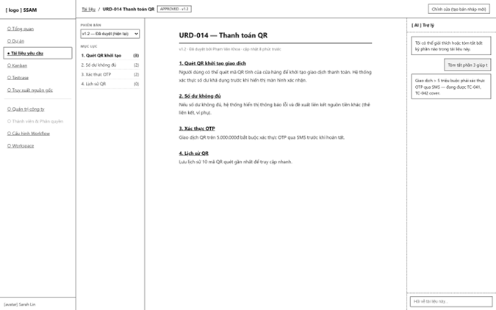
Read-only, continuous rendering of an APPROVED document for general consumption — three columns: version/outline navigation, flowing document body, and a contextual AI assistant panel (UC-55). Block boundaries are hidden in this mode; see 7.4 for the editing/review representation of the same document.
Field Name | Description
Version selector | Switches between historical versions.
Outline | Jump links to each heading, with a linked-testcase count per heading.
AI panel | Chat interface scoped to this document's content.

7.4 Compose / Review Document
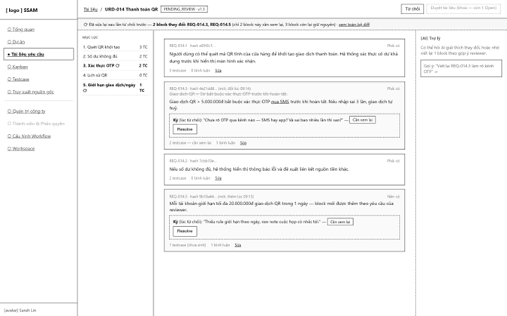
Block-level editing and review mode, shown while the document is DRAFTING or PENDING_REVIEW: each Requirement Block is a discrete, independently approvable/rejectable unit with its own content_hash, inline comments and diff view against the version last rejected (UC-53 compose, UC-58 compare version, UC-59 comment, UC-60 approve, UC-54 delete). The Approve action is disabled while any comment remains unresolved.
Field Name | Description
Block card | Shows blockCode, content_hash, priority and linked testcase/comment counts.
Diff (old vs. new) | Shown only for blocks changed since the last rejection, so the reviewer only re-checks what actually changed.
Resolve (comment action) | Marks a reviewer comment as addressed; required before the document can be approved.
Approve/Reject SRS (header buttons) | Reject (with per-block comments) or Approve (blocked by open comments).

8. UI/UX Structural Synchronization

8.1 Figma Sync
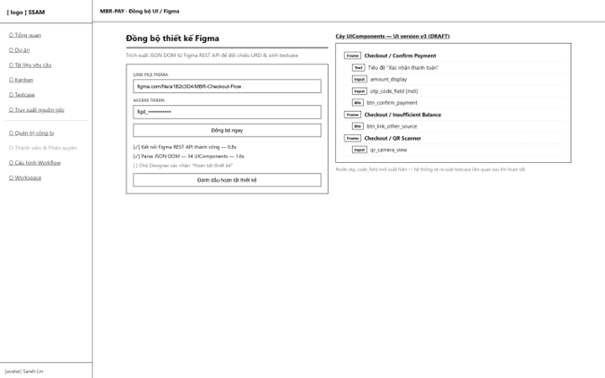
Pulls a Figma file's JSON DOM via the Figma REST API and renders it as a component tree for cross-checking against the Requirement Document (UC-75). Designers mark the sync "Completed" once satisfied; new/changed nodes trigger a downstream re-check of linked testcases.
Field Name | Description
Link file Figma / Access token | Inputs for the sync job.
Sync now (button) | Starts an asynchronous sync job.
Component tree | Parsed Frame/Input/Button/Text nodes for the current UI version; new nodes are flagged.
Mark design complete (button) | Freezes this UI version for AI testcase generation.

9. Issue Tracking

9.1 Kanban Board

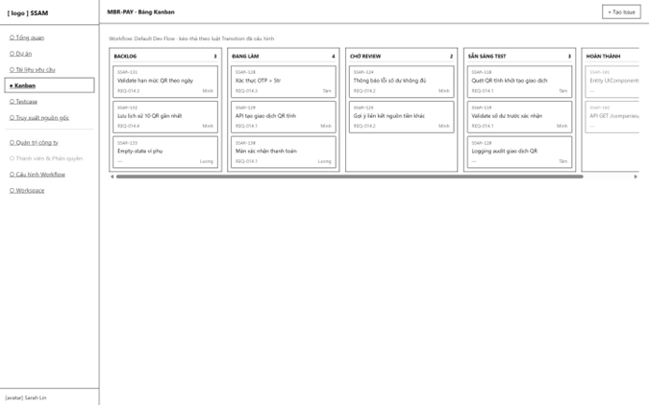
Visualizes Issues as cards across the columns defined by the project's active Dynamic Workflow (UC-65, UC-69); drag-and-drop transitions are validated against the configured rules.
Field Name | Description
Column | One per configured Status; shows issue count.
Issue card | Key, title, linked Requirement Block chip, assignee avatar; click opens 9.3 Issue Detail.
Create Issue (button) | Opens 9.2 Create Issue modal.

9.2 Create Issue (modal)
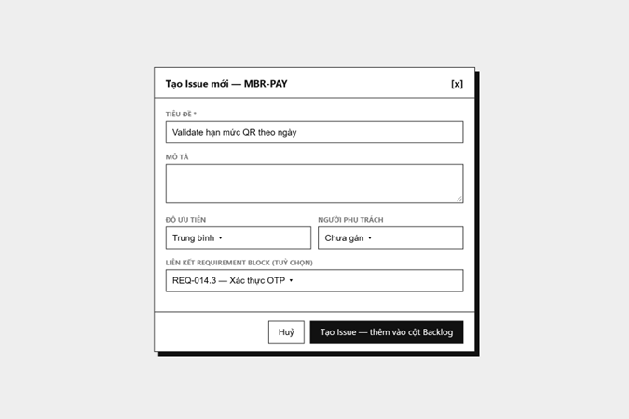
Creates a new Issue within a project, optionally pre-linked to a Requirement Block (UC-61).
Field Name | Description
Title | Required.
Description | Optional rich text.
Priority | Low / Medium / High.
Assignee | Optional at creation time.
Connect Requirement Block | Optional; feeds the Traceability Matrix once linked test cases exist.

9.3 Issue Detail
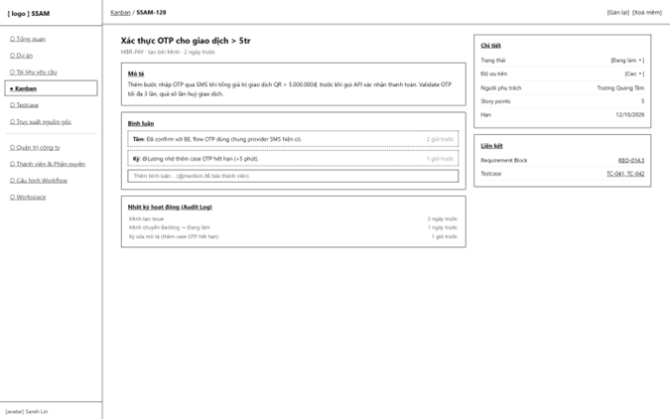
Full detail of a single Issue: description, threaded comments with @mention, an append-only activity log, and a sidebar for status/priority/assignee plus links to the Requirement Block and Testcases involved (UC-62, UC-63, UC-66, UC-67, UC-68).
Field Name | Description
Status dropdown | Changes are validated against the project's Workflow transitions.
Assignee | Reassigning triggers an email notification.
Connect(Requirement Block, Testcase) | Jump links into 7.4 and 10.3 respectively.
Comment box | Supports @mention to notify other members.

10. AI Testcase

10.1 AI Testcase Review

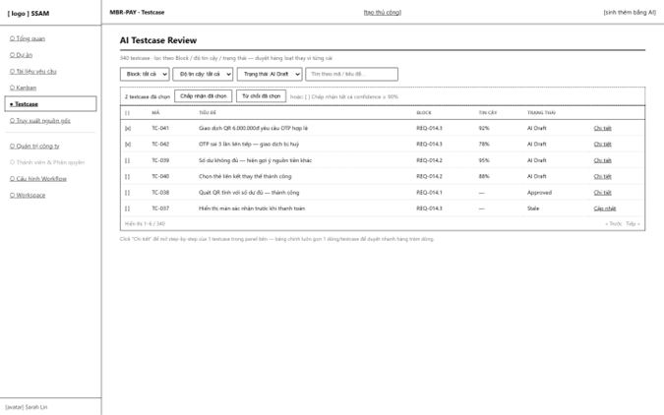
Table-based review queue for AI-generated testcases, designed to scale to hundreds/thousands of rows: filter by Requirement Block / confidence / status, select multiple rows, and bulk-approve or bulk-reject (UC-76 generate, UC-78 review/approve).
Field Name | Description
Filter(Block / Tin cậy / Trạng thái) / Filters | Narrow the list before reviewing.
Checkbox + Bulk actions | "Approve selected", "Reject selected", or threshold-based bulk approval (e.g. confidence ≥ 90%).
Detail (row action) | Opens 10.3 Testcase Detail for the step-by-step view.

10.2 Create Manual Testcase
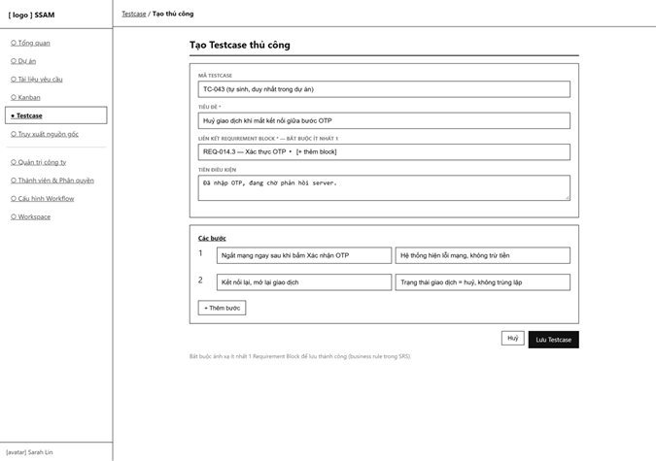
Lets a QA engineer author a test case by hand instead of relying on AI generation (UC-79). At least one Requirement Block link is mandatory to save, per the business rule in the SRS appendix.
Field Name | Description
Title | Required.
Connect Requirement Block / Linked block | Required — at least one.
Precondition | Optional free text.
Steps | Repeatable step rows; "+ Thêm bước" adds another.

10.3 Testcase Detail
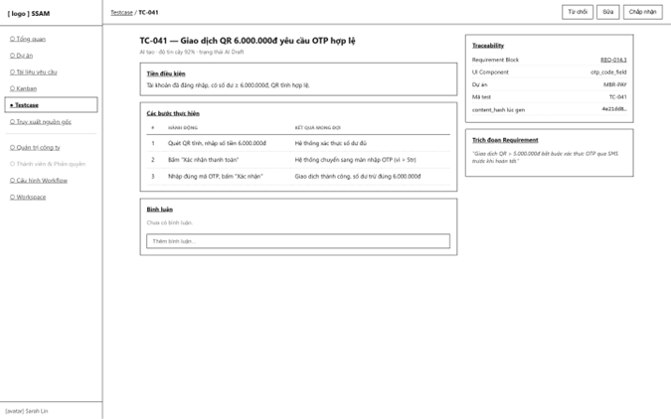
Full view of one testcase: precondition, ordered steps, and its traceability panel (linked Requirement Block with the content_hash captured at link time, and linked UI Component) (UC-80, UC-81, UC-82).
Field Name | Description
Steps table | Ordered action / expected-result rows.
Traceability panel | Shows the exact block/UI component this testcase is linked to, and the hash snapshot used to detect staleness.
Reject / Edit / Approve(header buttons) | Review the test case from this detailed view as an alternative to the bulk table.

11. Traceability

11.1 Traceability Matrix

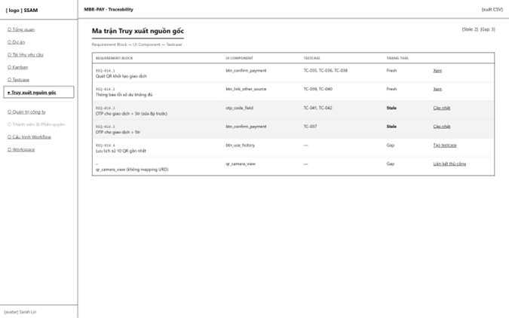Multi-dimensional mapping table between Requirement Blocks, UI Components and Testcases, highlighting Stale links (content changed upstream since the link was made) and Gaps (no testcase yet) (UC-83).
Field Name | Description
Link status column | Fresh / Stale / Gap.
Update/ Create testcase /Manual Connect (row actions) | Resolves a stale link, fills a gap, or opens 11.2 for a link the AI could not infer.

11.2 Manual Traceability Link
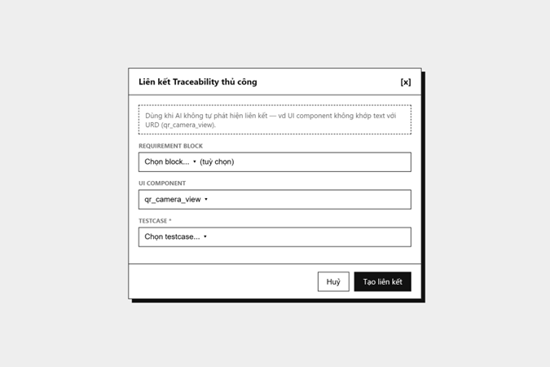
Lets a user manually establish (or later remove) a Traceability Link when automatic matching fails — e.g. a UI component whose name does not textually match any Requirement Block (UC-84).
Field Name | Description
Requirement Block Optional | May be left blank for a pure UI–Testcase link.
UI Component | Selected from the synced Figma component tree.
Testcase | Required.

12. Search & Notification

12.1 Notifications & Global Search
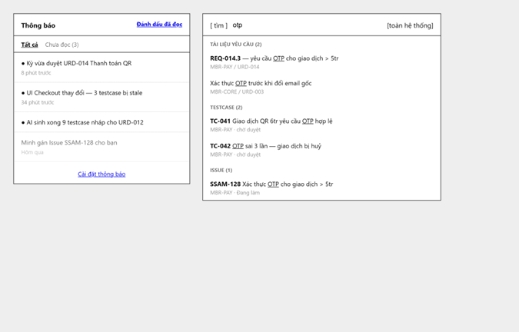
Two related overlays: the notification bell dropdown (read/unread list) and the global search palette, which scans Documents, Testcases and Issues the caller is permitted to see (UC-85, UC-86, UC-87, UC-88).
Field Name | Description
Tab All / Unread | Filters the notification list.
Search field | Debounced query across modules, permission-filtered.
Result groups | Tài liệu / Testcase / Issue, each linking straight to its detail screen.

12.2 Notification Preferences
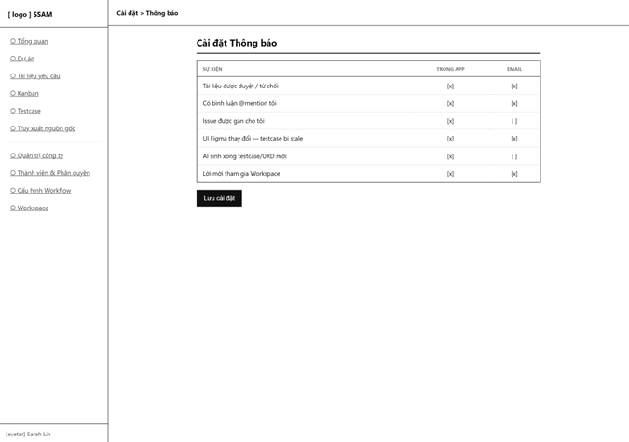

Per-user matrix of notification events versus delivery channel (in-app / email) (UC-89).
Field Name | Description
Event × channel matrix | One row per event type, two checkbox columns (In-app, Email).
Save (button) | Persists the preference matrix.

13. Dashboard & Report

13.1 Personal Dashboard
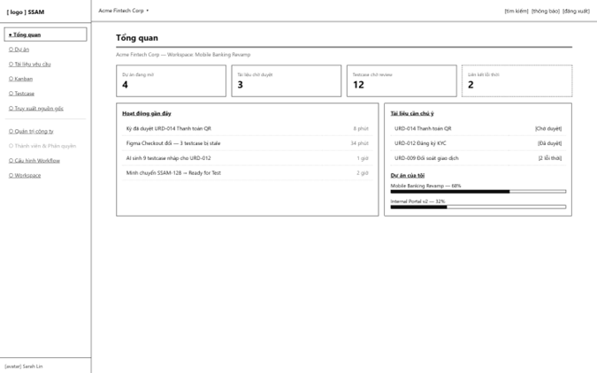
Default landing screen after login: personal stat tiles, a recent-activity feed, documents needing attention, and the caller's own project progress (UC-90, UC-91).
Field Name | Description
Stat tiles | Open projects, pending documents, pending testcases, stale links.
Recent activity | Reverse-chronological feed with deep links.
Documents needing attention | Shortcuts into 7.4 for documents awaiting the caller's review.

14. Audit & Platform Admin

14.1 Audit Log
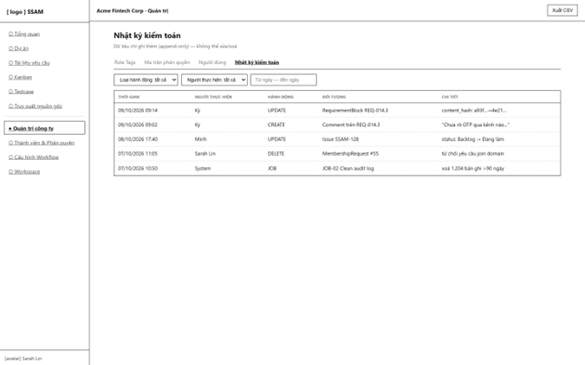
Append-only log of create/update/delete actions and scheduled job runs within a company, with filters and CSV export (UC-93).
Field Name | Description
Filters | Narrow the log.
Export (button) | Downloads the filtered log.

14.2 System Admin Console
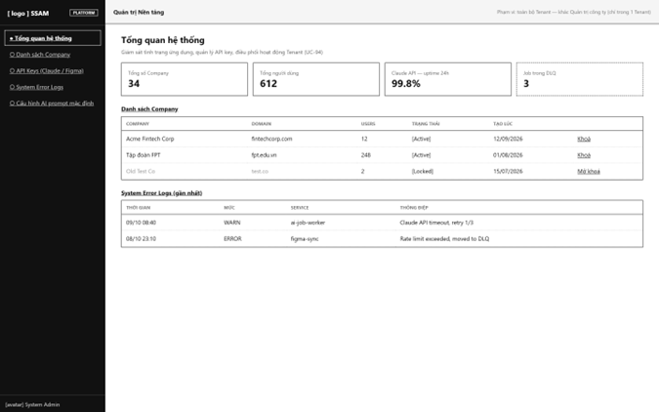
Platform-wide console for a distinct System Admin actor (not scoped to a single Company, unlike 3.2.1): company list with lock/unlock, platform-level stats, API key oversight and system error logs (UC-94).
Field Name | Description
Company list | Lock/unlock a tenant company platform-wide.
System Error Logs | Recent warnings/errors from background services (e.g. the AI job worker, Figma sync worker).

15. AI Chatbot

15.1 AI Chatbot
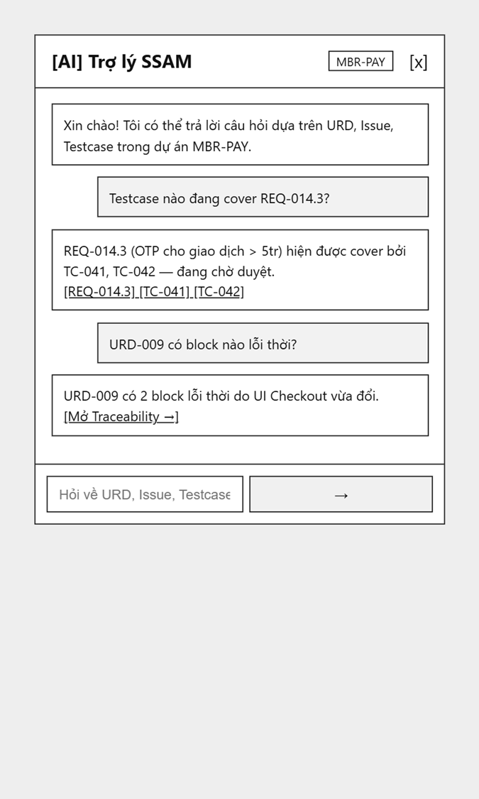
Slide-over chat panel scoped to the current project's context (Requirement Blocks, Issues, Testcases); answers are always paired with citations linking back to their source so the user can verify them (UC-95).
Field Name | Description
Ô nhập câu hỏi / Message input | Free-text question about the current project.
Trích dẫn nguồn / Citations | Clickable chips under each AI answer, pointing to the exact Requirement Block / Testcase / Issue used.

16. Background Job Inventory

17. External API Inventory

17.1 Claude Sonnet API (API-01)
URL | POST https://api.anthropic.com/v1/messages
Purpose | Generates Requirement Documents from raw notes and generates Test cases from approved Requirement Blocks + UI Components
Caller | SSAM backend AIGenerationJobs worker only — never called directly from the frontend
Auth | API key (x-api-key header); called with Zero Data Retention terms per the commercial agreement

17.2 Figma REST API (API-02)
URL | GET https://api.figma.com/v1/files/{file_key}
Purpose | Fetches a Figma file's JSON DOM so SSAM can parse it into UIComponents for cross-checking against URD content and generating test cases
Caller | SSAM backend Figma Sync worker only
Auth | Per-user Figma personal access token, supplied on the Figma Sync screen (8.1) and stored encrypted.

IV. Non-Functional Requirements

1. External Interfaces
User Interfaces: The system is developed as a Web application (Single Page Application using ReactJS), compatible with modern web browsers such as Google Chrome, Microsoft Edge, Mozilla Firefox, and Apple Safari. The user interface is primarily designed for desktop and laptop environments, with a minimum supported screen resolution of 1366 × 768 pixels. Additionally, the user interface shall display a timely warning when it detects that the document currently being edited has been modified and saved by another user, in order to prevent data conflicts.
Hardware Interfaces:
User Side: Users access the system through a personal computer with a stable Internet connection. The system requires an Internet connection to communicate with the Backend Server and does not support offline operation.
Server Side: The system is deployed on a virtual private server (VPS) running Ubuntu Server, which hosts the Backend API and database services.
Software Interfaces:
Figma REST API: The system connects to the Figma REST API to retrieve and analyze design structure and node data from Figma design files.
Generative AI APIs: The system connects to Generative AI services (Anthropic Claude API, OpenAI GPT API) through HTTPS REST APIs to send prompts and receive software specification documents (URD/SRS) and generated test cases.
Database: Microsoft SQL Server is used to manage user, project, workflow status, and traceability data.
Execution Platform: .NET 8 Web API serves as the backend platform for business logic processing and coordination between the user interface, database, and external services.

2. Quality Attributes

2.1 Usability
Learnability: The system shall enable users to learn and perform functions according to their assigned roles and permissions after basic guidance. Normal users shall be able to perform common tasks such as accessing workspaces, viewing projects, managing assigned issues, and accessing relevant documents. Users with advanced permissions shall be able to learn and perform configuration and management tasks such as workflow, project, requirement, testing, and AI-assisted functions. The required training time shall be validated through usability testing

2.2 Performance
Requirement | Target | Condition
Page load time | The main page shall load and display its primary content within 2 seconds. | Under normal operating conditions with a stable network connection.
Form submission response | The system shall provide confirmation for creating, updating, or saving data within 2 seconds. | For normal CRUD operations under normal system conditions.
AI Task Acknowledgment | The system shall accept an AI request, generate a Task ID, and enqueue the task for background processing within 1 second. | When the backend and queue services are operating normally. The processing time of the external AI provider is excluded.
Figma Data Synchronization | The system shall complete retrieving and analyzing design data from Figma within 15 seconds for a standard Figma file with fewer than 50 frames. | Dependent on the response time of the Figma REST API and the size of the design data.
AI Artifact Generation | The system targets completing the generation of software specifications or test cases within 15–45 seconds. | Dependent on the input/prompt size, selected AI model, and response time of the external AI provider. This is a performance target, not an SLA of the AI provider.
System Stability | The system shall maintain stable operation without service interruption or critical system failures under the expected workload. | The system is deployed in a Single VPS environment.

2.3 Security
Requirement | Description
Authentication | All system features and operations, except public functions such as Login, Registration, and Forgot Password, shall require users to authenticate using a valid JWT (JSON Web Token).
Password protection | User passwords shall never be stored in plaintext. The system shall use a secure password-hashing algorithm, such as BCrypt or PBKDF2, with a unique salt to protect stored credentials.
Account lockout | The system shall temporarily lock an account for 15 minutes after 5 consecutive failed login attempts to mitigate brute-force attacks.
Role-Based Access Control (RBAC) | The system shall enforce access control based on roles and permissions assigned within each company, workspace, or project. Users shall only be allowed to access features and perform operations permitted by their assigned roles and permissions.
Data Isolation | The system shall ensure data isolation between companies, workspaces, and projects. Users shall only be able to access information and documents within the scope of their assigned permissions, preventing unauthorized access to data belonging to other organizations or projects.
External API Credentials Protection | Sensitive credentials, including Figma access tokens and AI provider API keys, shall be securely stored and managed on the server side. These credentials shall not be exposed to the frontend or included in client-side source code.
Rate Limiting and Usage Quotas | The system shall enforce rate limits and daily usage quotas for AI requests to prevent excessive API consumption, control operational costs, and protect system resources. Usage limits shall be applied according to the system's configured policies.

V. Requirement Appendix

1. Business Rules
GBR-ID | Rule Statement | Applies To | Rationale | Enforced By
GB-01 | Documents with APPROVED status are locked in Read-Only (Safe Mode) and cannot be edited directly. | Document Management | Protects the baseline for development and testing, preventing scope deviations. | The system automatically disables editing permissions.
GB-02 | Every manually created test case must be linked to at least one Requirement Block before it can be saved. | AI-Generated and Manual Test Cases | Ensures the integrity of the Traceability Matrix. | The system disables the Save action until the required link is established.
GB-03 | Any modification to a Requirement Block automatically flags related test cases and comments as Stale. | Traceability Engine | Enables QA to identify test scenarios that are no longer aligned with the updated requirements. | An automated background trigger runs whenever a Requirement Block is updated.
GB-04 | An Issue may only be transitioned to another status via drag-and-drop if the user's role is authorized to perform that transition according to the Transition Matrix. | Issue Tracking | Ensures that workflow transitions comply with role-based authorization. | The system validates the user's permissions when the card is dropped.
GB-05 | All AI-generated content must be labeled AI-Generated and manually reviewed and approved by a user before being accepted into the system. | AI Requirements | Ensures accountability through a human-in-the-loop approval process. | The system requires the user to explicitly select Accept or Reject.
GB-06 | Users may access a Project, Workspace, or Issue only if they have been explicitly invited or granted the appropriate permissions. | Entire System | Ensures data isolation and prevents unauthorized access. | The backend validates access permissions on every API request.
GB-07 | A prominent red warning must be displayed before deleting any Entity (Issue or Document) that has existing traceability links. | Issues / Documents | Prevents accidental deletion that could break traceability relationships. | The system checks for existing mappings before performing a soft delete.

2. System Messages
# | Message code | Message Type | Context | Content
1 | MSG01 | Inline message | No results match the search criteria. | No search results.
2 | MSG02 | Red text below the input field | A required field is left blank. | The * field is required.
3 | MSG03 | Toast notification | Data is successfully saved or updated. | {Entity} updated successfully.
4 | MSG04 | Confirmation modal | The user attempts to delete an Issue or Document that has existing traceability links. | Warning: This item contains traceability links. Are you sure you want to delete it?
5 | MSG05 | Error toast notification | The user attempts an unauthorized Issue status transition. | Permission denied for this transition.
6 | MSG06 | Red text below the dropdown | No Requirement Block is selected when creating a manual test case. | Must link to at least one Requirement Block to save.
7 | MSG07 | Error toast notification | The AI service encounters an error, times out, or exceeds its quota. | AI service unavailable. Please try again later.
8 | MSG08 | Badge / Inline label | A test case is outdated due to changes to its linked requirements. | Outdated: The original requirement has been modified.
9 | MSG09 | Error toast notification | An invalid Figma URL or authentication token is provided. | Figma authentication failed. Please check the URL and token.
10 | MSG10 | Inline message | The user enters an incorrect username or password, or the account has been deactivated. | Incorrect username or password, or account deactivated.

